That all people should have access to the:

* **The Facts of Astrology (1)**
* **Facts of Extra Sensory Perception (3)**
* **Facts of Induced Emotion (5)**
* **Facts of Directed Thinking (7)**

That people must have:

* **Freedom from Want (2)**
* **Freedom from Fear (4)**
* **Freedom of Expression (6)**
* **Freedom of Religion (8)**

And these must culminate in the adoption of the Universal Moral Code:

* **Contribute your utmost to Universal Welfare (9)**

**THE PURPOSE**

To develop the four possessions, we take with us after death:

1. Knowledge
2. Ability
3. Character
4. Dominant Vibratory Rate

**Excerpt from Course 2, Astrological Signatures**

The mere union in the spiritual world of a male and a female soul, .... does not provide the form and functions of an angel, nor does the mere union of spermatozoon and ovum ensure that a child will be born. No more so than that the union of inner-plane facts and outer-plane facts, such as are represented by the two wavy lines which symbolize the sign Aquarius, alone insure there will be the New Civilization which the humanitarian side of the sign demands of the Aquarian Age. In each case, if that of which the union is but the start is properly to develop and result in the promised birth of something more perfect and glorious, development must take place which follows a definite nine-point plan. And even as in numerals the number 10 starts a new cycle, so the tenth step, of course, is the one of transition which marks the birth of that which has undergone the nine phases of gestation.

While the nine-point plan and its final result on each level very broadly correspond to the chain of ten planets, much more detail can be learned from the precise correspondence of the planet or sign to the sequence number in the plan. This astrological rulership of the numerals is set forth in Course 6, The Sacred Tarot.

In the Cycle of Necessity, the soul undergoes development in nine realms before becoming the transcendent angel which permits its birth into the celestial realm from which it started. This is the nine-point plan which to be successful it must follow: I Celestial, II Spiritual, III Astral, IV Mineral, V Vegetable, VI Animal, VII Human, VIII Astral, IX Spiritual. With these nine phases of gestation completed, Self-Conscious immortality has been won and transition may take place in the perfect angelic form to X Celestial.

In the adjustment of mankind to the Aquarian Age, now at hand, the tenth and final step is the attainment of a truly enlightened and humanitarian civilization. And to make this transition properly, humanity must proceed according to the nine-point plan which follows:

As a cooperative intelligence working for the realization of God's Great Evolutionary Plan, the development of the powers and possibilities of his own soul is of paramount importance to the individual, and of paramount importance to the whole in proportion as the abilities and characteristics thus developed contribute to universal welfare. And this character development is influenced and conditioned by the environmental forces which it contacts not merely on one plane, but on both the inner and the outer plane.

Both the behaviour of the individual and the events which come into his life are primarily determined by the desires of the thought-cells and thought structures of his own soul. These thought-cell desires, in turn are determined by the experiences which have formed them or added to them; experiences with both the inner-plane environment and the outer-plane environment. Secondarily, the behaviour of the individual and the events which come into his life are determined by planetary or other inner-plane energies added to the thought-cells of his soul at a given time, which increase their activity and modify somewhat their desires, and by the facilities afforded by the outer-plane environment to some actions and events and the resistance the outer-plane environment offers to others.

Either freedom from want or any one of the other three essential freedoms which should be present in the outer-plane environment, implies effective use of abilities on materials, and the avoidance of disaster. Square pegs in round holes, people engaged in enterprises for which they have no talent, and people engaging in enterprises at times when failure is sure to result, do not lead to freedom from want. Effectively to guide character development, and to have freedom from want in ample measure, as well as to have the other essential freedoms, the 9-point plan states:

**FIRST, that all people should be familiar with the Facts of Astrology**

A lifelong physical environment of illiteracy, poverty, disease and heartrending toil, such as vast portions of the world have experienced, is not conducive to developing the potentialities of the soul. Nor is the acceptance of the doctrines of atheistic materialism. Under such physical environmental handicaps, the individual ignores or denies the existence of his soul, and is trained to function, whether his intellect is active or numbed by hardships, only on the self-seeking plane of the brutes.

To have sufficient leisure from incessant toil, and to possess the things properly to live, while thought is given to the soul, and effort spent in character development, the 9-point plan states

**SECOND, that all people should have Freedom from Want**

A haphazard universe moving without purpose gives few assurances that the individual will not be overwhelmed by disaster. Atheistic materialism, by force of arms if able to do so, and by cunning suppression of all facts which prove there are inner-plane forces, or life on any plane but the physical, if force of arms does not give it world dominance, is determined to compel all men to accept such a purposeless universe, in which selfish force and brutal shrewdness are extolled as the highest virtues. But millions of people, past and present, through their own personal experiences have proven to themselves that there is a Supreme Guiding Intelligence permeating the universe which, under special conditions, men can contact. And millions of people, past and present, through their own personal experiences have proven to themselves that physical death does not end either consciousness or the progress of personality. And in order that people may thus prove to themselves the existence of God, and the persistence of life and personality after the dissolution of the physical, the 9-point plan states:

**THIRD, that all people should be familiar with the Facts of Extra Sensory Perception**

There is possible either a constructive or a destructive approach to every situation of life. An approach which is accompanied by the emotion of fear is to that extent destructive, for fear is an agent of ineffectiveness and the foe of health and happiness. Even the facts of astrology when viewed from the standpoint of fear may be made detrimental, and freedom from want in proper measure is repelled by fear. Yet the attitude of fear is a conditioned state. It arises from considering the possibility or probability of want, disease, or other disagreeable things, including the cessation of life. Confidence that disagreeable things will not happen, that dangers can be surmounted, and that death merely brings a continuation of life on another plane, assist in conditioning the emotions to resist this most destructive of all attitudes. In order to promote happiness, usefulness and spirituality, the 9-point plan states:

**FOURTH, that all people should have Freedom from Fear**

The success with which an individual is able to express his natural aptitudes, to contribute to the welfare of all, and to develop his own soul depends, in addition to his familiarity with astrology and ESP and possession of the four freedoms, on the desires of the thought-cells and thought structures of his own soul. The conditions of external environment afforded by the four freedoms facilitate soul growth, and knowledge of astrology and ESP indicate the best course to pursue. But, in spite of knowledge and environment, both the actions which take place which we call behaviour, and the events which come into the life, are chiefly determined by the way the thought-cells and thought structures within the soul then feel.

The thought-cells and thought structures have the desires they do, and therefore influence the behaviour and events in the manner they do, because of the feeling energy and the emotional energy which have been built into them in the past. And the only way to get them to have different desires, and consequently influence the behaviour in a more beneficial manner, and to work from the inner plane to attract more favourable events, is to impart to them appropriate feeling and emotion. To do this intelligently requires the use of deliberately induced emotion. Thus the 9-point plan states:

**FIFTH, that all people should be familiar with the Facts of Induced Emotion**

But men will not be permitted to become familiar with the facts of astrology or the facts of ESP if atheistic materialism is able to gain the intellectual dictatorship over the people of the world it desires. Nor will it be possible to have either freedom from want or freedom from fear if such intellectual dictatorship is permitted to suppress facts relative to economic conditions and political oppression. To gain power through which to use others for their own selfish and brutal ends, tyrants always have found it essential to suppress and distort the facts.

But even when they have free access to facts, men also have individual aptitudes without the expression of which, either in the vocation or the avocation, they are unable to find happiness and are unable to contribute most to universal welfare. These creative talents should not be wasted through denying them opportunity for exercise. Therefore the 9-point plan states:

**SIXTH, that all people should have Freedom of Expression**

The proper exercise of each of the four freedoms, and the proper employment of the facts of astrology, the facts of ESP and the facts of induced emotion, that these may Contribute Their Utmost to Universal Welfare, imply that intelligence must be applied to formulate an effective plan, and that the energies instead of being permitted to wander aimlessly from this plan, be directed into its fulfilment. The energies tend to flow into and develop whatever thought the mind consistently entertains. Thought ever affords, both on the outer plane and the inner plane, the pattern of action. Consequently the 9-point plan states:

**SEVENTH, that all people should be familiar with the Facts of Directed Thinking**

The most important thing in the universe is God's Great Evolutionary Plan. The conception of this plan depends upon the spiritual and intellectual level of the individual trying to comprehend it. Also, as physical science and spiritual science discover new facts any adequate conception of this plan must be enlarged to embrace them.

To the individual, the most important thing of all is the progress of his own soul. And soul progression cannot be applied to him from the outside by others, no more than can intelligence. It requires effort on his own part to live, not as someone else believes, but according to his own highest conception at the time. It requires the liberty, as more complete information is gained, to modify the conduct to conform to this new information. Therefore the 9-point plan states:

**EIGHTH, that all people should have Freedom of Worship**

Both the progress of his own soul and the unfoldment of God's Great Evolutionary Plan depend upon the welfare of the various individuals who make up the conscious cells embraced within the whole. What affects one individual, in some degree affects all individuals. The 9-point plan therefore states:

**NINTH, that all people should adopt as the constant and dominant motives of their lives that they should contribute their Utmost to Universal Welfare**

The four freedoms set forth in association with the negative, or even, numbers, 2,4,6, and 8, relate largely to important factors of the outer-plane environment. There is no assumption that we know all we should about them. In fact, as evolution advances, we are sure to learn details which will assist us more perfectly to realize these four freedoms. And we should strive persistently to acquire such knowledge, which, no doubt, will be made available through the ordinary channels of education.

The four orders of facts set forth in association with the positive, or odd, numbers, 1,3,5, and 7, however, relate largely to important factors of the inner-plane environment. As information relating to them is mostly lacking through the more ordinary channels of education, the Brotherhood of Light lessons were written to make it accessible to all.

Yet these lessons, which are as comprehensive as it is possible to make them at this day, make no assumption that we know all we should about these four orders of inner-plane activities. In fact, although we now know the fundamental principles through which each operates, as times goes on we are sure to gain many new details which will assist us more perfectly to utilize these four different categories of inner-plane forces. As this new knowledge is gained it will be included in revised copies of The Brotherhood of Light lessons. And to hasten acquiring it, The Church of Light maintains three active research departments: The Brotherhood of Light Astrological Research Department, the ESP Research Department, and the Control of Life Research Department.

Even as Aquarius is symbolized by two wavy lines, one above the other, are there four essential freedoms which relate chiefly to the physical environment, and four orders of facts which relate chiefly to the inner-plane environment, the utilization of which are essential. But between the four outer-plane freedoms and the four inner-plane orders of facts, must ever remain as the central theme the all-inclusive principle indicated by the Deific number 9, the number of Aquarius: the constant and dominant motive in men's lives must be to Contribute Their Utmost to Universal Welfare. This is the most important factor of all in the Nine-Point Plan for the New Civilization.

**The Kabbalah and The Two Keys**

**Doctrine of the Kabbalah**

The word kabbalah signifies traditional knowledge. It thus refers to the Oral Law, as handed down from antiquity; and embraces the occult traditions of all lands and all peoples. Often it is used merely as referring to the esoteric doctrines of the Jews; but in its broader sense it includes also the secret doctrine of other races. This secret doctrine, common to many lands, was jealously guarded from the profane, and was never permitted to pass into writing except in such ambiguous terms as to baffle the uninitiated as to its true purport.

In this sense the sacred books of the world, including the Avesta, the Vedas and the Bible are largely kabalistic; for they set forth traditions that are capable of an inner, or esoteric, interpretation. In fact, there are usually several interpretations possible, each more inner version revealing a deeper truth to those who have advanced along the path far enough to comprehend it.

The kabbalah has two divisions; the written kabbalah and the unwritten kabala. Of the unwritten kabbalah, S. L. MacGregor Mathers, in his *Kabbalah Unveiled* says: "The term 'Unwritten Kabbalah' is applied to certain knowledge which is never entrusted to writing, but communicated orally. I may say no more on this point, not even whether I myself have or have not received it." The author of these lessons is not so modest about his acquaintance with the unwritten kabbalah. He has received it fully, and has also investigated the written traditions of the Jews and of all other people’s having had much influence in shaping the world's thought. And this seems the proper place to point out that the unwritten kabala, like the written kabbalah, is set forth in symbolical language, with purposeful blinds and subterfuges to confuse the uninitiated; so that of the few who undoubtedly exist at the present day who have received it, most remain in as much ignorance of its true interpretation as the majority of students do after studying the more accessible written Kabbalah.

This unwritten kabbalah has been transmitted only through certain secret schools. Those receiving it well merit what is given to them. They are left to their own devices in the matter of interpretation. And because the real keys to its interpretation - astrology and the tarot - have been largely ignored, or distorted, they have floundered sadly in arriving at its meaning. Whether written or unwritten, the kabbalah is a philosophy correlated to esoteric astrology as exemplified by the tarot; and it can only be comprehended fully by those who perceive the true relation between astrological energies and their pictured tarot exemplification

In all ages and in every land and clime there are progressive souls whose spiritual vision pierces the murky clouds of dogmatic illusion with which priestcraft and statecraft have ever sought to obscure the sun of divine truth. These bold aspirants to esoteric wisdom have the courage to burst the fetters that chain them to the lifeless creeds which are forced upon a benighted world. They free themselves from the thraldom of prejudice, and from that of servility to popular opinion. They intrepidly turn their faces from the blackness of the dead ages to knock resolutely at the door of the Temple of Knowledge. They realize that only within the sacred precincts of nature's sanctuary burn the altar fires whose light produces the shadowy illusions which are believed by the multitudes who worship them to be the only reality. And they learn that this sanctuary may be unlocked only by the use of two keys.

Such a candidate for initiation, having become as a little child, after divesting himself alike of the shroud of orthodoxy and the incumbrance of current scientific opinion - the one as dogmatic as the other - stands at the entrance of the temple, seeking admittance. This structure is the edifice of nature, the home of Isis, the lodge room of our Grand Master, King Sol; and is referred to in the Bible as Solomon's Temple. Now this name can hardly have been derived directly from so many divergent sources, yet in spite of this, SOL-OM-ON presents some interesting correspondences; for Sol is the Latin name of the Sun God Phoebus; Om is a Hindu name of Deity; and on is the Sun God of Heliopolis, Egypt, which anciently was called the City of On.

The candidate has heard it said, "Knock and it will open; Ask and ye shall receive; Seek and ye shall find." So, sustained by a love of justice, he stands with clean hands and a pure heart at the gate to the sanctuary. After a time, his efforts are rewarded by glimpses of the interior as the gates are opened by other hands, or the intuitions of his soul penetrate their opaqueness. His summons are finally answered by the Voice of the Silence, encouraging him to further endeavor; but at the same time admonishing him that there is no vicarious atonement or attainment. Each must unlock the doors that bar his progress and that guard the temple from profanation, for himself.

King Solomon's Temple has two doors; so also, there are two doors to its oracle. He who would enter either must possess their respective keys. The door on the right is opened only with the aid of a golden key; that on the left requires a key of silver. These same two keys with which the outer doors of the temple may be unlocked will also open the doors of the oracle; but the keys that are turned from right to left in the outer doors must be turned from left to right to unlock the inner. That keys are extant by which their possessor may penetrate the barriers of objective phenomena is common knowledge among all well posted occultists. Students of masonic symbolism go further; for they recognize that these keys are two in number. In fact, the literature on ceremonial magic very largely revolves around the two productions, the one entitled, "Clavicula Solomonis" (The Key of Solomon the King), and the other entitled, "Lemegeton" (Lesser Key), there being an English translation of both. But the usefulness of these volumes, if they may be said to have a use, pertains to the history of mystical aberration, and to magical practices of doubtful quality, rather than to any revelation of the mysteries.

Turning from these again to freemasonry, we find the symbol associated with the Fellow Craft degree to be complex. We are in search of keys; therefore, the other symbology need not here concern us. But one prominent feature of the symbol are Two Crossed Keys, one of Silver and the other of Gold. These are the keys for which we seek. Masonry in its symbolism has preserved the keys to initiation. They are the keys that unlock the doors of King Solomon's Temple; but precisely what these two keys symbolize in occult science no modern expounder, in so far as I have been able to learn, has explained. Therefore, I shall devote this lesson to bringing to the notice of all and sundry who are interested in occult matters, both the importance and the nature of the key of silver and the key of gold...

Let us consider that nature in all her various manifestations is under law, and that this law invariably is based upon mathematical principles. Mathematical relations are absolute, and pertain as well to spiritual, celestial and angelic spheres, as they do to our humble planet. Everything, from the tremor of a thought wave to the evolution of a universe, operates in strict obedience to numerical law. The eight volved tower of Babel rose on Shinar's plain to exemplify the numbers understood by the Magi to govern race evolution. The pyramids yet stand as a monumental proof of the numerical relations existing between the earth, the universe, and the soul of man.

And though the Pythagorean system of numbers was never placed in writing, and hence is dimly grasped except by the few, yet its fame has echoed down the corridors of time and prompts our soul to listen to the music of the spheres. Mathematics alone enables one to avoid mental pitfalls, and it is due to this fact that the Golden and Silver keys are the most valuable possessions that the occultist can obtain in the world of mental research; for they are each grounded in, and strictly built upon numerical proportions.

To comprehend their function, we must have recourse to the Written and Oral Laws. Initiates understand the Written Law to be that Law inscribed in scintillating characters of light, by the ever-moving finger of Deity, in the azure dome that spans our midnight sky. It is written in the Language of the Stars, and thus revealed His will to the primitive Assyrian Shepherds. Its study later gave to Egypt her splendor, and made the Chaldean Magi so justly famous. It was the knowledge of this ineffaceable Written Law, the sublime science of the starry heavens, that constituted the wisdom that flowed from the magical schools of Atlantis toward the rising sun; and in the dim and distant past, in those remoter periods of racial childhood, before material struggles had crystallized the sensitiveness of the soul, it was the pure intuitional recognition of the Written Law that constituted primitive religion...

**Astro-Tarot Series**

**About...The Astrological Significance of each Egyptian Tarot Card**

**DW Sutton**

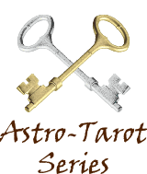

In March 1914 Elbert Benjamine commenced writing The Brotherhood of Light lessons and during 1918 he wrote the 12 lessons that comprise Course 6 – *The Sacred Tarot*. In April 1924 The Brotherhood of Light Astrological Research Department was established and over the next twelve years the search to discover and verify new astrological data accelerated rapidly.

Elbert completed the first writing of the lessons in February 1934 and by 1936 he had scientifically upgraded our understanding of astrology, the birthchart and the unconscious soul-mind. And in 1936 he revised Course 6 – *The Sacred Tarot* – to incorporate much of this new evidence-based knowledge.

At this time the public's interest in astrology was running hot so Elbert took the opportunity to incorporate all the new astrological knowledge in a 23-part series of articles which he titled: "The Astrological Significance of each Egyptian Tarot Card." In the articles Elbert not only merges the wisdom of the ancients with the latest findings of astrological science he also refers to recent discoveries by orthodox science and celebrity personalities of the time. His use of the generic pronouns he, him, his and man include women. The first installment appeared in the January 1937 issue of American Astrology magazine and over the next two years the astrological community in America feasted on what many consider to be the greatest series of articles ever written on astrology and the tarot cards.

Modern scientific astrology provides evidence-based data on the planets and zodiac signs and when it comes to understanding yourself and your life – via your birthchart – astrology is the **Golden Key**. The tarot is the **Silver Key**. It consists of 78 cards of which 22 are identified as Major Arcanum. And each Major Arcanum has a correspondence with a planet or zodiac sign. Data provided by your birthchart and data provided by the tarot represent two keys that you can use to unlock the mystery that is you and guide your self-development.

Now in 2015 the Church of Light has pleasure in presenting Elbert Benjamine's sensational 23-part series on "The Astrological Significance of each Egyptian Tarot Card" for a world-wide audience, confident that the series has as much to offer students of astrology in the Internet Age as it did when it was first published in 1937. More than 23 articles on astrology and the tarot this series is an astrology textbook of the highest caliber. And the Church of Light is inviting you to feast on the glorious world of astrology and the tarot courtesy of Elbert Benjamine. It's where ancient principles on best living are supplemented by modern science.

**Astro-Tarot Series**

**Introduction:  Astrological symbolism  
and pictograph writing**

**Elbert Benjamine**

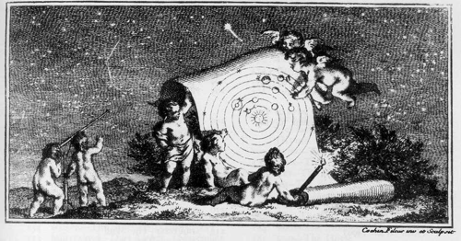

Information can be conveyed from one mind to another in a variety of ways; but as objects themselves do not bodily enter consciousness, each of these methods of necessity must employ symbols. Those, therefore, who before the time of recorded history made painstaking research into the relation between the soul of man and the twinkling stars, who ascertained that things onearth are influenced by signs and planets, when they desired to pass that information on to others, had no recourse but the use of symbols.

|  |
| --- |
| Rosetta Stone |
| Rosetta Stone |

Yet even in the short span of a few hundred years the characters used in writing English have so changed that the reading of Chaucer in the original script would be difficult for most of us. For nearly 2,000 years before the discovery, in 1799, of the Rosetta Stone, bearing parallel inscriptions in Greek, in Egyptian demotic characters, and in Egyptian hieroglyphics, that which the Egyptians so painstakingly had engraved on stone in hieroglyphics had been lost to the human race. Time makes sad havoc with arbitrary forms.

Yet even before the time of Egypt, and long before complex hieroglyphics came into use, men had put their thoughts into writing. Pictures of the aurochs, the European bison, were traced on the walls of their lairs by cave-men; perhaps not long after the last ice sheet receded from the region; and molded images of this and other game, with arrows piercing, have been found far back in the ceremonial crypts of their caverns.

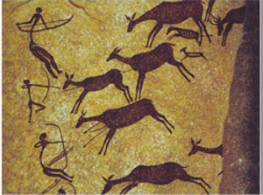An image of a bison pierced with a spear, or a wild hog with a knife in its side, tells a story. It suggests also, in the light of what even at this date we know of primitive customs, that there were medicine men or witch doctors, who performed ceremonies in which the game to be hunted was killed in pantomime, that on the morrow it might, through, what now our New Thought friends would term, “Demonstrating,” be the more easily located, overhauled, and slain without accident to the hunters.

Yet a time came in the evolution of mankind when the Egyptians developed their hieroglyphic and demotic characters, the Maya of Guatemala developed other hieroglyphics, the Chinese invented their arbitrary symbols, and the inhabitants of Mesopotamia devised a method of writing by means of wedge-shape (cuneiform) imprints made on little bricks of adobe before these had dried; **wedge-shaped because the papyrus stem they used for a stylus grows triangular. But before these times of using such arbitrary symbols men recorded their ideas as symbolical pictographs.**

Peru, Mexico, Crete, China, Mesopotamia, India and Egypt—the seven chief colonies of Atlantis—each shows at its very beginning a rather high cultural development, such as entitles it to be called civilized. Not only some more or less arbitrary form of written language, but art, medicine, agriculture, astronomy, and political codes set each apart from adjacent savage people. Yet the early forms of more arbitrary writing mentioned were supplemented, at least where astrology and spiritual ideas were concerned, by the still older form, the characters of which probably were derived from ancient Atlantis.

This older form was made use of, for instance, by the American Indian, until he was induced to attend our modern schools and learn English. To represent good hunting, he painted or carved on a rock a picture of a mountain sheep or other game. To record a rabbit drive he drew the crude outline of a net into which grotesque hares were scampering. This was simple pictograph. It was effective up to a certain point; but was incapable of portraying philosophical ideas or opinions. For that purpose it became necessary to picture some object which would suggest by its common association, the thought the writer had in mind.

In our desert region the Indian artist, when he wished to indicate where a waterhole was located, would trace a line on a rock in that direction. He felt no need of picturing the water or the waterhole; for every Indian trail, in such a region, ends only at a waterhole. Where the line stopped this became the symbol of a waterhole; and in drawing such a line, he was using symbolical pictograph writing to indicate where other Indians might find relief from burning desert thirst. Such picture writing can be found throughout the western arid region all the way from Canada to Mexico.

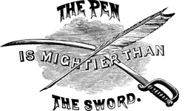Or to come nearer home, when we say, “The pen is mightier than the sword,” we convey the idea that the written thought is superior to warfare. If this same idea were to be written in symbolical pictograph, it would present to view a broken sword lying beneath a pen. That is, to a people conversant with the common use of both sword and pen, the superiority of writing would immediately be apparent in the picture.

For such symbolical pictographs to be intelligible age after age, and thus not change their meaning markedly, as do more arbitrary forms of writing, the objects depicted must be such as readily to suggest, through their common associations, the thought it is wished to convey. That is, a balloon pictured among the constellations would have had no significance to ancient peoples; for they had had no experience with aeronautics. For that matter, the full significance of Sagittarius, Centaurus, Equulus, and Pegasus could not have been comprehended by American Indians before the landing of the Spaniards and the consequent introduction of horses. To get the complete meaning those who placed these figures in the sky sought to convey, one must be conversant with the use of a horse to carry its rider. Then the implication of the speed and carrying power of thought are suggested.

But the arrow which Sagittarius aims was well understood to them. And the Hopi Indians, in their ancient Calling Back the Sun ceremony, held exactly at the winter solstice when the Sun moves from Sagittarius into the earthy sign Capricorn, have their Thunderbird man, who was their Santa Claus before the Whites landed on our shores, snatch up arrows and throw them violently into a little mound of earth (Capricorn). That is, arrows, because their common associations are more widely recognized, are symbols more universal than are horses.

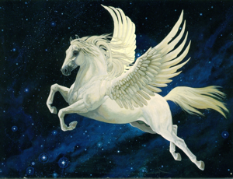Yet if an Indian or other primitive man had been shown the symbolical pictograph by which the constellation Pegasus is portrayed in the sky he would have understood one portion of the conception perfectly. He would be familiar, through watching the flight of birds, with the idea that wings are used to carry their owners aloft. He would also be familiar with the thought of a higher, or spiritual realm, a Happy Hunting Ground, a region in which apparently, he travelled in his sleep, and from which he brought back memories of those occurrences we call dreams. And thus, would he largely have grasped the thought of contacting inner realms, which caused the Greeks to say that all poets, before they can attract the Muse, first must drink at the fountain created by a blow from the hoof of Pegasus.

What I here am trying to emphasize is that the chief tenets of astrology have been handed down from a past so remote that those who passed this information on, either had no arbitrary form of written language, or such as they did have has long been lost in the inexorable changes wrought by passing time. Either because they had no other written form, or because they recognized the more permanent nature of such characters, therefore, they recorded such ideas as they left to us in the same language still employed by primitive people; in the language whose written characters are symbolical pictographs, and whose oral expression takes the form of myth and legend.

Nor is it unusual, even when more modern forms of writing come into use, for people to use the earlier types of language to convey their spiritual conceptions. The Roman Catholic religion still adheres to Latin, a language which has passed from common usage; and the Egyptians used hieroglyphics in practically all their religious writings, long after the adoption, for other purposes, of the far simpler forms.

If we are intelligently to study what the ancients thought and taught, we must drop our assumption of mental superiority based merely on the fact that we use a different method of acquiring information and a different language in presenting it to others. We must be willing, not to accept their ideas merely because they taught them, but to test statistically, or at leastscientifically in the modern way, what they taught in an effort to perceive how much is truth and how much they left is rubbish. And to know what they taught, and thus to know what to put to

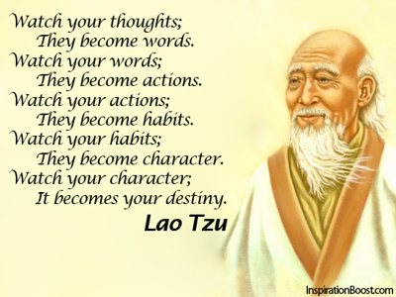

the test of modern scientific methods, we must learn the language which invariably they used to record their findings.

That is, we must be able to translate into plain straightforward English the symbolical pictographs which constitute the 48 constellations they traced in the sky, and the symbolical pictographs which constitute an additional commentary on the teachings of the 48 constellations, on the influence of the planets, on thoughts, and on people born under the various signs, which they inscribed on tarot cards.

And we must not entirely overlook what has been recorded orally. The myths and legends and folklore of the various peoples of the world often are very interesting as stories. But in addition to their entertainment value, which has been given to them to insure that they shall be perpetuated, they also, quite as much as pictures drawn upon a rock, convey ideas of more serious import.

Either pictures or stories may have a certain attractiveness of form; but pictures are not drawn, in the sky or on rocks, nor are stories perpetuated, by primitive peoples except they are employed to give expression through pictograph or universal symbolism to important thoughts which there is a desire to convey to other minds.

Because each card of the tarot was designed to depict in more detail, the significance of some astrological principle, including the signs, decanates and planets, it would be interesting if we knew exactly where the Stellar Wisdom which they portray first was practiced. We know that in forms which are but modifications of an identical original, it was present at the very beginning of the seven mentioned ancient centers of civilization. And experience proves that wherever a particular biological form, or a culture having many complex yet identical interrelating factors, is present in different areas of the world, it had its origin in a single region of dispersal. The inference, therefore, is that the symbolical pictographs of both the constellations and the tarot, as well as much important myth and legend, were carried from Atlantis to various regions of the earth before that ill-fated continent sank.

The value and correctness of the ideas left by ancient minds, as recorded in the constellations and on the tarot cards, should never be taken for granted. They should be subjected to the strictest tests. Yet in view of the fact that most of the astrological precepts thus handed down have stood the severe tests of practical application, and are found sound by modern astrological practitioners, it would seem that other of their ideas well warrant thorough examination. After all, they were specialists, not in mechanics and invention, as are modern men, nor even in art and literature as were the Greeks, but in determining the relation between the soul and the stars; between the influences of signs and planets and the things of the earth. For thousands of generations specially gifted men were set apart to devote their entire lives exclusively to such research**.**

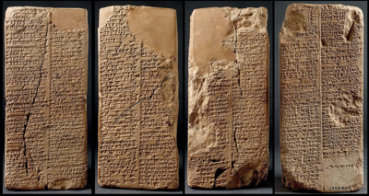The Anu Enlil Series of Chaldea, for instance, which recorded both the positions in the heavens and the coincident events whichhappened on the earth in an effort to correlate these factors, extended unbroken for over a thousand years.

It is from these Chaldeans we derive the pictures of the constellations. Modern maps of the sky have many more than 48 constellations, because with the study of modern astronomy, kings and notables desired something placed in the heavens to remember them by, and the astronomers, who were dependent for livelihood upon such patronage, were accommodating. But the Greeks visited Chaldea and brought home the celestial sphere of the Chaldeans. And these old Greek sources show only 48 constellations, each describing, in characters of symbolical pictograph, one of the 12 signs, or one of the 36 decanates into which the Chaldeans divided their zodiac.

To give more details in reference to astrological principles and the spiritual science which they ever linked to these principles, the ancients had recourse to plates containing other descriptions also written in symbolical pictograph. That is, having traced in stars of light above the broader principles of that which they had learned they sought, and found in the tarot pictures, a medium for supplementing the amount of knowledge to be conveyed to following generations.

To make clear what I mean let us briefly consider, say, the symbols used for Mars, and the picture used for the constellation Virgo:

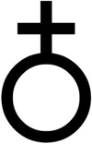The symbol of Mars, as it has come down to us, shows either the cross of earth, or the spear of aggression, above and dominating the circle of spirit. This portrays well enough that a warlike spirit, or passions and gross appetites, prevail over the finer nature when Mars has unbridled sway; but it does not convey the almost equally important information that, as we have now determined statistically, Mars is responsible for more accidents than any other planet. Yet this is portrayed clearly in the Mars tarot, Arcanum XVI, where lightning striking the top of a pyramid smashes it and hurls two men to the earth.

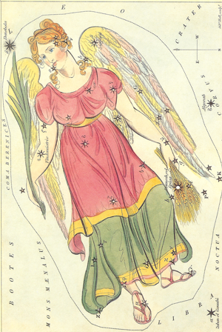The constellation Virgo, picturing the sign, is represented by a woman who holds a palm frond in one hand and ears of wheat in the other. This suggests the raising of crops and their harvest, and the Tree of Good and Evil which grew in the Garden of Eden which attracted Eve. And if we know the Bible story in which through yielding to Eve’s temptation, man was condemned to live by the sweat of his brow, it links the sign up with the house of labor, which in a natural chart it rules.

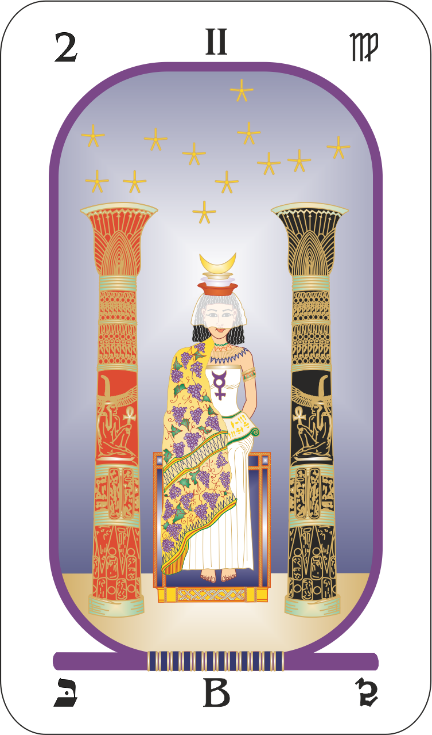**All that** the constellation pictures is true enough; but if we now turn to the Virgo tarot card, Arcanum II, showing a woman seated at the Temple of Isis, crowned with a tiara of three stories, and on her knees an open book which she half covers with her mantle, and the symbol of Mercury upon her bosom; we find emphasized that this is a mental sign, that objective consciousness perceives only the external side of truth, that thought determines on each of the three planes of existence the level occupied by the person, and much information on how to acquire a mental harvest of value.

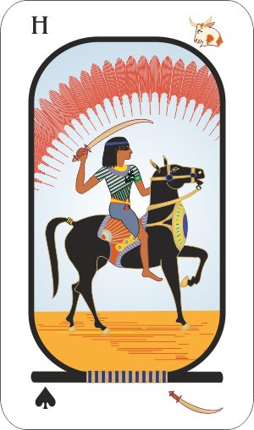Later generations not only added new constellations to the sky to honor their kings and nobles, but they also altered the tarot pictures to conform to their religious conceptions and their mode of life. To indicate more clearly what I mean, consider that on one of the best English packs the horseman of swords is an armored crusader, dashing across the frontier into another’s domain in the well-known effort to spread enlightenment by means of the sword. The picture instantly suggests the conquest of far-flung empire and the forceful dissemination of Christian creeds among the benighted heathens thus conquered.

Or consider that the Jews believed that they were a chosen people; that Jehovah was a God of favoritism who could be cajoled into granting unmerited rewards to those who gained His good graces. Christianity inherited the same idea; and therefore, in many Christian tarot packs, we find justice, not blindfolded, as the Egyptian pack portrays because Egyptian initiates believed justice to be the operation of an undeviating natural law; but with her eyes wide open to bribe and prejudice.

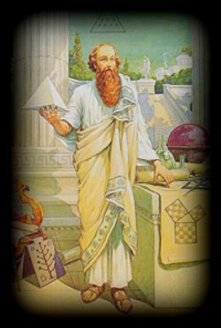As in the case of the constellations, if we wish to know what the ancient initiates intended to convey through the tarot, we must go back to a time when astrology was looked upon with favor. And fortunately, just as the Chaldean constellations were correctly preserved by the Greeks, so also a Greek, Iamblichus, a Neo-platonist of the fourth century, has preserved for us in a document entitled, *An Egyptian Initiation*, an accurate description of each of the old Egyptian tarot pictures.

These tarot pictures were frescoed on the walls of an ancient Egyptian initiation chamber, and The Brotherhood of Light Egyptian Tarot cards were designed painstaking to preserve, in every detail, the pictures exactly as described by him. The Egyptian tarot pack in its symbolical pictographs thus accurately portrays the Stellar Wisdom as it was understood by Egyptian initiates. And these, as well as the Chaldeans, were thoroughly conversant with astrology.

Signs and planets — Of chief importance in astrology are the influences of the 10 planets and 12 zodiacal signs. Therefore, to describe these influences those who designed the tarot drew 22

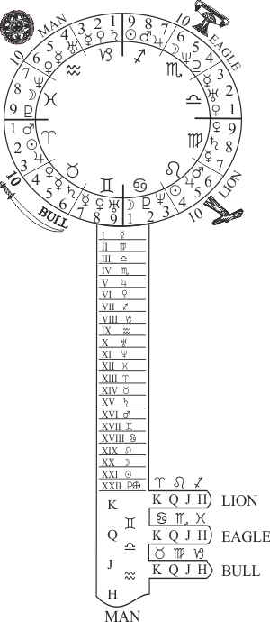 more complex symbolical pictographs; one to explain each planet and one to explain each sign. These constitute the 22 Major, or more important, Arcana. Arcanum means a mystery; and the tarot cards are called Arcana because they explain the astrological influences, without a knowledge of which the cause of most of the conditions and happenings of life remain a mystery.

Decanates — The signs of the zodiac are divided into three sections of 10 degrees each, called decanates, and having each its own distinctive influence. As there are 12 signs this gives 36 decanates; therefore, to describe their significance, which is not so important as that of planets and signs, the ancients designed 36 less complex symbolical pictographs, which are known as the Minor Arcana of the tarot.

Triplicity — There are 9 decanates in the zodiac belonging to each of four triplicities; and on the Minor Arcana describing their influence the triplicity to which the decanate belongs is indicated by its suit. But these astrological principles of fire, water, air and earth were deemed of sufficient importance by the ancients that they designed a Minor Arcanum No. 10 for each of the four suits to explain them. Thus, even as in modern playing cards, which were derived from them, there are a total of 40 Minor Arcana.

Aspects — The astrological aspects are classified as harmonious or discordant. Unlike playing cards, the tarots have a top and a bottom; and when a card is right way up it signifies that the influence is as favorable as if the astrological factor received a harmonious aspect; but when the card is reversed it signifies the influence is to be considered as if the astrological factor received a discordant aspect.

Houses — Houses, which in a birth chart indicate the departments of life affected by the influences are not given separate characters in the tarot; but are signified by the Spread; that is, by the manner in which the cards are placed in giving a reading.

People — Because what happened to people and the influence upon their characters and lives of astrological forces, was of paramount importance to those who designed the tarot, as they are to astrologers of this day; they devoted one card to explaining the character and probable activities of persons born under each zodiacal sign. Some of these are pictured as men and women. A card representing a woman when reversed signifies a man, and a card representing a man when reversed denotes a woman. These constitute 12 of the Court Arcana, corresponding to the face cards in the common playing pack.

Thoughts—But astrological energies also have an influence over people’s thoughts; and the type of thinking thus stimulated was considered by these Wise Men of the East to be of vast importance. Therefore, they explained the influence of each of the four types of thinking—about business and honor, about affections and the home, about money and health, and about war and strife—by a separate card, which because it depicts a human figure on a horse is also classified as a Court Arcanum. In addition to the 12 face cards of the common pack, the tarot has four horsemen, or 16 Court Arcana in all.

The complete pack of cards, each Egyptian tarot explaining in the language of symbolical pictograph some vital astrological information, contains 22 Major Arcana, 40 Minor Arcana, and 16 Court Arcana; or 78 explanatorydesigns in all.

**Elbert Benjamine**

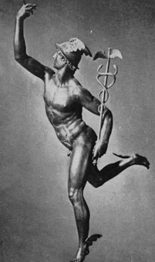

Even as we do, the ancients considered mental expression to be the most important, as well as most distinctive, attribute of being human. Had they permitted their imaginations to select a planet to rule over this significant influence, they likely would have chosen a conspicuous orb such as Jupiter or Venus. It is unlikely they would have chosen a planet, so inconspicuous that it is seldom seen with the naked eye, to represent the ability to think

Of all the orbs within the olden septenary Mercury, by far, is least conspicuous and most difficult to observe, and thus the least likely to be selected in any imaginary system as playing so important a part in the affairs of men. We must believe, therefore, that those who gave it rule over thought and mental expression, did so rather reluctantly, and only after a vast amount of observational research had convinced them that it has the precise influence which modern astrology, through statistical studies, likewise has demonstrated.

These old-time observers of the stars and students of human attributes, to express the relative qualities of the planets, used one or more of three symbols in different combinations and in different positions. The circle, because like spirit it has no beginning or end, was used to represent spiritual qualities. The sun, presenting the appearance of such a disc, was recognized to be, like spirit, the source of that energy which expresses as life. Because the moon was observed to exert so powerful an influence upon the emotions, and its phases had so noticeable an effect upon the mind, its crescent was used to represent soul, or mind. And as the earth is the place where lunar and solar forces meet, or cross, and where under the impetus of spirit the mind evolves by means of experience, the cross was used to denote that which is material.



To express the qualities of Mercury by means of a simple hieroglyphic, for instance, they placed the crescent of mind above, in a dominant position, showing it to be the guiding force. Immediately below the crescent of mind, was placed the circle of spirit. Thought ever guides and dominates the spiritual principle in man, evolving it or holding it back, as the case may be. Yet below the circle of spirit was joined the cross of matter, to indicate that material things were subservient to mind, and when Mercury’s influence was dominant, of less importance than the things of spirit.

The circle, above and attached to which is a crescent and below and attached to which is a cross, quite precisely denotes in terms of universal symbolism the most outstanding attributes of the influence of Mercury in human affairs. And careful study of the implications of these three symbols thus joined to form the emblem by which this planet is indicated in the common astronomical ephemeris will bring a good general understanding of the planet’s significance. But to convey more detailed information relative to the principle over which Mercury has ruled the ancients had need of something more complex than this hieroglyphic of mind and matter united by spirit. They therefore designed a picture, which should convey in a language altered not by the passing of time nor affected by race, all of importance they had discovered through countless generations of observation as to the significance in the life of man of those things under Mercury’s rule. This is the symbolical pictograph now known as the first Major Arcanum of the tarot.

They had observed that before a man does anything the image of the action is present in his consciousness. Before he builds a house he makes a mental plan. And further observation convinced them that something analogous to thought preceded the activities of plants and animals; and that the thought composition of their astral bodies determined the form into which they grew, their reaction to subsequent environment, and even the type of environment which they attracted. As is plainly indicated by allocating the first tarot card — to explaining the significance of thought, the ancient wise men believed, as do most modern philosophers, that thought is number 1; that is, it is the commencement of everything. As the Bible states; before the light of intelligence was present ‘The earth was without form, and void.’

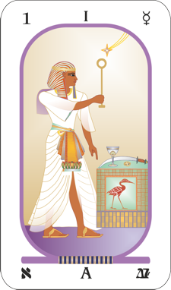This first tarot card is called The Magus. A magus is one who practices magic, that is, who uses his thoughts to demonstrate some desired condition. This magus is standing; the attitude of will which precedes action. His robe is of white, image of purity, original or regained. And his forehead is girt with a circle of gold, symbolizing the possession of light, or intelligence.

Each emblem in the picture, and its relation to every other emblem, is portrayed thus to give some definite teaching about Mercury and the things this speedy planet rules. But the most significant teaching, here plainly stated in the language of symbolical pictograph, is revealed by the magus raising a scepter of gold to heaven in his right hand, while with his left he points the index finger toward the earth.

This scepter is raised to the proximity of a four-pointed star. The star with rays extending heavenward is the symbol of the overshadowing genius of his spiritual master directing his efforts and counselling him in his upward struggles. But even more obviously it is the symbol of those planetary forces which have so powerful an influence over the life of every man.  
This magus, however, is not negatively reclining; passively waiting for what appears to be a progressed aspect to bring into his life whatsoever it commonly signifies. Instead, he is on his feet, with one of the implements signifying the four chief departments of human life raised in his right hand and the other three before him on the cube signifying the physical plane, handy to his use. As pictured in the very first, or Mercury, tarot card, I’ll briefly explain the astrological significance of these four emblems.  
The suit of Scepters (the magus holds a scepter in his upraised hand), which in common playing cards is the suit of Clubs, symbolizes the element fire. This in human life becomes enthusiasm, ambition and enterprise. Consequently, this suit belongs to the department of life having to do with business, occupation, station, honor and profession. In astrology it is represented by the Mid-heaven where the sun appears at noon.

The suit of Cups (a cup is before the magus on the cube), which in common playing cards becomes the suit of Hearts, represents the element water, symbol of the emotions and typical of domesticand affectional relations. It thus broadly corresponds to the western angle of a birth chart, where the sun sinks below the horizon.

The suit of Swords (such a sword lies on the cube of the physical world), which in common playing cards becomes the suit of Spades, represents the element earth, symbol of struggle, allied to affliction and death. It thus corresponds to the Nadir, where the sun is in its grave or lowest point in the diurnal cycle.

The suit of Coins (such a coin as is on the cube before the magus), which in common playing cards becomes the suit of Diamonds, represents the element air, the breath of life. The foods needed to live may be purchased with money and thus money has become the symbol of life itself. It therefore corresponds to the Ascendant of a birth chart, where the new-born sun each day rises above the eastern horizon.

The attitude of will which the magus in the picture plainly holds is not that of submission. Much as Benjamin Franklin’s lightning rod was raised to capture the destructive lightning and conduct it harmlessly to the earth, so the magus holds aloft his scepter to act as an aerial to capture the energies plainly being radiated from the planet. But it is clear to see that he proposes to do more than merely deflect this captured planetary energy into some harmless expression. His whole attitude portrays the determination to use it in connection with the emblems representing the chief departments of his life that symbolically lie before him on the cube of the physical world.

To enable him to capture planetary vibrations and divert them into channels of his own choosing, instead of being shoved about, puppet like, by them, he must possess high intelligence, which is denoted by the band of gold about his head. But even endowed with such intelligence, how can any person rule his stars, as this magus clearly is pictured doing?

The pictograph explains that it is done through the use of thought; that is, through the function which is the distinctive attribute of Mercury; for the characteristic of a magus is that his work is performed through the agency of thought. It is because mental expression is the outstanding quality both of Mercury and of a magus, that such an individual was used to depict the ancient teachings relative to this versatile planet.

Mercury rules the human nervous system over which flow those etheric currents which carry messages to and from the brain. Dr. George Crile in his book, The Phenomena of Life; A Radio-Electric Interpretation, which appeared in February, 1936, gave conclusive proof that these energies are electric in nature, and constitute the vital force of life. And Dr. Edwin J. Cohn, Professor of Biological Chemistry at Harvard, revealed at the meeting of the American Chemical Society on April 12, 1936, that he had measured the tiny electrical charges which carry messages over the nerves, and had found their source of origin on the giant protein molecules, hitherto considered electrically neutral. He pointed out that the movement of such an electro-magnetic molecule is like the armature of the dynamo. It produces an electric current. By means of the electric currents thus generated the mind exercises its control over the body.

Protein molecules are able to release the high-frequency energy of the lightning which fixed the nitrogen that plant life took from the soil. This is in accordance with Einstein’s Law of Equivalence: that the energy of an atom is given out in the same quanta as those received by the atom. And these short-wave radiations have properties with which we have become familiar in the radio. In fact, Dr. Cohn uses the same technical developments in the measurements of the electrical properties of the giant protein molecules that have led to the improvement of the radio.

Of all the cells in the human body, those of the nervous system, which are ruled by Mercury, are best adapted to the production of short-wave radiations, as well as to carrying electric currents. And the gray matter of the frontal lobes of the brain is best adapted of these nerve cells ruled by Mercury in this respect.

This means, as occultists have long held, that the human nervous system is a radio broadcasting set. And it also means, because scientists have found these electrical phenomena of the nervous system to be reversible as when the cells recharge in sleep, that the nervous system is a delicate receiving set, capable of intercepting short-waves which reach it from other broadcasting sets.

Telepathy, which material science very reluctantly is being forced by the experiments of its own savants to accept, thus finds its explanation. And thus, also is explained the process which the magus, pictured in the first Arcanum of the tarot, is employing to utilize the energy of a selected planet, or the energy of a planet which reaches him because at the time it receives a progressed aspect.

Not that the ancient initiates, who left to us their explanations of astrology and of life in the language of symbolical pictograph on the tarot, were aware of the modern technical explanation, which is in terms of electrical phenomena. But they, as those who used the power of thought for practical purposes, came to understand how thoughts are able to tune the nervous system and the currents passing over it to the planetary energy they wished to receive; and how because its energies reached the astral body by way of the nerves in such volume, other and more discordant energies were shut out.

But to explain in modern scientific terminology just what Mercury, which rules the thoughts, is shown doing in tarot Arcanum I: Through his thoughts and feelings man has the ability to increase or decrease his mental and nervous tension, which means the rapidity with which the nitrogen compounds release radiant energy, and thus by controlling the comparative shortness of the wave lengths emitted, he can tune in on various levels. And as the etheric energies of the nervous system are ready transformers and conductors of corresponding astral broadcasts, he can tune in on broadcasts through the ether and the astral broadcasts from the planets and from minds that are no longer of earth. The magus of tarot No. 1, is shown in the act of thus tuning in on such a broadcast. And as this tuning in process is accomplished through directing the thoughts, it is eminently fitting that the explanation should be thus pictured on the tarot illustrating the functions of Mercury.

In fact, whether you are aware of it or not, you tune in on the energy of any planet that makes a progressed aspect in your chart. If you have a progressed aspect to Mars, for instance, the aggressive thought-cells in your astral body receive, through the aerial mapped by the aspect, an additional supply of energy. Because they have more energy they can impart it to the nerves of the gonads and of the adrenal glands. This local electrical stimulation releases hormones in the blood. These reaching the cells of the body increase their electrical discharge.

These electrical discharges over the nervous system, unless there is a deliberate effort made to cultivate other thoughts, stimulate thoughts of the aggressive type, which keep the nervous system constantly tuned to pick up still more of the Mars broadcast. But as the brain-cells generate high electrical charges under the processes of thinking and feeling which accompany the Mercury-ruled thoughts, it is within their power to reverse the process. That is, instead of being stimulated by the electrical current coming from the body cells, the process of thought can initiate a current which stimulates another hormone, which has quite a different effect upon the body cells.

As the magus in the tarot picture is doing, by selecting such thoughts as stimulate the feeling commonly induced by the vibrations of a given planet when it receives a harmonious aspect, it is possible to tune the nervous system and the etheric energies flowing over it, so that they pick up, radio fashion the harmonious broadcast of energy from the selected planet. And by association, through the thoughts, the harmonious planetary energy thus acquired can be diverted into working to attract fortunate events which, without the use of thought, would have only come into the life at a time when there was an unusually favorable progression involving the planet.

We of the present age possess mechanical contrivances of which the astrologer initiates of old never dreamed; and in the precision of scientific observation, we far surpass their most skilful efforts. But in the practical application of thought and the utilization of astrological forces, by comparison we are mere apprentices. Through the process of trial and error, which continued through the ages unfettered by such materialistic dogmas as confront us today, they learned how to do those things which give control of life and destiny. And while they gave their attention to other things in acquiring such control, they found the chief tool for their mastery of life in the utilization of planetary forces through the proper application of thought.

To state their views in modern terminology, your unconscious mind is built of thought-elements even as your physical body is built of chemical elements. This unconscious mind, or astral body, is fed by thoughts, or states of consciousness which accompany experiences. That is, in its ascent through innumerable lower forms of life, the awareness and emotions accompanying your soul’s experiences-built thought-elements into its four-dimensional or stellar body. Through other experiences these thought-elements became organized as stellar cells, and these in turn into dynamic stellar structures.

The most powerful of these thought structures in your astral body are mapped by the planets in your birth chart; and their outstanding relations to other dynamic thought structures are mapped by the aspects in the chart. Thus, your birth chart is a map of thought organization of your finer body, or character, as it has been constructed up to the moment of your birth as a human soul.

These thought-groups and the way they are organized indicate your innate natural abilities and, because thought-cell activity has an attractive power, the kind of events that will be attracted into your life unless some effort is made to change the thought-structure of your character.

Thus does Arcanum I give a concise explanation, in symbolical pictograph, that any ability mapped by the planetary positions is due to the volume and arrangement of thought-energies within the person’s unconscious mind. Consequently, another person can acquire identical abilities if he builds thought-energies in his unconscious mind in similar volume and arrangement. And it also shows how this is done.

By the proper use of thought you can voluntarily tune your nervous system and the etheric energies flowing over it to pick up the energies of a powerful planet in your birth chart that is selected because it maps a harmonious thought-structure within your unconscious mind. Thus, you can acquire, through your own efforts, the ability to attract into your life fortunate events that otherwise could only be brought in when some powerful and favorable progressed aspect is present.

A progressed aspect may be inevitable in the heavens, like rain or snow, heat or cold, wind or calm; but its effect on you is determined by the way you handle it. It means that a temporary stellar aerial is built across your astral body, for the duration of the aspect, which picks up the energies of both planets either harmoniously or loaded with static, according to the nature of the aspect.

It is so much additional energy of a given kind, reaching the thought-cells in a certain compartment of your astral body, and causing them to become unusually active. It is the unusual four-dimensional activities of these thought-cells which attract into your life events at the indicated time.

If, therefore, through some consciously directed process a large volume of energy of a different quality is supplied the thought-cells which otherwise would get only the energy indicated by a progressed aspect, their type of activity is changed and they work from the four-dimensionalplane to attract events at that time of a quite different character. Furthermore, as all important events that come into the life are due to the activities of thought-cells that then receive unusual supplies of **energy of a** particular kind, if these thought-cells are supplied with that particular kind of energy in proper volume the characteristic event will be attracted, even though at the time there is no progressed aspect in the chart.

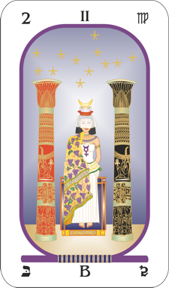The ancient masters considered the use of thought, to tune in on planetary vibrations such as would supply the thought-cells with the proper additional energy to attract desired events, of such vast importance that they gave this teaching clearly in the very first tablet on which they inscribed what they had learned of stellar wisdom.

All that the constellation pictures is true enough; but if we now turn to the Virgo tarot card, Arcanum II, showing a woman seated at the Temple of Isis, crowned with a tiara of three stories, and on her knees an open book which she half covers with her mantle, and the symbol of Mercury upon her bosom; we find emphasized that this is a mental sign, that objective consciousness perceives only the external side of truth, that thought determines on each of the three planes of existence the level occupied by the person, and much information on how to acquire a mental harvest of value.

**Part 2:  Virgo and Veiled Isis**

**Elbert Benjamine**

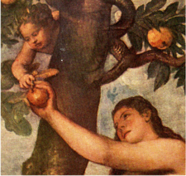Eve was driven from the Garden of Eden, together with her consort, because she possessed an irrepressible curiosity. She was the first experimental scientist. A lot of theory was current as to how the forbidden fruit tasted, and what would happen to anyone who ate it. One is reminded of that fervent Dutch naturalist of the seventeenth century, Jan Swammerdam, who first made exhaustive studies of the bee. Not content with counting the facets of the eyes, and discovering the three other eyes, which are simple like our own, and that the sting of the worker is straight, is wanting in the drone, and is curved in the queen, he had to know also all about its venom. He thrust the darts into his arms, rolled the poison on the tip of his sensitive tongue, and finally swallowed it.

It was to be expected, as came to pass, that Swammerdam should die young; but in true Virgo fashion, he made a careful record of each of these ardently pursued experiments, so that his contemporaries were given exact information about bees and many other insects that would long have remained unknown except for Jan's many health-breaking adventures. And it was to be expected also that Eve, and those like her who followed, would get into difficulty, but the world is vastly richer in knowledge for their prying into things.

Taking the premise which has since found no improvement, that mental expression, which the planet Mercury rules, is the commencement alike of an activity by man or the evolution of a universe, it seemed to the Wise Men of old that thought, instead of an abstraction, was always about something. In fact, all existence seemed to be divided into that which acts and that which is acted upon, into positive and negative polarity. The Chinese expressed this idea of a male and a female potency in the familiar cell-like Pentacle. The Bible draws this line of distinction at its very start when it says God created; and then refers to that thus formed as the heaven and the earth.

Now if Mercury, the planet of thought, represented more closely than other orbs intelligent force controlling will, what best represented that which was acted upon? This was both a philosophical and a practical problem to the ancient initiates.

That it was solved before Bible times is clearly indicated in the story of Adam and Eve and the Garden of Eden. The most outstanding characteristic of those born under Virgo, the earthy and practical sign ruled of Mercury, is their determination to know 'how' things can be done. Virgo, the sign of the garden of fruits, of the harvest, and of labor, adjoins the autumnal colure the sun crosses into the winter signs of the zodiac, into the cold of the great annual day. But while the sun is in Virgo the days yet exceed the nights in length, so that poetically, at least, its position there well may be called the cool of the day. Thus, zodiacally, it was quite consistent that after the transgression in this garden sign, Adam and Eve should hear the Voice of the Lord God walking in the garden in the cool of the day.

It was quite consistent, too, because this harvest sign Virgo belongs to the triplicity of earth, that out of the ground of this garden the Lord God made to grow every tree that is pleasant to the sight, and good for food, and also the tree of life as well as the tree of good and evil. Yet because of certain

actions on his part, man was not permitted to partake of the tree of life; but he did partake of the tree of good and evil, through the advice of Eve; and thus, the woman in the sky still holds the palm branch in her hand.

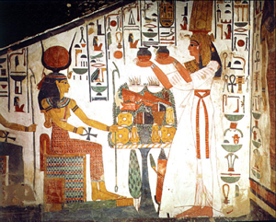This sign Virgo, however, has rule not merely over gardens where dates grow on palm trees, but over labor and harvests of all kinds. Therefore, when Adam, and the woman who was called Eve because she was the mother of all living, were thrust from the parental environment to shift for themselves, it was said that in order to live they must till the fields and raise crops, not all of which would be wheat, as thorns and thistles are mentioned. Furthermore, to keep them warm they had to make clothing, which also is ruled by Virgo.

All of these things required just such labor as the zodiacal sign governs; and people still sweat to get the bread they eat, such bread as is signified by the ears of wheat held in celestial Virgo's hand.

Because that for which the thoughts of Mercury work is to secure the fruits of effort, because people born with the Virgo influence prominent are noted as harvesters of information, because it was considered that the purpose of the soul on earth was to gain a harvest of experience, and because the sign was found experimentally to rule grains and other foods, it was quite natural that to express the sign hieroglyphically a sheaf of wheat should be used. Such is the origin of its symbol as yet used in the ephemeris.

****The constellation traced among the stars, depicting a Virgin Mother, who in Egypt was called Isis, tells more about the principle related to the sign thus portrayed. Yet what could thus be told by the starry picture was limited. Therefore, to give additional information the ancients wrote it in the language of symbolical pictograph on one of the tarot cards. This tarot card, because earth was considered the feminine of creative mental activity, the mother, or matrix, upon which Mercury (number 1) operated to bring forth an immortal harvest, was given the number 2, and was called Veiled Isis. The picture, as the Egyptian initiates designed it, with the stars of the constellation Virgo above as they appear in the sky, is here illustrated.

Every object and relation here set forth speaks in no uncertain terms of some attribute of the zodiacal sign Virgo. They summarize both the philosophical concepts and the practical information those who designed the picture had gained through long years of careful research. But before speaking further of this picture of Veiled Isis, let us get some insight as to the esteem in which Isis was held in many lands, and especially in Egypt from whence these tarot pictures were derived.

Each of the face cards of the common playing pack represents an individual born when the sun was in a different zodiacal sign. The Queen of Spades is the card thus representing the influence of Virgo. Each of the four queens of our playing cards bears in one hand the blossom of a flower. We do not need to speculate upon the significance of such blossoms, because the Hopi Indians of America still employ it in its original significance. Hopi girls, from puberty until marriage wear very attractive coiffures. With elaborate pains the hair on either side of their heads is built into a representation of a squash blossom. Only those of marriageable age who are as yet virgins are permitted to adorn their heads in this becoming fashion.

The snake dance ritual of these Indians is always commenced when the sun is in the sign Leo in August; for not only is the snake the symbol of creative energy, but the very symbol of the sign Leo, in which the sun exerts its greatest power, is a representation of a snake in the form it takes when held in the mouth of a snake dancer. And with similar significance, as representing masculine creative power, is the serpent pictured in Egypt at the brows of their most enlightenedcharacters. Not only does the snake dance ceremony commence while the sun is in the sign of greatest virility, which also is natural ruler of the birth chart house of love (fifth), but it always ends a few days after the sun has passed into the sign of the zodiac pictured in the sky by the Virgin.

Virgo is the harvest sign, and in its more exoteric meaning the snake dance is a ceremony to protect the harvest and to assure a bounteous yield. And on the sidelines during the time of the public exhibition stand antelope initiates shaking an instrument which has its counterpart in shape and function in the harvest ceremonies of Egypt.

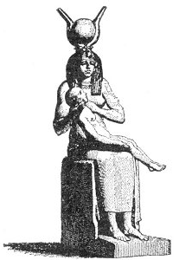Isis represents the feminine principle in nature. Its most characteristic attribute, and the one held most sacred, is pictured by tarot Major Arcanum 2. This Virgo function is that of motherhood. Even today we recognize it as woman's crowning glory; and it was represented both in Egypt and in America by an instrument representing the uterus wherein Nature performed her most holy work, that of developing new life.

In the pageants and processions in honor of Isis the Egyptians carried this musical instrument, called the sistrum. It was a thin metal frame of characteristic shape through which were passed rods of metal so that when shaken they would jingle. These rods were given a curl at either end to represent the serpent symbol of the adjoining sign, Leo, and thus to signify that the solar force — even as the heat of the sun must fall upon the earth and warm it if the planted seeds are to grow — is an essential to new life, as well as the mother principle symbolized by the sistrum. The white gourds filled with seeds, which during the snake dance the antelope priests continually rattle, are identical in shape and in significance to the Egyptian sistrum. Likewise, each of the queens of our playing cards bears the blossom of a flower. But only the Queen of Spades, representing the sign Virgo and the Virgin Mother, bears also in her other hand a lighted torch, to indicate that she has conceived by the solar power, that is, by the power of the Holy Ghost.

The ancient initiates, to whom we are indebted for the pictures on our playing cards as well as those on the tarot and those traced in the sky, were interested not merely in man's fortune here, but also in his after-life possibilities. To them, in their quest for soul knowledge, the earthy sign Virgo represented the earth as the womb of Nature. This they depicted in Major Arcanum 2. The sun entering this zodiacal sign symbolized the descent of the soul into matter, explained the necessity of physical incarnation, and indicated the glorious future it would harvest as a result.

The Chaldeans and the Egyptians in their oldest traditions relate the immaculate conception. Quetzalcoatl of the Aztecs was virgin born, as was Montezuma of the Pueblo, Mojave and Apache Indians.

The snake dance of the Hopis and the Isis pageants of the Egyptians were not merely rituals to assure an abundant harvest. Their initiates believed and taught that only through the harvest of experience on earth could the soul gain the love and wisdom which would enable it to inherit everlasting life. The sistrum and the white gourd rattle, as well as the symbol of Mercury traced upon the bosom of Veiled Isis, were more than symbols of physical fruitfulness. They also expressed the spiritual significance of the immaculate conception; that physical existence is a place of gestation for the soul, limiting it by the narrow walls of three-dimensional existence.

Passage of the soul to the next life is its deliverance into a region of wider freedom for the expression of its desires and abilities. And finally, according to the wheat held in the hand of constellated Virgo, and according to the grapes prominently pictured with Veiled Isis, it was held that every soul properly garnering its harvest of love and wisdom is immortal, and in its turn becomes the seed of a future universe.

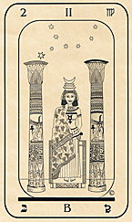Veiled Isis, as here shown, is figured by a woman seated at the threshold of the Temple. She is seated between two columns, the one on her right signifying the realm of spirit, and the one on her left indicating the realm of matter. The Book of the Secrets of Nature upon her lap is half hidden under a mantle adorned by the vine and the fruit of the grape. Instead of apples which tempted Eve, we here have grapes; and instead of a Tree of Good and Evil, we have here a Pillar of Good and a Pillar of Evil. But the Book of Nature she attempts to read indicates this to be merely one version of the old Bible story.

Quite in conformity with our present knowledge of the operation of natural law, only one part of the book wherein is inscribed the manner in which Nature operates on all things is apparent to unaided observation. This is the portion adjacent to the dark pillar, representing the world of atomic matter. In fact, that crass materialism from which our more enlightened men of science are fast emerging would have us believe that this left-hand side of Nature's Book explains her completely. But we who study astrology, and compile statistics of the observed effects of the influence of the signs and planets not merely upon human life, but also upon all other material objects and forces in so far as such studies have taken us, know that the left-hand, or material, side of existence is less important.

Some grapes there are, to be sure, pictured beneath this left-hand side of the book, but they are few in comparison to those on the mantle which covers the right-hand, or invisible, side of this scroll of Isis. Some fruits of effort are of the material kind, but those more abundant and lasting are the outgrowth of character: a harvest stored not in the warehouses of the material world, but in the organizations of the finer body which persists after the three-dimensional physical form shall have perished.

It is this mantle which covers the knowledge of the operation of natural law on the four-dimensional plane, where mind and character reside, which we astrologers are attempting to lift. Some of us may not be entirely aware of the nature of our effort. But when we tabulate the observed influence of the signs and planets as affecting physical life and destiny, we begin to peer beneath the cloak of appearances and read the writing about the world of reality.

People think they take a short journey, for instance, because suddenly they feel the inclination to make such a trip. And so far as the left-hand side of this book is concerned this is true. But the right-hand side shows that invisible energies from the planet ruling the third house in their birth charts is reaching the thought-cells in the third compartment of their astral bodies at this time in unusual volume. They are making the journey because they feel so inclined, but they feel so inclined because certain factors within their characters are receiving an abnormal amount of energy. When the third compartment of their astral bodies does not thus acquire an unusual amount of planetary energy they do not feel inclined to take a short trip, and they do not take it.

How do we know so much, especially as this half of the book on the lap of Virgo is concealed? It is because, in regard to this matter, and in regard to matters pertaining to each of the twelve compartments of the four-dimensional form, we have used the typically Virgo method. We have not been content to accept the findings of the psychic faculties without further proof. But we have not scorned to use the psychic senses, have not looked with contempt upon the pillar at the right of Isis. Two realms are clearly indicated, and it is the Virgo function in reference to each to ask 'how?' But of all the zodiacal signs Virgo is most critical, most painstaking in the use of discrimination.

Such discrimination implies that the left-hand pillar should be weighed in evidence against the right, that what is contained on the easily visible part of the scroll should be compared with what is written on the part from which the cloak must be removed.

As to what is said on the invisible side of the book in reference to people when they make a short journey that is outstanding enough to cause it to seem rather an important event, it is difficult to prove that the thought-cells, or character factors within their unconscious minds, residing in the third of the twelve departments of their astral bodies are given new planetary energy at the time such a trip is taken. How these thought-cells, operating from the four-dimensional realm they occupy, can bring things to pass is difficult of three-dimensional demonstration.

But when we turn to the other side of Virgo's book, and deal with things which can be observed with the physical senses, our statements become more positive. Out of 100 persons who sent us the time of day, as well as the date of their birth, and the date on which they took a short journey, there was a major progressed aspect, heavier than the progression of the moon, and within one degree of perfect, to the ruler of the third house in the birth chart in every instance. This analysis enables us to say that people only take short journeys when such a progressed aspect is present. Two pillars are shown in the pictograph of Major Arcanum 2, even as to acquire all information both the visible and the invisible world must be explored. But in addition, there are two well-recognized symbols to indicate the means to be used in such complete investigation. Mercury,the planet of objective thought, of statistical analysis and of reason is inscribed on Virgo's breast. But surmounting her crown, or tiara of three stories, is the crescent symbol of the Moon.

The Moon is the ruler of the Mentality. That is, in a birth chart it maps the most open avenue by which impressions reach the unconscious mind. Because the impressions from the sign in which the Moon is found at birth thus reach the unconscious mind in greater volume than other impressions do, this Moon-sign gives the key to the mental capacity. Mental capacity, ruled by the Moon, and Mental Expression, ruled by Mercury, are two quite different things. Many who possess great wisdom are poor hands at expressing what they know, while the chatter-box who tells everyone he meets all thoughts that pass through his mind may create an impression of erudition quite unwarranted by fact.

Every planetary position in the birth chart maps a receiving set through which impressions of a definite kind reach and influence the unconscious mind or soul. But because the Moon terminal is the most receptive to impressions coming from either the external or the internal plane, and thusis responsible for so much that influences the unconscious mind, it may be said, more than any other planet, to rule the unconscious mind, or mentality. Thus, has it been used as the symbol of the soul.

The soul, as symbolized by the crescent in the pictograph, is perched atop the tiara, showing that it has triumphed over the three planes, physical, astral and spiritual, represented by the three distinct stories. And this supremacy of the Moon symbol, related to the unconscious mind as distinct from the objective mind of Mercury, shows that the faculties and senses of the unconscious mind, the psychic senses, are employed in this conquest. The crowning glory of Virgo is to employ the four-dimensional senses indicated by the Moon, to acquire information not merely from one plane of existence, but from all planes.

But this is only part of her work. The Moon relates to impressions and feelings, and to those manifestations of the unconscious mind that bring up into the realm of objective consciousness what commonly lies well below its threshold. But information obtained through such psychic channels is all too easily subject to misinterpretation. And critical Virgo can take no avoidable chances on being wrong.

The planet Mercury, signifying conscious reasoned thought is inscribed not well above her head, not in a realm where common faculties falter and breathe confusedly in the too rare atmosphere. It is inscribed on the very middle of her being. She may be said to revolve around it. Whatever the psychic Moon faculties bring to her attention, whatever is seen on the pillar at her left or on the pillar at her right, and whatever is read from either the right-hand page or the left-hand page of the book she holds, in the end to be true to her nature, and to be true to the science she represents, she devises methods by which reason based upon experiment can prove or disprove what she is inclined to believe is true.

Eve was not content with current theories about the apple. She had to know. If those who ridicule astrology were as intelligent, they would cease likewise to be content with scholastic theories and would bite into stellar art to taste it for themselves. Finding it of a different flavor than they had anticipated would bring them the work of readjustment, even as the Bible Virgo incurred a life of labor. But thus, to partake of the tree of knowledge would well be worth it.

**Part 3:  Libra and Isis Unveiled**

**Elbert Benjamine**

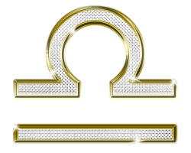

Libra, the sign of marriage and partnership, suggested vastly more to ancient initiates than could be expressed in so simple a hieroglyph as a feminine, or curved, line adjacent to a straight, or masculine, line. This concise and commonly used symbol merely indicates the union of positive and negative forces, the interaction of which is responsible for every conceivable kind of activity. It is equally applicable, therefore, to chemical changes, which take place in the marriage of atoms, and to centripetal and centrifugal forces which keep the planets each revolving in its appointed orbit about the sun, as it is to the most intricate of human relationships.

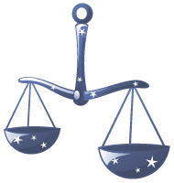

The Scales, by which the sign is pictured among the stars is more replete with meaning; but it gives scant information about the astrological principles which guide those who enter marriage. It presents to view two dissimilar entities united by a common purpose; two spirits, as it were, represented by the circular pans, each dangling free to move in its independent orbit, yet both united by the beam to which both are attached. It thus indicates plainly the thought that one essential of success in marriage is a strong mutual interest in something.

But the masters of old believed marriage to be the foundation upon which society must rest, and that the edifice of society as a whole, of necessity, would be weak unless this foundation were properly constructed. Consequently, their researches embraced all its fundamental principles; and wishing to give posterity the benefit of these findings they incorporated them in symbolical pictograph on the tarot card designed to explain the marriage sign.

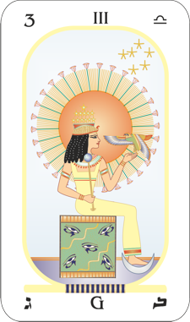In this pictograph, here illustrated as Arcanum 3, we see a woman seated with the head and region above the waist surrounded by a radiant Sun. Thus is the masculine potency clearly indicated. At her feet is the Moon to represent the feminine potency. And the cube on which she sits relates to the cross of matter where rays of sun and moon meet, and thus signifies the union of male and female forces.

But before considering what is taught in this pictograph in reference to the astrological principles that should guide human marriage, let us discuss briefly that even more familiar union, or balance between contending forces, represented by night and day. We awaken and we sleep at their behest. Light becomes a symbol of life and activity, and darkness of sleep or death. And sleep, as we now know from laboratory experiments in our universities, is the reversal of the electrical expenditure of the brain during its waking state. The electric batteries which are formed by organic cells, like the batteries of an automobile, recharge themselves when inactive. Sleep gives the brain opportunity to recharge itself.

Looking at nature in a larger way, those days in which the hours of darkness exceed the hours of light may well, therefore, be placed in one pan of the annual scales, and those in which the hours of light preponderate may fill the other. Thus are day and night weighed in Libra’s Scales; and the Autumnal Equinox marks the point where summer and winter signs are married, one half of the zodiac balanced against the other.

At this time the sun moves out of the harvest sign, pictographically described by Arcanum 2, where the grain was cut, into the place where its value shall be ascertained. The produce of the fruitful period of the year is weighed, and the wholesome kernels are separated from the chaff. Such estimating of its worth, either of crops from the field or of those from the span of life, most fittingly takes place when the vital forces, symbolized by the sun around the upper regions of the woman in Arcanum 3, have succumbed to those of cold and darkness.

The Jewish people, retaining the old-time significance of this period—though their calendar in modern times has been permitted somewhat to go astray—still honor the passing of the sun each year into this sign of the Scales. This custom dates back to Leviticus 23:24, where it is commanded, ‘Speak unto the Children of Israel, saying, in the seventh month, in the first day of the month, shall ye have a Sabbath, a memorial of blowing of trumpets, and holy convocation.’ The year, of course, began with the Vernal Equinox, and Rosh-ha-Shanah is thus held the first of Tishri, or Libra. As the day is yet observed, to still further explain its import, it may be well to quote in reference to it a paragraph from the Jewish Encyclopedia:

“Rosh-ha-Shanah is the most important judgment day, in which all the inhabitants of the world pass for judgment before the Creator as sheep pass for examination before the shepherd. Three books of accounts are opened on Rosh-ha-Shanah wherein the fate of the wicked, the righteous, and those of intermediate class are recorded. The names of the righteous are immediately inscribed, and are sealed ‘to live.’ The middle class are allowed a respite of ten days until Yom Kippur to repent and become righteous; the wicked are ‘blotted out of the book of the living*.’”*

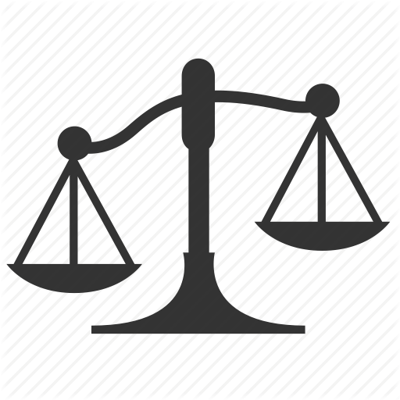

The matter of judgment, based upon the ability to weigh evidence and from a comparison of diverse factors to pass sound judgment, such as the Scales implies, is portrayed in Arcanum 3 by the eyes on the seat where the woman rests; indicating that through union, as more fully explained in the story of Adam and Eve, the eyes of the soul have been opened to a knowledge of good and evil.

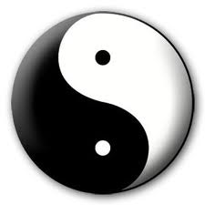

But however important these wider aspects of Libra may be, they rank far less than those involved in the close association of people in partnership, and especially of that most intimate partnership called marriage. And here it is that the ancient masters have portrayed principles of the most practical and vital kind which we moderns have just commenced to understand.

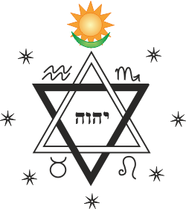

Looking at Arcanum 3, that which seems most conspicuous in reference to the woman: in addition to the twelve stars, the eagle and the scepter, are the Sun, Moon, and cube of matter which clearly represents the Ascendant. These imply that marriage when properly consummated, is not of one plane alone, but is a spiritual union, a mental union, and a union of the flesh.

The crown of twelve stars worn by the woman picturing the Venus sign indicates that the positions of the planets in the twelve zodiacal signs are factors of significance in the development and maintenance of love and matrimonial harmony. These stars adjacent to the brain proclaim that people to be companionable must have at least some interests in common. Only through kindred interests can mental harmony be sustained.

If all the husband cares for is business and golf, and all the wife cares for is bridge and social life, they are sure to bore each other, and probably will seek companionship with those of similar tastes. Yet often it is equally disastrous for husband and wife to have abilities so closely identical that they become rivals. Not always, but all too frequently, when this is the case, each is jealous of the praise bestowed upon the other.

Commonly it is better that each have qualities which the other has not, but which the other admires. Their tastes, however, should be sufficiently alike so that they have interests in common. The best possible mental combination is when the husband and wife are vitally and enthusiastically absorbed in some interest to which each contributes an element of success which the other cannot.

To determine the things an individual will be interested in, and thus if two people will be mentally compatible, can be ascertained from the temperament, disposition and mental ability, as mapped by the planets in the chart of birth. Of chief importance in this determination are the Dominant Planet, represented in Arcanum 3 by the scepter of power which the woman holds; the Sun-sign, represented pictographically by the radiant sun; the Moon sign, indicated by the Moon beneath the lady’s feet; the sign and planet in the Ascendant, portrayed as the cube of matter; the sign occupied by Mercury signified by the twelve stars in the region of mental expression; and the aspects made by Moon and Mercury. To indicate that the degrees occupied by the planets, and therefore their aspects as well as sign positions should be taken into consideration, the rays from the sun which surrounds the twelve zodiacal stars number thirty, the number of degrees of one zodiacal sign.

Aspirations, symbolized by the soaring eagle which the woman of Arcanum 3 holds before her, and on which her attention seems centered, are the chief factors involved in spiritual harmony. People tend to be uncomfortable when closely associated with those whose characters are in marked contrast to their own. Similarity or diversity of character can be determined from a comparison of birth charts.

Because the dominant planet maps the dynamic stellar structure through which the most energy flows, it must be considered as of first importance in determining character. But as mapping the most deep-seated and permanent of all the thought-elements within the astral body, the Sun-sign is next in importance in such determination. Third in importance, as indicating the type of impressions most readily received, and therefore as determining mental capacity, must be considered the sign occupied by the Moon. And finally, as least important of all as regards the real character, but of so much importance in mere personality, are to be considered the rising sign and rising planet.

The spiritual level, including the religious conceptions, the ideals, and the many individual trends and traits, all are embraced in the character so determined. One who lives on a low spiritual level, likes riotous living, is keenly dishonest, and cares nothing for others or for the future life, is quickly irked by the companionship of a clean-living, honest and pious companion. A materialist husband is a source of incessant worry to a spiritual wife. One who cares only for the fleshpots is hardly a suitable mate for a fine-grained aesthete.

A divergent philosophy of life, because philosophy determines action, is a common source of discord between wedded people. If one is progressive, is interested in astrology and the occult, and the other is conservative enough to believe that such things are the work of the devil, it does not conduce to happiness. Many instances come to light also, in which one member of a married pair has concluded that all expression of sex is sin, while the other believes such doctrines are contrary both to sound psychology and to physical health. Both then consider the other selfish in demanding a type of life of which the other does not approve. Had they the same ideals, as indicated by the eagle, the symbol of transmutation and sublimation, such misery would be spared.

This eagle of Arcanum 3 is right in the rays of the radiant sun. And the Sun-sign, as mapping the most deep-seated and permanent of the thought-elements embraced within the astral body, is a very significant factor in determining spiritual harmony. Fire and water, of course, are wide apart in their spiritual relations as revealed by the motive of their conduct. And even the degree of the zodiac occupied by the Sun, as here indicated by the eagle touching one of the thirty rays, seems quite important in this respect.

Marriage, however dependent upon mental harmony and spiritual harmony for its more complete expression, has as its foundation a physical relation. The woman of Arcanum 3 is seated upon, and supported by, the cube of physical substance. And no matter how harmonious the partners are on the mental plane and the spiritual plane; their close association will be detrimental to health and disposition unless it is thus based upon physical harmony.

Within the last year or two it has been definitely demonstrated that the nerve currents which with their radiations formed the etheric body, are electric currents generated by the physical cells. Each cell is a miniature electric battery, the cells of the nervous system generating more than other cells, and those of the gray matter of the frontal lobes of the brain being most powerful of all in this respect, they are enabled through higher electrical potential to direct the electric flow and thus control behaviour. These electric currents which flow over the nervous system, and their radiations, are given special qualities and trends by the thoughts and by planetary vibrations. These special qualities of the nerve currents give rise to the various kinds and degrees of feeling.

Between people so closely associated as man and wife there is an exchange of these electric energies. The etheric body is a union of energies of opposite electric polarities; solar etheric energy and lunar etheric energy, as clearly portrayed in the Arcanum by the sun at the head and the moon at the feet. The nerve currents, or electrical impulses traveling over the nerves, have their vibratory rates determined, other than those given temporarily by the transient thoughts and feelings, by the thought-cells of the astral body as mapped by the planets.

The positive electric energy is ruled by the sun. Its quality, therefore, is largely determined by the Sun-sign; but to a degree also by any planet aspecting the Sun; for such a planet reaches the etheric body through the dynamic stellar structure mapped by the sun, into which its aerial leads.

The negative electric energy is ruled by the moon. Its quality is largely determined by the sign occupied by the moon in the birth chart; and to a much less degree by any planet aspecting the moon. Such an aspect implies an aerial leading into the dynamic stellar structure mapped by the moon, through which it gains direct access to the etheric body.

Any planet aspecting Mercury, at times, through the thoughts it stimulates, reaches and influences the quality of the etheric body. The conscious thoughts, ruled by Mercury, tune the etheric energies to their vibration. But this influence is pronounced only while the particular thoughts are prominent in the mind. It may, therefore, be considered not as the permanent rate to which the electric currents passing over the nerves vibrate, but merely those tuned in on temporarily. Aside from such temporary tuning in by means of the conscious thoughts, which may or may not be habitual, the quality of the etheric energies of the body may be determined chiefly by the signs occupied by the sun and moon; carrying in minor degree the vibratory rates of the planets from which these luminaries receive aspects.

In reaching the outside world and thus affecting another person with whom closely associated, however, the solar electric energies and the lunar electric energies, thus colored by planetary vibrations as indicated by their aspects, must pass over the ground-wire mapped by the degree on the Ascendant. Etheric energy which thus passes over the ground-wire to the world without is known as personal magnetism. This ground-wire itself has a vibratory quality which also is imparted to such electric energies as pass over it. Not only must the sign on the Ascendant be considered, but all the planets in the first house, because they are closely enough associated with the ground-wire to impart their vibratory rates to it.

The magnetism of an individual, therefore, is not a simple energy, but a compound of solar electricity and lunar electricity of the quality indicated by the signs occupied, and the aspects made, by sun and moon, to which still other vibratory rates are added by the sign on the Ascendant, planets in the first house, and planets strongly inspecting the degree on the Ascendant. And each of these factors is described in symbolical pictograph, in terms of specific principles rather than in terms of electric energies, on Arcanum 3.

To the extent etheric energies, or personal magnetisms, have a similar vibratory quality do they more readily fuse and blend. The magnetism of watery signs blends best with the magnetism of watery signs. It also blends in less degree with the magnetism of earthy signs; but will no more blend with the magnetism of fiery signs than oil will blend with water. Magnetism of the fiery signs blends most readily with that of the fiery signs. It blends somewhat with that of the airy signs; but refuses to unite with the magnetism of the earthy signs.

Yet if the sun in one chart is in a fiery sign and the moon or ascendant of another chart is in a fiery sign, the magnetisms, to the extent shown, are given a fiery vibration, and to that extent will fuse pleasantly. That is, for magnetic harmony, it is not absolutely essential that the Sun-signs shall be of the same triplicity, or even of complementary triplicity, although the energies blend more completely when they are. Etheric energy of the same, or of complementary quality, will blend whether given its quality by the sun, moon or ascendant.

The strong aspect of a planet to the sun, moon or ascendant tends to color the electric energies by the quality of the planet, and thus the personal magnetism radiated is quite complex; more so because in addition to other qualities it partakes of the sex of the individual. Personal magnetisms of similar vibratory rate fuse readily, and without jar or discomfort, and if at the same time they are of opposite sex, and to the extent they are strongly sexed, there is a pronounced attraction of the one for the other. But even when of the opposite sex, magnetisms which are of too dissimilar characteristics do not fuse or blend, and often are violently destructive, one to the other; the weakest suffering most. When the vibrations are thus so divergent, as indicated by signs which are contradictory opposites, such as Aries and Cancer, Capricorn and Gemini, or Taurus and Leo, they cannot be brought into synchronism, and they jar from their impact.

To show that the success of marriage must of necessity rest upon physical magnetism, the Libra woman was pictured seated on a cube representing the physical plane; but to indicate that the most important factor in this relation is that of harmonious magnetism the ancients not merely pictured a radiant sun, but they gave it a size larger than any other object in the picture, and made its radiations a conspicuous feature, as if they were likewise the aura radiated by the seated lady.

When these vibratory rates are not too antagonistic and people marry, under kindness and sympathy the feelings so engendered are able to raise or lower or otherwise adjust to each other so that they enter into a satisfactory fusion. And under such conditions, so long as the kindness lasts and hardships do not too greatly, through thoughts about them, cause a reversion to the natural birth chart vibrations, the magnetic blend will persist. But when irritations arise and financial worries absorb much of the attention, this artificial adjustment is destroyed.

**Scorpio and the Sovereign**

**Elbert Benjamine**

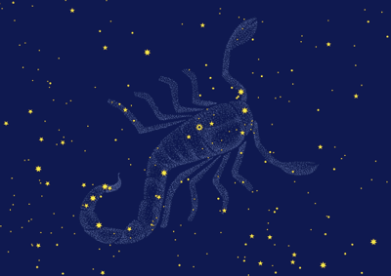Those who in an ancient day scanned the sky in the effort to determine the influence of each section on the affairs of earth, found in the thirty degrees along the annual journey of the Sun mapped by Scorpio a perplexing problem. This was a watery sign; plastic, emotional and receptive as all the watery signs should be; but those born under its influence also exhibited an aggressiveness and force far removed from the ordinary conception of water; quite suggestive, in fact, of fire. We of a later age, familiar with the tremendous force and aggressive quality of water when it has been converted into steam, water which having been sublimated is no longer a liquid, but a gas with properties quite distinct on that account, can consider this aggressive force paralleled by water which has been heated.

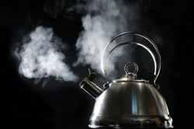

Water thus sublimated into gas is no longer rigidly bound to earth, but moves freely in the third dimension. Thus also does human life function freely on the fourth dimension instead of the third to which its physical form has bound it, when through death, which Scorpio rules, it avails itself of its thought-built body, in turn a sublimation of three-dimensional experiences.



One can scarcely contemplate the sign without at once being brought face to face with the doctrine of transmutation, or as our modern psychologists prefer to designate it, sublimation; for from most ancient times to the present day, the sign has been associated with both the highest and the lowest. Those with this birthchart influence strong are never mild and insipid; instead, they are decidedly noble, or completely debased. Thus, has it been pictured with an alternate influence; one represented by the eagle soaring into realms celestial, and the other as the crawling vermin of the desert floor.

The oldest seals and boundary stones of Mesopotamia, for instance, bear the picture of the constellated Scorpion; and it is one of the most prominent pictures on the Arkansas Astrological Stone. Yet in old-time zodiacs where the four fixed signs are used, each as representing one quadrant, it is the eagle which is used as emblem of the autumn and never the scorpion.

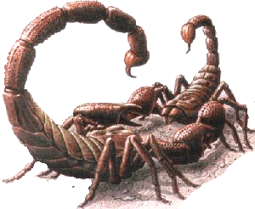

To know why the men of old used this desert creature to picture the vilest aspect of sex and death, which the sign had been recognized to rule, consider that no other animal, perhaps, exhibits such intensity in its love making, and none is more jealous and cruel once its desires are satisfied. The male and female scorpion, preceding the nuptial union, clasp hands in ecstasy, and each in rapt admiration of the other stands immobile for as much as a night and a day. The enthrallment of the other’s touch seems, for the time being, to lift them to such heights of bliss that they are oblivious of the world and passing time. They are entranced. Desire so permeates their bodies as to render them motionless.



Yet when finally, the spell is broken, and fertilization has taken place, a monstrous change in attitude occurs. In members of this and allied tribes, such as the spiders, the female is the larger. And it is as if, satiated by the long embrace, she was consumed with jealousy of a future rival, driven to frenzy that her mate might desert her for another. This, at any cost, and at any cruelty, she is determined to prevent. She therefore grasps her erstwhile lover, and despite his frenzied struggles, his mute entreaties, and his attempts to recall to her the beauties of their recent honeymoon, she tears him limb from limb and devours him completely.

Now consider the eagle, mating for life and maintaining throughout a fine solicitude for the one companion of his choice: a bird which it was believed flew higher than any other creature. At least, in its upward soaring it ascends until completely out of sight. Nor in its attack is it ever treacherous, but bold and vigorous; a bird of tremendous power, of a power and freedom of movement which is paralleled by that of steam when compared with earth-bound water. And thus, fittingly has it been employed as the universal symbol of that sublimation by which alone the highest spiritually can be attained.

The scorpion, condensed and conventionalized into the hieroglyph we yet use to designate the sign, conveyed information about the brutal and primitive impulses when their energy was permitted to express in grosser ways. Astrologers give Scorpio the key-phrase, I desire. Yet when these desires which exemplify the scorpion traits, were sublimated, it was recognized that they became the source of those powers so well depicted by the soaring eagle. That is, the scorpion told the story graphically enough, of desires basely gratified; while the eagle told the story equally well of desires properly sublimated. But neither picture told how that sublimation could be accomplished; how the scorpion could be converted into the eagle. It was this that the fourth Major Arcanum of the tarot was designed, through the language of symbolical pictograph, to explain.

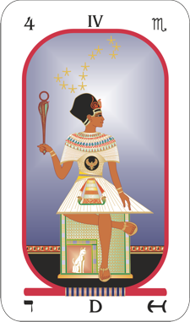

Outstanding in this pictorial representation is the upraised scepter of peculiar design. It is chiefly in form a cobra, sacred to the virile sun, and when curled is used instead of the lion, as the hieroglyph by which we represent the sign, Leo. And quite intentionally is this Leo emblem here employed; for Leo is natural ruler of the fifth house of a chart of birth, the house that relates to children, love-affairs and pleasures. And all the desires, including those which Scorpio more specifically rules, are founded upon the principle of pleasure. They strain to release energies in the direction of enjoyment or in a direction to escape pain — this latter relatively considered also being in the direction of the greater pleasure.

But this emblem of both power and pleasure related to the dominating Leo sign is not thus held high before the view merely to show the source of Desires which are recognized to be so strong in those born under the influence of the sign Scorpio. For surmounting it is the emblem of spirit, the circle. Thus, does it explain clearly in symbolical pictograph that Desires can, and should, be sublimated—as indicated by the circle which is the highest emblem in the picture, yet which is joined to the cobra—through the use of pleasure. In fact, that is the only way they can be transmuted; for efforts to change them through the use of force fail completely and result in inner conflicts.

The cube on which this sovereign sit is the emblem of matter and the physical world, the experience with which, little by little, has built into his unconscious the thought-elements and feeling energy which in their present organization constitute that character which his birthchart maps so perfectly. Whatever is now within his unconscious mind is derived from past experiences. Simple sensations have fused to become perceptions, perceptions have amalgamated to produce conceptions, and these in turn combine to express as intuition and reason.

Coincident with every experience, physical or mental, feeling energy, which is some degree of pleasure or pain, is also built into the unconscious mind along with the mental images of the experience. It is this feeling energy which conditions the desires, that is, which tends to cause the organism to act in a certain manner when again brought in contact with a similar situation. An amoeba moving in contact with a drop of acid retreats because of the pain. Next time it comes close to a similar drop of acid it retreats more quickly because it has built a desire thus to avoid the acid. An infant roughly handled by some person, soon learns to kick and cry when that person puts in an appearance. A desire has been built, through the pain associated with the image of that person, to escape from him. Yet an amoeba, a child, or other creature having felt the pleasure of satisfactory food gained through some specific action, because of the desire thus built up in association with that action, quickly learns to repeat it.

This process which the psychologists call Conditioning is not confined to human life, but is characteristic of all organic existence, and is the process through which all learning takes place, and through which all desires have been energized. The cat, as well as the lion, is associated with the house of pleasure, but not in so noble a manner. On the side of the cube here presented, it indicates that the vision of the soul penetrates the illusions of matter; but of greater significance. It signifies that pleasure has organized the unconscious mind as it now exists, and that all the individual has to work with in attaining the spirituality to which he now aspires is the energies built into his unconscious in lower forms of life which now express as his desires.

The chart of birth maps the manner in which the thought-cells and organizations were conditioned at the time of birth: that is, the general trend and intensity of their desires. It does not indicate that they must remain conditioned in that particular way. In fact, even as the primitive desires characteristic of the snake, the scorpion, the badger and the fox, existing in the human astral form as derived from pre-human experiences, are usually conditioned during infancy into socially acceptable channels of expression, so should the primitive desires which now determine the individual’s thoughts and conduct be reconditioned to express in a more spiritual manner.

The cat, because it is an emblem of the house of pleasure in the birthchart, represents the various desires within the unconscious mind as these have been conditioned by pleasure up to the present time. These are shown to be the foundation of the work of sublimation which the sovereign performs.

The apron above the legs which are bent presents the form of a trine above a cross; the symbol of mind dominating matter. Not only should the individual who seeks to lead a higher type of life use careful discrimination in selecting how to condition his desires so that they will release their energies, not as in the past, but in the new paths of his choosing, but he should use high intelligence in selecting that which is truly beneficial to desire. Many false notions of spirituality gain wide acceptance—notions which in practice injure the health and tend toward the disintegration of society.

It has even been taught in the Orient that to be spiritual one must kill out desire. Yet instead of being something inimical to human welfare, the teaching of modern psychology is that desire is the most essential asset possessed by any living thing. Without it there is no activity. Such activity as is expressed, is the expression of desire; and what is done, whether beneficial or the reverse, is determined by the manner in which desire has been conditioned. Therefore, there is but one possible avenue by which man can attain morality or live a life which is better in any respect, and that is not through eliminating desire, but through the proper use, or conditioning, of his desires. That is why this conditioning process is so carefully explained in the Scorpio tarot card.

Essential in this conditioning process is the use of pleasure, as signified by the upraised scepter. That is, it is possible to develop pleasure in almost anything through associating it with other things which already possess a high degree of pleasure. And it is through this process also, that the energy of primitive or anti-social desires can be diverted to flow through spiritual channels which are beneficial to the individual and to society at large.

But before he proceeds with this process of sublimation, he must first aspire to make the change in his character which this implies. He must have the prompting to live a higher type of life; and this is portrayed in the picture by the hawk, symbol of aspirations, on the breast, the region where emotions dominate: This man felt high aspirations, and in response to them has decided to be more spiritual than in the past.

But to practice the sublimation which has become his task, he must be able to direct his thoughts. That is, instead of permitting them to wander as fancy dictates, he must be able to select the objects on which to train his attention. If he permits his thoughts to dwell on the pleasure to be derived from the old avenue of expression of desire, action will follow in that direction. Instead of sublimating, he will follow the old habit pattern, and be no more refined than before.

The trine over the cross made by the apron above the legs indicates that mind, symbolized by the trine, has made such a triumph over matter. Not only has this individual used discrimination in selecting the type of desires into which to divert the more primitive energies which seek release in action, but he has cultivated considerable ability to determine what shall and what shall not occupy the attention of his thoughts.

This ability is extremely valuable also in attainment other than sublimation; especially in handling the unseen influences relating to the eighth house which Scorpio naturally rules. Those therefore who designed this Scorpio tarot felt that specific instructions should be included in reference to the influences exerted by the dead; and for this purpose, they placed upon the sovereign’s head the helmet of Pluto. The significance of this is clarified through the story of Perseus, who after slaying the Gorgon Medusa, was able to escape reprisals from her two furious sisters through a helmet which made him invisible. This helmet like the one here shown, had been provided by Pluto, ruler of the underworld and of Scorpio.

Such as have difficulties of a psychic nature, who have tampered unwisely with the invisible world, are here instructed by the wisdom of the past, in the best method of escaping such persecution. When through strong desire, we tune ourselves quite completely to one frequency of vibratory rates, this automatically cuts off others. When the dial of a radio set is tuned to pick up the program broadcast by one station, this eliminates the reception of programs which are broadcast over frequencies quite dissimilar. Thus, it is, as proved by the experience of many people, that the best way to escape an undesirable psychic influence is not to fight it, which tunes the finer body to receive its rates, but to wear the helmet of Pluto here depicted, and to become invisible and unaffected by its power, through completely and persistently tuning in on some dissimilar and constructive interest.

We cannot transform a Mars desire into a Saturn desire. Mars must always express destructively or constructively and with aggression and initiative. Saturn must always express in terms of safety, but such expressions may be related to fear and selfishness or to system, organization and persistent labor for the welfare of others. Thus, it is that sublimation of any desires does not change the basic thought-elements which are striving through it to find expression. Instead, it finds a new and better outlet for the energies of those same thought-elements; for the mental factors of the unconscious mind mapped by the same planets in the birthchart.

When the individual decides that some desire or propensity which is customary to himself is not such as to fit in with the high standard of conduct to which he aspires, his next step should be to ascertain through what avenue of expression that same planetary type of energy can express in a manner not in conflict with such standards. The reproductive desire, for instance, may express in gross dissipation, in the finer relations of family life, in engineering, or in any of the creative arts, such as musical composition, writing and painting. As a concrete example of such sublimation of this Scorpio desire consider that Michelangelo never married, yet his name marks the pages of history as a man of almost superhuman talent and energy, both of which were devoted to high accomplishment. He records in his own words how he sublimated his great passion for the one woman of his choice into energies that were expressed by him in his works of art:

*“As a stone, when an intaglio is cut upon it, becomes more precious than in its natural state, so am I of greater worth since your image has been graven on my heart. When a sculptor would give shape to an idea, he makes a mold of it in some base material such as clay or wax; then he puts it into marble and secures its immortality. So, I born but the model of my future self, have been reformed and made by you, O, lofty and noble lady, into a more perfect expression.”*

Of course, there are many other desires than the one here considered which can, and should be, sublimated. These cannot be made to express through creative activities, but only through avenues which are of their own essential nature. The desire for significance, ruled by the Sun, for instance, often expresses as an undue tendency to show off, to boast, or to bully others. And its energies can only be made to express, because they essentially are Power energies, in something which will add to the feeling of significance. Yet this object is not difficult to attain through sublimating them to find satisfaction in some worthwhile accomplishment that gains the respect of others and thus heightens the esteem for self.

But to get the desires to release their energies in these sublimated channels, it must be devised, as indicated by the cobra held aloft on Arcanum 4, that the individual gains a more intense pleasure from this new expression than from the old. Habit breaks a channel through which the energies flow with ease. To break a new channel, which must be accomplished in sublimation, is hard work, and therefore essentially painful. Yet the artificial association of something else which is highly pleasurable with this new method of expression lends pleasure to the whole, and thus because it then affords more joy, the new habit is established.

Whatever the nature of the desire to be sublimated, if you have Mars prominent in your birthchart, you can utilize the pleasure you normally feel in Mars expression to assist in that sublimation. You can look upon the old propensity as an enemy to be vanquished. And every time you are successful in diverting the energy of the primitive desire into a more spiritualized type of expression, you can feel the thrill of a victory and the glow of a hero who has vanquished his adversary. The more joy you get from the victory, the greater assurance you may have that similar victories will follow in the future.

Or if you have Jupiter, the religious planet, exceptionally prominent in your birthchart, you can utilize its energies to enable you to sublimate any desire. Think about the sublimated expression you have selected as aiding you to lead a religious life, as something of which the Supreme Intelligence is sure to approve. And when you have succeeded at least temporarily in this task of sublimation, permit yourself to feel deeply thankful to the higher powers. Associate with this expression also the feeling of benevolence and joviality. Because the thought-cells mapped by Jupiter in your unconscious mind possess so much energy, by associating that energy pleasantly with the expression decided upon, it is able to do what no amount of stubborn will power could accomplish.

If you have been accustomed to get high pleasure from using intelligence (Mercury), think how intelligent it is to express the desire energy in a sublimated way. Associate it with the feeling of significance if the Sun is prominent in your chart. In some manner tie the new expression in as giving pleasure to as many other strong desires as can be recognized, such as those mapped by prominent planets in the chart of birth. As explained by The Sovereign of the tarot, in order to sublimate any desire, find a more acceptable channel that will permit the essential nature of the desire to express. Then guide its energies into this channel through associating the desire with this expression, and with the pleasant realization of as many other desires as possible.

**Part 5: Jupiter and the Hierophant**

**Elbert Benjamine**

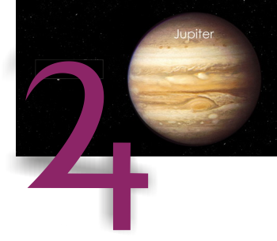Except the Sun, which rules the Drive for Significance and thus the urge to live and accomplish, Jupiter, the planet of the bands, is the largest of the astrological orbs; in fact, it has a volume greater than all the other planets combined. And this huge volume well represents the importance to our lives of the thoughts and behavior which are accentuated by his benevolent rays.

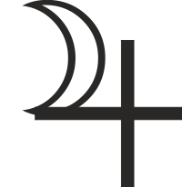

The conventional hieroglyph by which astronomers designate the planet is the cross, symbol of matter and the physical instincts, on the left arm of which is superimposed a crescent, like a new moon, symbol of mind and feeling. Such a hieroglyph is designed to indicate that the grossness of the purely physical is under the control of mind. And so far as it goes this portrays accurately enough the part which Jupiter plays in human life, and the attitude toward the department of existence mapped in the birth chart by the house he occupies. But for a comprehensive understanding of the planet’s influence this hieroglyph deals too largely in generalities.

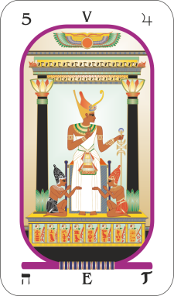

To preserve the information so painstakingly gained about the orbs they called wanderers, those of old designed Major Arcanum 5 of the tarot specifically to explain, in the language of symbolical pictograph, important things they had learned about Jupiter. It is pictured as a hierophant—that is, an authority on religion—who is seated between two columns of a sanctuary. He leans upon a cross of three bars, and with his right hand makes the sign of the pentagram. At his feet kneel two human figures, one dressed in red and the other dressed in black. Over the sanctuary, within which he is seated, the protecting vulture wings are spread.

The implication is obvious that here was an attempt to describe the function of religion and to indicate its tremendous power over human affairs. Modern astrologers all agree that Jupiter, ruler of Sagittarius, the sign naturally relating to the house in a birth chart which maps the section of the unconscious mind where one type of religious experiences is registered, is the planet governing religion. The ninth house, however, maps those mental factors not merely relating to religion, but opinions of all kinds which are given public expression; while the position of Jupiter in the chart of birth maps mental factors which relate to faith, devotion, benevolence, good cheer, joviality and veneration; mental factors which more specifically are built into the unconscious mind as Religious thought-elements.

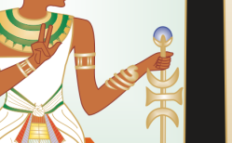

The hierophant, with his right hand, makes the symbol of the pentagram signifying that he has tuned in on the benevolent power of Deity and thus transmits goodwill and helpfulness to all. His left-hand rests upon the cross of three bars, representing the realms of spirit, astral and matter, which in turn correspond in human life to spirit, intellect and body. Thus, is signified that the religious propensities of Jupiter, which when properly tuned in on, or when adequately cultivated, extend their power to every plane and in turn markedly influence the things of life that have become associated with them. Changes are instigated not only at the level of the body, but also in mind and spirituality.

This we find to be most true: people tune in most readily on Jupiter’s benevolent vibrations through that station of their astral bodies mapped by the planet’s position in their charts of birth. And the department of their lives thus associated with these vibrations, as indicated by the house position of the planet, in some manner is always subject to abundance. Unless pronounced discords prevail this department is also subject to much good fortune.

About those things, to which the house occupied by Jupiter in a birth chart relates, the individual has a special mental attitude. This attitude often does not extend to other departments of life. One may infer that the special type of fortune experienced is due to a special mental attitude about them. Where they are concerned one tends to be more optimistic than is the usual wont. There is an abiding faith that all will turn out well regarding them. If, for instance, Jupiter is in his house of friends (11th) goodwill toward friends, there is likely an attitude of always being willing to go out of one's way to do them favors. Joviality in their company, and the spirit of fine fellowship which is radiated, insures there will be an abundance of friends, and that they will be loyal and render assistance. Or, if Jupiter is in the house of those who labor (6th), a benevolent and loyal attitude toward those who work for, and with whom one works insures the utmost in loyalty and service in return.

Whatever house of the chart of birth we find the planet Jupiter in, its position maps a powerful group of thought-cells which have had their origin in thoughts and experiences relative to the things of the department of life that birth chart house rules. These thought-cells have been built throughout the past, before the soul was born in human form, through experiences with tolerance toward other members of the group, through confidence in a higher authority, such as faith in the parents or leader, and through obedience to the ruling power, which is at the foundation of veneration and devotion. And they are added to, and altered by, other thoughts since human birth which relate to benevolence, optimism, faith and religious devotion.

Both the thinking and the behavior relative to the department of life governed by the section of the unconscious mind mapped in the chart of birth by Jupiter are powerfully influenced by the release of energy from these so-called Religious thought-cells; the individual thinks differently and acts differently about the things of this portion of their affairs than he/she is likely to think and act about other things. The consequence is a different kind of fortune.

Furthermore, when a progressed aspect to Jupiter in one's chart is present, the stellar aerial then formed picks up the energies radiated by the planet in the sky in more than usual volume. Through this aerial, mapped by the progressed aspect, this unusual supply of energy is added directly to the Religious thought-cells in the unconscious mind. These thought-cells—which like physical cells have sufficient intelligence of their own to be able to perform their functions—are able to work energetically from the four-dimensional plane to attract an event into the life of the Jupiterian quality, and affect the department of existence shown by the house in the chart which the planet occupies.

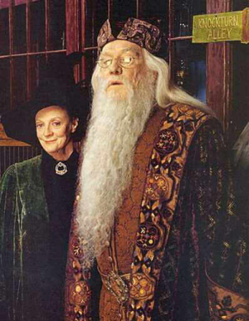

To the extent an individual develops the power to feel and think the type of thoughts associated with Jupiter, thus actively tuning in on benevolent vibrations, is one also able to energize other departments of his life beneficially with them. To habitually associate any endeavor or phase of existence with thoughts of faith, good fellowship, helpfulness, joviality and religious devotion adds benefit to the thought-cells in the unconscious mind. If the feeling is maintained, the planet’s vibrations are added to that compartment of the astral body, in much the same way as if a progressed aspect to Jupiter were present.

It was to explain how the benevolent vibrations of Jupiter could be utilized to benefit any phase of life that those who designed Major Arcanum 5 pictured the religious hierophant making the sign of the pentagram with his right hand, while his left rests upon a cross whose upright penetrates all conditions and every plane.

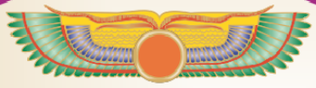

The outspread wings above the sanctuary, and the kneeling human figures, one black and the other red, who supplicate the aid of the religious master, have a wider significance. 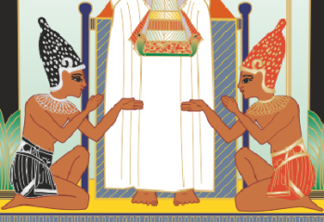People should, as the attitude of the hierophant suggests, reflect the Will of Deity, which is a concept back of most religions. The overshadowing wings represent that Omnipresent Intelligence which most enlightened beings accept as the guiding power behind all manifestation. It is through observing the direction in which creation is moving, and watching the course of the stars for future trends that humans are able to acquire some knowledge of the Deific Plan.

It is a human function to cooperate in the progressive fulfilment of that Divine Scheme of things. Efforts to do so are prompted by the religious thought-cells within the unconscious mind which are mapped in the chart of birth by the planet Jupiter. They cause movement toward a course of conduct considered moral, and avoidance of other types of conduct considered immoral or contrary to the accepted religion or philosophy one has accepted.

But whether one's accepted religion is based upon the altruistic desire to perform one's particular constructive function in the Cosmic Plan, or is as narrow as the witch-burning orthodoxy that once taught that being joyful was a sin, a person is far better able to fulfil its demands if well versed in astrology.

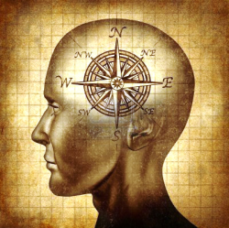

The black figure at the hierophant’s feet indicates those times when the individual errs in conduct, either through faulty judgment or through being overpowered by temptation. The red figure indicates the times when he/she has made the correct choice, has acted according to the highest dictates of their conscience. True religion, as signified by the dominant position of the hierophant, serves as a guide for truly moral conduct and affords the utmost facility by which truly moral conduct is directed along truly moral lines. These things are within the province of astrology.

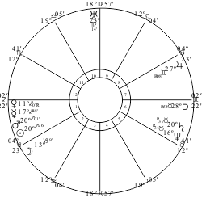

The birth chart unerringly maps both the strong points and the weaknesses of an individual’s character. Neither is unalterable. The chart of birth reveals the organization of the unconscious mind as it existed at birth. Without the aid of astrological knowledge, subsequent experiences tend to be along the lines indicated in the chart of birth and thus merely accentuate the various traits of character with which the individual was born. But, with a chart of birth at hand, those given the responsibility of training the child can take special pains to strengthen points of weakness and disadvantage. An adult with such knowledge can guide the child to cultivate traits of character of which there is most need.

For the individual to merely resolve to live a life of moral rectitude seldom is fruitful of permanent results, else the multitudes who become converted at popular evangelical revivals would populate the land largely with holy men and women. At the time they feel the surge of great desire to live a righteous life. But mostly within a few months afterwards their lives run in much the same channels of partial goodness and partial error that they did before. Not because the desire at the time of conversion was lacking in sincerity, but because, as mapped by the planets in their charts of birth, their unconscious minds contain many other very strong desires.



It is the release of the desires, stored within the unconscious mind, that determines habitual behavior. Aspects between planets indicate whether desires tend to express constructively, in a direction beneficial to self and others, or tend to be spent in riotous living, subversive activities, or in channels that are detrimental to society. Desire energies within the unconscious mind, mapped by any planet, can, with proper training, be made to express constructively instead of destructively. It must express its own essential type of activity, it is true, but there is full scope for it to express that type of activity through some avenue beneficial to the individual and beneficial to society.

Most who become criminals could have been transformed into honest law-abiding citizens if someone, during their childhood, had taken them in hand and afforded them a little training based upon astrological knowledge. For instance, the problem child who in later life becomes a petty thief because they never learned the discipline of making an honest living, is nearly always a child who, because of over sensitiveness—revealed by upper-octave planets dominant in their chart—has never been able to fit into the conventional methods of life. Yet, unless that child is decidedly deficient mentally, which commonly is not the case, there is always something they can do in which pride is satisfied.

Everyone has the desire for significance. All resent the feeling of inferiority. Due to peculiarities of makeup, the child with heavy afflictions to Pluto, Neptune and Uranus may find it very difficult to compete in school with other children where conventional forms of learning are required. If unduly ridiculed or punished because he/she will not study, the aversion to such effort is heightened. They become completely discouraged. Soon they begin to think they are quite different from others. A feeling develops which causes them to be unable or unwilling to make the effort others make to attain success in life. Cast upon their own later, they become a hobo and drift into petty crime.

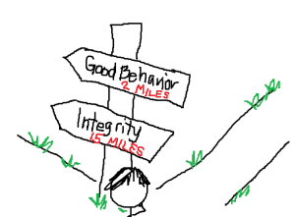

Every child who is not hopelessly deficient mentally has certain capabilities that are mapped by the positions of the planets in their chart of birth, which give a certain facility in some special endeavor. Even if they are frustrated in their studies or the parental home environment offers great discouragement, it is always possible, by tact, to gain a child's interest. Later their efforts can be directed into some constructive activity which utilizes the natural facility. Proper praise and encouragement when such activities produce results bring a glow of self-esteem. In this line there is a satisfaction for the Drive for Significance. Continued encouragement and praise for work well done, especially along the lines of their natural aptitudes, build the habit of looking to their work as something that can lend itself to making a living, and in which, they can hold up their head and be respected by others.

The more bold and daring criminal frequently was abused in childhood because their initiative and aggressiveness got them into mischief. The aggressive thought-cells, mapped by a prominent Mars in their chart of birth, contain so much energy that they must express in some form of destructive or constructive activity. When, in exuberance of spirit, the youngster leads their companions in some daring exploit, they are beaten at home and made to feel miserable at school. With so much Mars energy they cannot be idle. As no proper avenue of expenditure is at hand, it is quite natural they should get into trouble.

This trouble draws the negative attention of elders, adding to a sense of importance. Other children see this child as a hero each time they engage in some hazardous undertaking, such as grabbing fruit from under the nose of a vendor, or breaking the seal on a boxcar to get the watermelons within. To be a hero is reward enough for any Mars child, even if in the process he incurs trouble with authority.

Thus, through one pleasure after another, in which authority is flouted and legal restraints broken, the child is conditioned to gain satisfaction for both the desire for significance and the desire for adventure in the avenues of smaller crimes. These lead on to larger ones. Greater hazard or risk equals a sense of being a greater hero. Finally, society has on its hands a confirmed criminal.

Had someone conversant with astrology taken the child early in hand and devised an outlet, such as building something or working with tools of repair, by which according to the other planetary positions in the chart the Mars energy could express satisfactorily along some constructive line, the same child, finding himself a hero in the eyes of other children for mechanical skill, would never have become a criminal, but a doctor or an engineer instead.

Furthermore, the individual who aims to live a moral life, but at times finds the conditions of temptation so strong as to cause him to act quite discreditably, has a powerful lever to rise above such periods through familiarity with astrology. The birth chart shows the trends against which one specially needs to guard. The progressed aspects indicate the exact periods in which environmental pressure will be brought to bear in the direction of some special weakness. Knowing beforehand the nature of the condition with which they will be confronted, and when it will be present, the individual can develop the tools and attitudes to escape the moral transgression.

On the one hand, progressed planetary vibrations reaching a certain group of thought-cells within one's unconscious mind may give so much discordant energy that they stimulate powerful impulses to act in a way at variance with what is considered normal, constructive behavior. This energy may further stimulate activities which have previously been kept somewhat in restraint. On the other hand, if the individual recognizes that the progressed force of energy that is urging undesirable action will subside when the progressed aspect has passed, he/she can choose to behave like the white figure at the feet of the hierophant. This knowledge can also aid the individual to take precautionary action by shaping the environment and training oneself in advance to choose the constructive conduct the white figure represents.

True religion seeks a larger perspective on what is and is not moral behavior. I seeks behavior that is in the best interest of the individual and others. It is not merely the premeditated acts of an individual, or those in which one is desirous of doing wrong, that are immoral. A person who runs down and kills a pedestrian with their automobile may have no desire to do so, but they nevertheless injured another human being. The head of some bank who, through its failure, leads a whole community to be impoverished, may have no intention of causing others loss. They merely may have invested the money entrusted to them in assets which became frozen. Yet the fact remains that through the confidence placed in them others have lost their all.

True morality, in this wider sense, can be assisted by astrology and in no other way. This is the deeper significance of the black figure of Arcanum 5, representing the tendency to act, under progressed afflictions, in a manner not merely derogatory to oneself, but injurious to others; and by the white figure of Arcanum 5, representing the tendency, under better progressed aspects, to act in a manner helpful both to oneself and to society.

Had the person who ran down and killed a pedestrian been conversant with astrology, they may have recognized the progressed energy operating in their life at the time and have taken sufficient precaution to avoid the accident. Had the bank president been conversant with astrology, the progressed aspects in their chart would have informed them that it was not a time to invest too freely in assets which could not be quickly liquidated. Had they been truly moral, they would have foregone those financial transactions which led to the ruin of self and others.

Arcanum 5 of the tarot explains quite clearly, in the language of symbolical pictograph, that no one can be most highly moral who is ignorant of the influence of astrological forces in his life.

**Venus and the Two Paths**

**Elbert Benjamine**

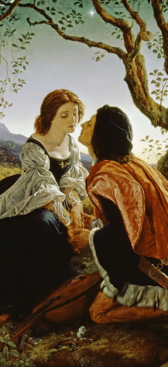Looking to the Westward just after the sun had wearily dropped in slumber behind the evening rim of the earth, those of the ancient time saw a silvery white lamp hanging in the fast darkening sky. Sometimes it snuggled close to the horizon, as if it too had labored hard, and sought quick rest; and at other times it glowed and sparkled as if alive with merriment, far above that place of sleep. For some ten months it thus appeared, brighter even than Sirius, and more conspicuous than Jupiter, the planetary king. Venus thus was known as the Evening Star.



Then came a period of some ten months when its white radiance no longer shed soft blessings upon lovers who strolled arm in arm after the close of day. The sun no longer was followed in his declining by the fair and lovely Evening Star, but was preceded in his morning rising by one equally brilliant. It was of course the same attractive planet and this the astrologers of old well knew. But something had happened to it; it had fallen from grace, banished from the soft and charming vesper gardens, where peace and harmony gave beauty companionship.



It was known to these wise men of a day long past, as it is known to astrologers of the present time, that Venus in its influence over human life is the planet of least resistance. What it brings comes without effort, if it comes at all. The house of a birth chart occupied by it thus is said to map the department of life which most attracts gratuities. There is nothing strong, nothing violent, nothing forceful, about Venus, the planet of love. Wherever the affections lean, in that direction does the Venus person move. It therefore may exalt the soul, or under adversity lead it into vice. Through their affections, which this planet rules, many a man and many a woman are made or broken.



Its rule over love is not merely that for the opposite sex. Its strength and harmony in the birth chart show the success or failure of the affections in general; those where husband or wife are concerned, those relating to the offspring, those which have to do with friends, those involving the kindred, and of course those aroused through love affairs. That is, from the position and aspects of Venus in the chart of birth can be determined how much success in general the affections will have and how much loss; but to determine their satisfaction in reference to any one of the mentioned departments of life the house ruling it also must be taken into consideration. Thus, a person with a good fifth house and a badly afflicted seventh would find little satisfaction for his affections through the marital partner but would, if his Venus was not too badly afflicted, find affectional joy in the companionship of his children.

There is a kind of vice which is malicious, which is planned well ahead, and then carried out with brutal determination. But it has nothing to do with fair Venus. When Venus falls into sin it is not because she plots to do so but because she is too weak to offer the required resistance. After all, it takes mental power to resist the attractions of the senses, and it requires intelligence to build up a love for those things which are high and pure, which are harmonious and healthful and which, could it but be perceived, yield a higher harvest of pleasure and happiness than the coarser joys of dissonance and sin.



But Venus has to do with feeling and not with intellect; a fact well portrayed, though limited as to its further explanation, by the brief hieroglyph used to denote the planet. The circle of spirit is superimposed on the cross of matter, indicating that, left uninfluenced, the trend is toward refinement and spirituality rather than toward the physical and gross. Yet no place in the emblem is the crescent to be found. Intellect plays no part in the promptings either of Venus or Mars. In so far as the energies of these two planets stimulate the thought-cells within the unconscious mind to action, those actions are directed by feeling alone.

And for that matter, as psychologists have been at great pains to prove, all action is prompted by feeling. Past feelings have conditioned all desires, and it is the release of the desire energy thus built into the thought-cells of the unconscious mind that determines the direction in which action will be taken. But this conditioned response, as the psychologists call it, may have been cultivated in such a manner that it is influenced by more remote considerations, such as require some intellect to apprehend. Or it may have been cultivated so that it responds merely to the immediate sensation with no consideration of ultimate pain to follow.

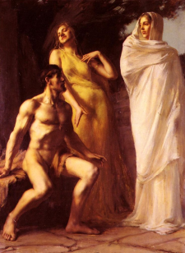

When it is said, as so often it is, that love is blind, this implies that the attributes of Venus tend to be little influenced by considerations far removed in time. It implies that which astrologers recognize, that Venus is the planet of least resistance, and therefore not through desire of iniquity, but through weakness, the thought-cells within the unconscious mind it maps open the individual to temptation.

At many points in his journey through life the individual is called upon to make a choice. Before him lies a parting of the way, such as is pictured in Major Arcanum 6. Virtue points to the path of rectitude, and vice brings to his attention the highway of sin. What his choice will be depends upon the things he has trained himself to love. If his feelings are more strongly and pleasantly stimulated by thoughts of debasing conduct, he will follow down the left-hand path. But if his affections have been cultivated to find higher pleasures in noble actions and things refined, he will turn up the highway to his right.

This function of feeling, and the power of love to mold the endeavors, was recognized by the masters of the past and properly associated with the most beautiful and the most brilliant planet in the sky. Its loveliness in the evening suggested to them that it was on the right-hand path which led to spirituality. Yet they had also witnessed the degrading process by which affections, misled in their object, took the left-hand downward leading path which ended in dissolution. And thus, comes down to us the old Semitic myth, referred to in Isaiah 14:12, ‘How art thou fallen from heaven, 0 Lucifer, son of the morning!’

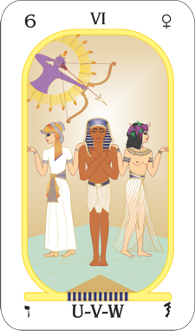

Yes! It is true that the mental factors within the unconscious mind ruled by Venus may lead us to the heights or sink us in the depths. And to explain this and the retribution which inevitably befalls those who follow the path of vice, the ancient sages designed a symbolical pictograph, showing a man standing motionless at the angle formed by the conjunction of two roads. In indecision, his looks are fixed upon the ground and his arms are crossed upon his chest. Two women, one at his right, and the other at his left, each place a hand upon his shoulder, showing him one of two roads. The woman at his right is modestly clothed and has the sacred serpent, indicating enlightenment, at her brow. She thus personifies that virtue which so well was symbolized by Venus as the kind and affectionate Evening Star.

But the woman at his left wears less clothing and is crowned with the leaves of the grape, the fruit from which is pressed the accomplice of debauchery. She points to the left-hand road; she is vice, the temptress, the fallen woman, the one who loved not wisely, but too well, and who so appropriately was symbolized by the archangel fallen from heaven to become Lucifer, the Morning Star.

Truly enough, man is reached and most strongly tempted through appeals to his emotions. But the temptation of one is the fortitude of another. Things appeal in different strengths to those whose birth charts show diverse positions. That which tempts the Aries person most forcefully may be a matter of utter indifference to the person most strongly influenced by Cancer. Each sign has its own best quality and its own worst quality, has its own particular strength and weakness, that which most readily enables the person born under it to express the high attributes of his divine soul, or which with most difficulty resists the temptation of the animal soul to take possession.

Of course, as a matter of hard fact, a person has only one soul, which embraces all those experiences of the past that have registered in his astral body and have there built psycho-plasm and stellar-cells, and thus constitutes the organization of his unconscious mind. But some of the desires thus built by past experiences have been conditioned to release their energies, not in the direction beneficial to society as a whole, but at the expense of society to benefit the individual. These more primitive desires, existing as energies under tension within the unconscious mind, because they tend to express on the plane of life of the animal world, are said to belong to the animal soul.

But within the unconscious mind there are other desires, conditioned by later experiences, desires often times which derive their energy from a sublimation of the more primitive urges of the animal soul, which seek the welfare of society and are willing to sacrifice personal comfort and to undergo hardship to that end. These more socially beneficial desires, because they tend to express on the plane of life of the spiritual world, are said to belong to the divine soul.

This idea of man's good angel and his bad angel, each of which pulled him in the opposite direction, which we now know is in truth the power of desire energies within his unconscious mind thus pulling him, was prevalent in ancient tradition, as was also the inevitable punishment of each transgression that we now recognize as the operation of natural law. And thus, to explain that each zodiacal sign has its own tendency to some special virtue and to some special vice, those who designed the tarot Arcanum called The Two Paths, placed above and back of the man being influenced by virtue and by vice, a flashing aureole of twelve rays, and in it the genie of justice, who draws his bow and directs toward vice the arrow of punishment.

The ancient teaching embodied in this Venus tarot card is very plainly pictured. Venus is the planet of feeling, and the outstanding psychologists of our day state that when all is analyzed man is led by his feeling alone. And the picture explains, for there are twelve rays to the aureole, that for each sign two easily travelled roads are open. These roads are not the same for different signs, but nevertheless there is a pulling for each in different directions. Yet, as shown by the genie of justice aiming the arrow at vice, if the individual follows the path which for his sign is the one of least resistance, misfortune surely will come to him.

Usually, the two paths open to those under the influence of each sign are the expression of much the same essential attributes, except that in one they are used in such a manner that they are more highly advantageous to others, and thus ultimately also to the one expressing them. The best quality or the worst quality of a zodiacal sign often largely lies in where the emphasis is placed. Or an over-eagerness to express the characteristic quality right, may easily turn the expression from harmony and construction into discord and ruin.

Yet when an individual realizes the line of demarcation that divides the constructive and socially beneficial expression from that which is destructive and socially detrimental, this knowledge makes it far easier to choose the right-hand upward path, for as is suggested in the picture it requires no tremendous change in the basic energies within the individual whichever of the two roads he takes instead, it but requires a choice of the right direction along which those energies shall express.

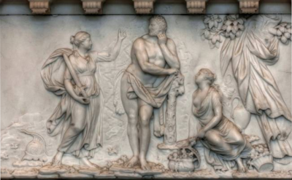

Therefore, that what the ancients taught by Major Arcanum 6 may not remain in the vague and nebulous clouds of mere theory, let us consider briefly the two roads open to each of the signs:

**Aries**

The Aries person to be at his best requires the zest of competition. He feels the need of combat in some form, and ever strives for personal leadership. His enthusiasm often leads him to rush into controversy before he has had time to examine the justice of the matter. And at once he takes up arms in behalf of a cause he is very difficult to dissuade. The channel through which he most naturally strives to attain significance is that of leadership. In fact, we can say that Leadership is his best quality and indicates the proper path. In his zeal and enthusiasm, however, he easily may forsake this constructive road to unduly interfere in the affairs of others, then taking the way expressing his worst quality, officiousness.

**Taurus**

The Taurus person is steadfast in mind and in habit. He follows a certain routine in the performance of his tasks and very much dislikes to change his methods in any way. He is thorough in all he undertakes, given to perfecting the small details and cannot be hurried, pushed or frightened out of his rather deliberate pace. When his characteristic quality follows the destructive path, it expresses as obstinacy. But if early in life he forms the habit of being steadfast toward truth and justice, so that this attitude becomes firmly entrenched, it then will not be difficult for him to give way in smaller things, that he may maintain his original purpose. Thus, will he follow the proper path, which is that of stability.

**Gemini**

The Gemini person has a very active brain and is at his best when his intellect has full scope for work. He is restless and must constantly express himself in some way. Not only is he restless, but he can do so many things well that he will not endure disagreeable conditions in one occupation because he can always get work to do in another. In expressing along the constructive path, he exhibits his best quality, which is versatility. Yet this quality, expressing along the adverse road, becomes changeableness. Not merely changing his point of view, but also changing his occupation so frequently he falls far short of success. To keep on the upward, right-hand road, he should realize that any task can be made worthy of all his ingenuity and talent and that instead of changing occupations he should change his methods in the one he has chosen.

**Cancer**

The Cancer person is exceptionally emotional and above all else craves sympathy. He becomes greatly upset on hearing unpleasant news or when he fancies, he has been slighted. The fear of ridicule is torture to him and prevents him from asserting himself to advantage; yet when he has a friend or an idea or a purpose to cling to he does so with the utmost patience and perseverance. By absorbing the idea that people in general are sympathetic and friendly and that those who are otherwise are not worth bothering about, he can turn from the destructive path of touchiness, which is his worst quality, and take the constructive way of tenacity whereon his talent for finest expression lies.

**Leo**

The Leo person has great faith and trust in other people. And they usually respond to this faith by endeavouring to live up to his expectations. Yet he also tends to have a thirst for personal glory and craves a position of authority. When on the right-hand path, he does not demand of subordinates that which is impossible of fulfilment. And in all his contacts with them and with others he expresses his best quality, which is kindness. Yet if he takes the opposite path his desire for significance becomes overpowering and he feels he should have a position of importance even when in reality he is quite incapable of efficiently filling it. It is then impossible for him to realize that kindness may often best be expressed through work rather than through issuing orders and that the highest glory obtains to him who best serves. Thus, he treads the obnoxious path of his worst quality, which is domination.

**Virgo**

The Virgo person loves to deal with facts rather than with theories. He inclines to statistics, and often is a walking encyclopedia of information. His powers of discrimination and his practicality instantly discern the flaws of other people and their plans. Thus, is it easy for him to follow the roadway of his worst quality, which is destructive criticism. But if he takes the pains to realize that it requires just as keen discrimination to find the good points in people and things as to find those objectionable, he then turns up the path of his best expression, which is analysis.

**Libra**

The Libra person is a lover of perfection. He is courteous and kind and greatly craves understanding and companionship. As a rule, he should not live an isolated life but follow his social inclinations. He is a lover of harmony and so dislikes to hurt another's feelings that he can seldom say no. Thus, in his desire to give pleasure to them he may take the path of least resistance, forsaking virtue and honesty for the sake of his love of approbation. Yet if he realizes that he will be better liked by others in the long run if he manifests enough character to render a firm decision and to be uninfluenced by flattery he then turns on to the road of his best quality, which is affability.

**Scorpio**

The Scorpio person is very intense in his likes and dislikes, and whatever he finds to do he does with his whole might. Unlike Libra, he can be trusted to grapple with the most difficult and disagreeable tasks, in which he exercises his best quality, which is resourcefulness. Yet he early should learn to realize that his advantage is in concentrating his energies on the solution of his own problems and in overcoming the obstacles to his success, rather than in insisting upon the proper conduct of others. For he believes strongly in duty and often takes special pains to see that others fulfil all their obligations to society. In this he easily turns down the detrimental path of his worst quality, which is troublesomeness.

**Sagittarius**

The Sagittarius person can both give and take orders. He is naturally an executive, and in both thinking and deed goes straight to the mark, caring more for effectiveness than for elegance. His love of games and good fellowship makes it easy for him to follow the downward path of his worst quality, which is sportiveness. Yet when the attraction of good fellowship is permitted to express in the higher and more constructive manner and he finds a work in life so interesting to him that it becomes a game in which success is the hazard, he with equal ease turns up the road expressing his best quality, which is loyalty.

**Capricorn**

The Capricorn person is methodical and highly ambitious. He has a faculty for bringing together dissenting factions, for synthesis and economy. He is at his best and on the right road, when given responsibility and permitted to exercise the quality of diplomacy. He is a good manager but ever tends to keep an eye on his own advantage. Thus, should he early realize that the greatest advantage a person can have is integrity of character and devotion to the welfare of others. Unless he gains this conception, it is not difficult for him to turn down the highway of his worst quality, which is deception.

**Aquarius**

The Aquarius person understands human nature better than those born under any other sign. He knows just what to say and just what to do to produce a given effect upon those with whom he is associated. Merely for the sake of discussion he often will take the opposite side of an issue, thus following the road of his worst quality, which is argumentation. Yet because he knows so well how to influence people and has tendencies which are progressive, with equal facility he can turn up the bright trail of his best quality, which is altruism.

**Pisces**

The Pisces person is inclined to be plastic and thus much influenced by environment. He has high ideals and loves harmony. And because he is so sensitive to discords and to the thoughts of others, he is inclined to magnify the importance of slight adversity or imagine adversity that never comes to pass; and thus, he turns down the left-hand path expressing his worst quality, which is worry. Yet if he encourages a greater trust in Deity to handle the details of life and permits his feelings for the welfare of others to displace fear, he then turns up the right-hand road of his best quality, which is sympathy.

**Astro-Tarot Series**

**Part 7: Sagittarius and the Conqueror**

**Elbert Benjamine**

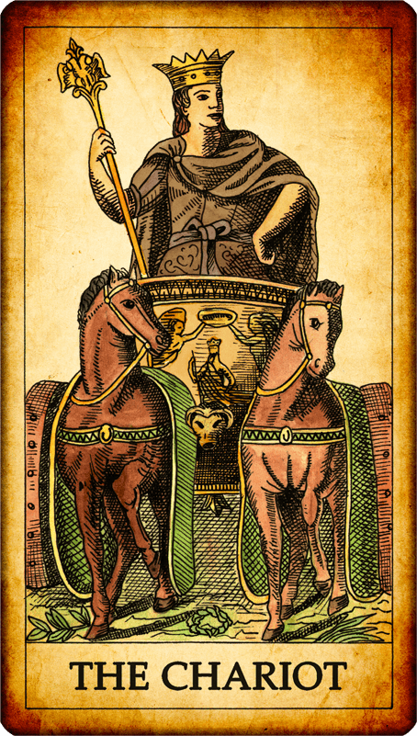One or more thirty-degree section of the orbit of the Sun among the stars bears a close affinity to the influence of each planet. Thus does Jupiter, the planet of religion, have an influence most similar to the Sagittarius sign, which in turn is natural ruler of the ninth house of the chart of birth, where the individual more publicly expresses his views, and airs his philosophy of life. That philosophy, to him, is a most important thing, for it determines what he will do when confronted by various exigencies.

When the ancient masters of wisdom, therefore, wished to explain how the individual could live to his highest — for the longing thus spiritually to live is most strongly associated with Sagittarius — they drew a rather complex design in pictograph. Instead of placing a red man and a white man at the feet of a religious potentate, as they did when explaining the significance of Jupiter, thus pointing to more general moral principles, they presented a conquering hero riding in a square-formed car.

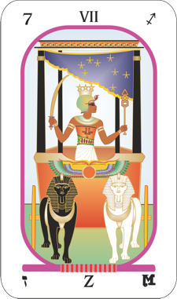

Sagittarius is an executive sign, and the broader principles of spirituality which its ruling planet advocates, in this picture are shown to have been carried out in action; and complete explanation is given in the design as to the methods the conqueror has used in the victory which so plainly he has gained. True to his sign, he has carried into action the precepts he has learned.

The square car, in which he travels, of course, is the physical world over which each person seeks dominion. The sphere sustained by the two outspread wings on the front of the chariot, is the symbol of the flight of his soul through the infinitude of space and time, of which the present moment is but a single cross-section. This war chariot of the physical world wherein he travels is surmounted by a starry canopy sustained by four columns. These columns represent the four quadrants of heaven, and the canopy is so conspicuously marked with stars that it is obvious it is intended to convey the thought that the stellar bodies above are the powerful influences in his life.

Upon his breast are traced a T-square and two trying squares to indicate the aspects which, forming among the orbs above, make their impress upon his behavior, upon his thoughts, and upon the events that are attracted to him. And in front, drawing the chariot of his physical existence, are two sphinxes, one white and the other black. A sphinx, as composed of the four emblems of the zodiacal quadrants — lion, eagle, man, bull — indicates the passage of time. The white sphinx thus signifies fortunate periods, such as tend to be attracted when progressed aspects are favorable; the black one denotes periods of adversity, such as tend to be attracted when the progressed aspects are discordant; yet both of which, according to the picture, have been harnessed by the conqueror, and compelled to do his will.

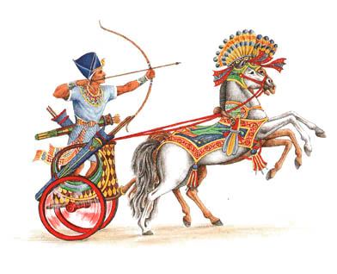

Because they believed the highest function of religion was to enable the individual to master his destiny, rather than submitting limply to what the stars seemed to foretell, when the sages of old designed the explanation of the function of Sagittarius on Major Arcanum 7, called The Conqueror they sought to give practical information on how the individual could utilize the planetary energies to enable him to live the kind of life he sought to lead, and to attract to himself not those conditions which would cause him to do less for others, but which through being fortunate for him, also could be used to the benefit of all. Unwittingly to attract misfortune is to lose that much of power to benefit the race. It may even cause others terrible suffering. But to be able to rule one's destiny, in spite of the stars, is to gain a power by which the highest ends of religion can be attained.

For man to rule his stars and thus determine his own destiny, which the initiates of old considered to be essential to the highest type of religious life, for only by so doing could he lend most spirituality to his behavior, his intelligence must be directed to solving three different types of problems; therefore, as a five-point star indicates dominion of matter by intellect, they crowned the Conqueror with three such stars. Their proximity to his brain reveals that they relate to thought.

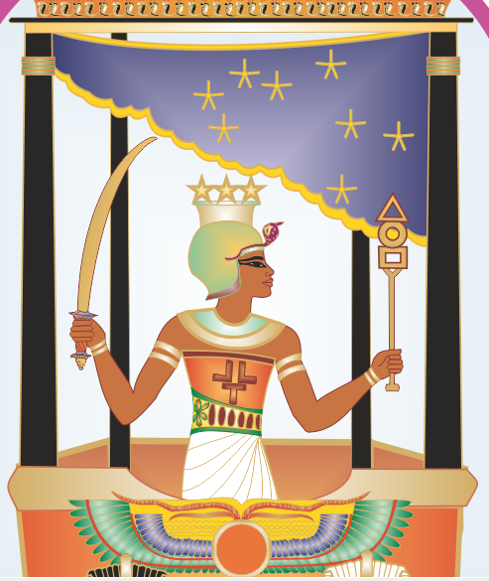

The first of these problems is signified by the square form of the car in which the Conqueror moves; the square is the emblem of the physical, and thus as one great aid to ruling the stars, man can use his intelligence in the proper selection of his environment. That is, he can do this if he is conversant with astrology, as the Conqueror is shown to be; for conspicuous immediately above his head are pictured the stars.

The earth is subject to different weather conditions simultaneously in different regions. As the energy of the thought-cells in a certain compartment of the astral body, and therefore influencing that department of life, is in the nature of an astral condition affecting one region strongly and perhaps another region not at all. That is, either a birth chart aspect between the planets, or an aspect by progression, may affect money, yet have no influence over the health or affections.

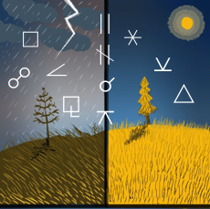

Thus, may one take heed of storm warnings in a particular department of life to prepare the external conditions so little damage will result, and turn the attention to some other region where the sun is shining. Or to state the astral storm indications in terms of energy and work: the activities of the stellar-cells from the four-dimensional plane can only bring such events into the life as the physical environment makes possible. If the physical environment is so arranged that a certain type of event cannot happen, it will not happen, no matter what the birth chart and progressed aspects are. That is, the thought-cells can only do as much work from the astral plane as they have energy to accomplish. And if the environmental resistance to a particular event is sufficiently high, they do not acquire enough energy, and an event that they otherwise would attract does not happen.

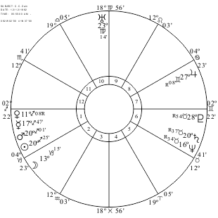

The positions in a birth chart which indicate a predisposition toward a given condition or event are called the Birth chart Constant. Each Birth chart Constant really maps the thought-compounds and their relations in the astral body at birth, which if later given additional thought energy brings the condition or event into the life. That is, a Birth chart Constant is the thought organization of the astral body at birth, which gives the predisposition toward some particular misfortune or toward some particular fortunate event.

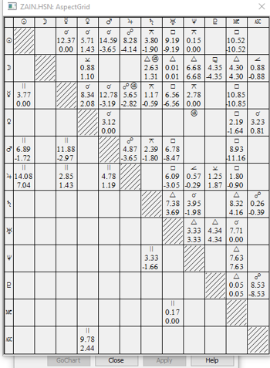

The events themselves, as there is ample statistical evidence to prove, to the extent they are noticeably either more fortunate or less fortunate than the normal trend of life, are attracted only at such times as the thought-cells relating to the department of life affected receive new energy. This new energy gives the stellar cells thus involved additional power to work from the four-dimensional plane, to stimulate objective thoughts of a similar nature, and to influence the physical conduct.

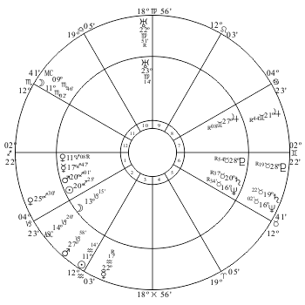

The more common sources of such additional energy supplies are mapped by the progressed aspects of the planets. Planetary energy picked up, radio fashion, by the aerial developed across the astral body when a progressed aspect is formed, is made available for the use of the thought-cells and stellar structures at the terminals of the aerial. But the event is not attracted by the new supply of planetary energy thus made available; it is attracted by the thought activities then stimulated. The stellar cells work with such intelligence as they possess, and with the energy supply thus made available, to bring events of a certain nature into the life.

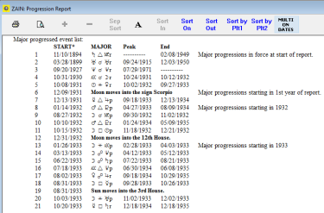

In addition to Birth chart Constants, which reveal the predisposition — due to the thought compounds in the astral body at birth — toward certain conditions, the Progressed Constants for a great number of events have been worked out statistically. These represent the type of thinking which when given additional energy through a specific progressed aspect, brings the event into the life toward which the birth chart shows a predisposition.

Events, apart from the normal trend of life, are attracted only at those times when thoughts of a particular type become unusually active. During the time when an important event is thus attracted through additional thought-cell activity, a close acquaintance usually can notice the change in the individual's habitual attitude. But, because these more than normal thought activities have been worked out in close detail for many varieties of events, it is more convenient to acquire this information from the Progressed Constant in its relation to the birth chart The Brotherhood of Light Astrological Research Department has worked out a great many astrological constants.

The individual, therefore, who is conversant with his own birth chart and progressed aspects, and who is familiar with the Birth chart Constants and Progressed Constants for various conditions and events, is in a position to know just about what will be attracted into his life at any given time if he does nothing special to counteract the planetary influences. And being apprised of about what thus will happen, if he desires to encourage it, and give it emphasis, he can manipulate his environment so that the thought-cells working from the four-dimensional plane will find little resistance to their endeavors. But if the event is such as he deems to be detrimental, he can select such an environment that it will offer so much resistance to the operation of the thought-cells from the four-dimensional plane that it is impossible for them to bring the event to pass.

The events which come into the life are attracted through the four-dimensional activities of the thought-cells within the unconscious mind. These thought-cells, or stellar-cells, as they also are called, can move the physical environment either in the direction of fortune or misfortune only to the extent they possess or acquire energy. And with the same amount of energy at their command the degrees in which they can move the physical environment depends upon the weakness of its resistance. The environment may be such that no amount of energy the thought-cells can muster can overcome its resistance and bring into the life some particular event. And it is such an environment that the individual should select when his progressed aspects threaten an event which would mean misfortune.

On the other hand, the environment may be such that almost no effort must be spent by the thought-cells from the four-dimensional plane to bring the event to pass. What happens on the physical plane is never dependent upon the four-dimensional energies alone, nor upon the physical environment alone; but upon the resistance or its lack, of three-dimensional factors to four-dimensional energies. Therefore, when the progressed aspects indicate the approach of some special fortunate event, the individual should select his environment so that the thought-cells will have a minimum of work to do to bring it to pass, and will encounter conditions that will assist them to bring it in more abundant measure than they otherwise could.

It should not be lost to sight, however, that what takes place in an individual's life is due to the action of his character upon environment. The second five-point star in the Conqueror's crown, instead of designating the use of intelligence to select an environment suitable to the ends sought, indicates that the most effective of all ways to rule the stars and handle destiny is to make intelligent changes in the character itself.

The lines through the astral body, such as the birth chart and progressed aspects map, are not due to planetary positions, but are due to associations between different groups of thought organizations within the astral body. Such associations are not merely energy relations between groups, but these energy relations have caused the mental elements at each terminal to enter into a type of compound characteristic of the association. The aspect thus points infallibly to the type of compound in the stellar cells, unless something special since birth has been done to change it.

As the line across the astral body mapped by an aspect is not due to planetary positions but to the thought-cell composition and the thought- cell organization, if the thought-cell composition of the stellar cells is changed, and a different organization effected, the line across the astral body which is the outgrowth of the original compounds and relationships also will be changed. Through rearranging the thought-elements a compound such as is mapped by a square aspect between planets, can thus be transformed into a luck compound, such as is mapped by a trine aspect between planets.

The sword presents the appearance of two lines crossed, and therefore, like the cross, has been used extensively as a symbol of change and of union, except that it has a more aggressive and militant significance in the changes thus signified than does the cross. And thus, in the Arcanum picturing Sagittarius, the Conqueror holds aloft in his positive right hand the weapon of change. To change the composition of the thought-cells within the unconscious mind, so that whatever energy they receive through progressed aspects, they will nevertheless work from the four-dimensional plane in a more harmonious manner, is the positive method of mastering destiny as taught by ancient initiates.

Whether the compound within the unconscious mind is mapped by a square or by a trine, the same thought-elements are present in each in about the same proportion. But they have been conditioned at the time of the formation of the obstacle (square) compound so that they have arranged themselves in a manner to express a type of desire which works energetically to attract obstacles into the life. Yet when they are reconditioned, as indicated by the Conqueror's lifted sword, through giving the thought-cells at either terminal of the aerial harmonious associations of greater volume and intensity of energy than was given to them discordantly in their building, the thought-elements become rearranged in the thought-cells, and the old line across the astral body is dissolved. In its stead there is gradually built as an outgrowth of the new compound, another line, not mapped in the birth chart, but which acts quite as effectively in its capacity as an aerial to pick up planetary energy as the old one did.

This new, deliberately built, stellar aerial picks up the energies broadcast from the same two planets that the old one did. But it picks them up only in harmonious vibratory rates, such as when delivered to the thought-cells at the terminals intensifies their desires to work from their four-dimensional plane to attract fortunate events into the life. That is, it gives them the additional energy they need, and in the harmony, they require, to enable them to perform on the astral plane work of the character they represent which is beneficial to the individual.

In spite of the kind of energy reaching them through progressed aspects, as the nature of the work done from the four-dimensional plane by the thought-cells and thought organizations within the astral body is determined chiefly by the thought compounds of which the thought-cells are formed, changing these compounds gives them a different type of activity. When the attempt is made chiefly thus to rearrange the thought- elements already present within these compounds, the process is called Conversion.

Yet there is another type of change which also is designated by the Conqueror's uplifted and curved sword. For even as when certain chemical elements are added to a chemical compound already formed, they unite harmoniously and readily with one or more of the elements present, converting what was before a dangerous compound into one highly beneficial; so there are mental elements, called Mental Antidotes, that when added to a compound containing another specific mental element, unite with it and quickly change the compound into one harmless or even beneficial. The thought-cells then act differently when they receive energy either from the aerial mapped by a birth chart aspect, or from a temporary aerial mapped by a progressed aspect, because they have changed their substance into a very different psychoplasmic compound.

The third star above the Conqueror's brow relates to the use of intelligence, not in changing the thought compounds within the astral body which react to the energy received by them, but, as signified by the peculiar scepter which he holds up among the stars, to tuning in on the type of energy which will give the thought-cells those activities which will attract more fortunate events.

The nervous system of man, through the electric currents flowing over it, is tuned by his thoughts to pick up, radio fashion, the type of planetary program corresponding in harmony or discord and in type to these thoughts. That is, the individual can tune himself and feel rather intensely in a certain way, and the etheric currents flowing over his nerves then pick up energy of this quality radiated from one or more of the planets.

Such electric currents also serve as conductors carrying the astral energy thus received to all the stellar aerials of the astral body. So long as a particular state of feeling is maintained, the chief astral energy received by the stellar cells at the terminals of all the aerials is of this particular planetary type, and of this harmony or discord.

Thus, can be controlled, to the extent the individual can direct his feelings, the type of planetary energy, and the harmony or discord of that energy, which is transmitted to the stellar cells in his astral body. As it is easier thus to keep the consciousness tuned to some aerial already present in the astral body, mapped either in the birth chart, or by progression, than merely to develop and hold a certain feeling, birth chart aspects and progressed aspects, as indicated by the circle, trine and square of the scepter held among the stars by the Conqueror, may be used to indicate the Rallying Forces, as they are called, which are easiest of cultivation.

As inharmonious birth chart and progressed aspects also map aerials that may tune the consciousness in on discordant Rallying Forces, these indicate clearly what feelings should be avoided to prevent discordant energy being delivered to the thought-cells.

A certain feeling developed and maintained tunes the person in so completely on a specific wavelength and program, that other wavelengths and programs are not strong enough to make their influence felt at the receiving sets. This does not to any extent change the composition, and therefore the basic desires of the thought-cells, but it does temporarily cause them to feel either better or worse than usual, and gives them energy with which to do more than the usual amount of work.

Furthermore, not only our human associates by their thoughts, but all objects and conditions of our environment, are radiating astral vibrations which are similar to those that reach us from the planets. Such astral vibrations not those of thought and not those from the planets are called Character Vibrations. And any such invisible energy reaching the astral body of the individual stimulates into additional activity the thought-cells of the astral body having the same vibratory tone. Names, numbers, tones, colors, types of environment, etc., radiate definite vibratory rates and thus influence those with whom closely associated. They may, therefore, as well as Rallying Forces, be selected for the specific effect they will have in furnishing a definite kind of energy to the thought-cells.

According to the Sagittarius Arcanum of the tarot, man has three broad avenues through which to rule his stars: As indicated by the square shaped car, he can manipulate his physical environment; as indicated by the uplifted sword, he can change the basic desires of thought-cells which constitute his character, and thus planetary energy reaching them will cause their activity from the four-dimensional plane to be of the kind he selects; and he can determine the kind of planetary or other invisible energy which is permitted to reach the thought-cells which constitute his character, and thus influence them to work to attract such events as he desires into his life.

**Capricorn and the Balance**

**Elbert Benjamine**

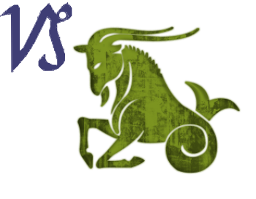The science of astrology is based upon the Balance in Nature which provides that what is above has its equivalent on earth, and that the occurrences below have their equivalent in the sky. Therefore, to correctly judge that which is past, or that which will occur on earth in the future, requires that the astrologer weigh, one against another, the factors observed in the sky, and from them pass an unprejudiced judgment.

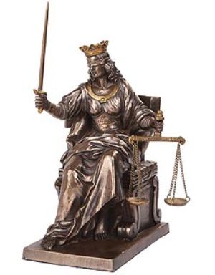When the forces are equally balanced, one against the other, there is no movement. Such inertia, as well as the reflective powers to weigh such influences, is best expressed among the zodiacal signs by Capricorn, the sign which the sun enters when life's forces are lowest and the waters and vapors of earth crystallize into ice and snow. And thus, when the masters of old sought to give a more complete explanation of the astrological significance of Capricorn, than that portrayed by the constellated goat which has a fish's tail, they designed Major Arcanum 8, which commonly is called *The Balance*.

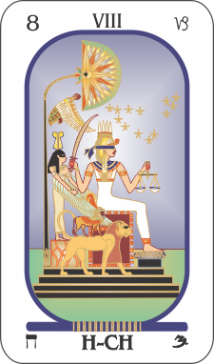

The woman seated on a throne is blindfolded, and in her left hand she holds a balance, to indicate that those who weigh the influences of the stars to determine their effect upon life, should be absolutely impartial and free from prejudice. The sacred serpent thrusting its head from her brow shows that to be a capable astrologer, one must possess a high degree of intelligence. The sword, upraised in her right hand, reveals that what the stars foreshadow may be in the nature of an affliction, or as symbolized by the overshadowing protection seen above it, may be in the nature of a blessing. But whatever their nature, the lances of inflexibility which adorn the crown, demand that there be no warping of reason by desire when judgment shall be passed.

At her side is a lion, symbol of the power which can be used, once judgment is passed, to fit one's life to a higher destiny by taking full advantage of what the stars reveal. And at her side also is a sphinx, the symbol of the passage of time and its recording; as it is for the moment a child is born, or the moment a question becomes clear in the mind, that the heavens are mapped, which provides the factors that must be weighed, one against another, to obtain the sought for knowledge.

This proper timing of the birth of an idea, the birth of a proposition, or the birth of a question, depends upon the sympathetic relation of the human mind to the astral world. That this balance between the positions of the signs and planets in the sky, and the factors stimulated at the time within the mind of man is quite dependable is evidenced by the results obtained through the use of horary astrology. Because horary astrology depends upon this mental balance to a condition existing in the unseen world, it is essentially not so much an exact science as a method of divination. Yet what it lacks in positiveness of method, it more than compensates for in wealth of detail.

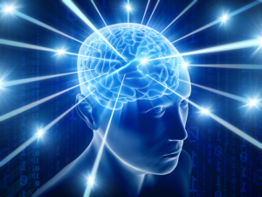The thoughts that enter, or reside within, the unconscious mind of man, are not mere nothings. They are real organizations of astral substance. They obey the well-known Law of Association, which controls all mental processes. They combine to form a plan, a question, an enterprise or an ideal, through definite attractions. That is, to state it in another way: the power of any thought to influence other thoughts depends upon the amount of energy it possesses, and the completeness with which the lines of association have been formed between it and the other thoughts.

If we consider any given thought, then, and suppose that additional energy is supplied to it by a stream of force of like quality from some planet, it will be seen that its power, for the time being, is greatly increased. It, therefore, has greater ability to combine with other thoughts. And if several thoughts receive such additional energy from the planets at the same time, all will have additional combining power, and, due to their temporary strength, they will be likely to move together as a plan, a question, or an idea; that is, as Arcanum 8 portrays, there will be a perfect balance between forces below and forces above.

With so much energy at its command, this plan, question, or idea then probably will make itself prominent in the objective mind. But the important circumstance of this process, which the woman in the act of passing judgment explains in symbolical pictograph, is that by determining the quality and nature of the streams of force that give such a plan, question, or idea power enough to become a cause of serious consideration, we thereby determine the quality and nature of the thoughts so energized. And, in addition, by considering the relationship of these energies, that is, balancing one against another, we can also determine whether or not the plan, question, or idea is harmonious or discordant. In fact, the whole inner-plane relationship is laid bare.

Now while not all things in the four-dimensional world have physical counterparts, all thoughts, objects and conditions of the physical world have a duplicate in the four-dimensional realm. Furthermore, events and conditions that occur upon the four-dimensional plane, tend to reproduce themselves, in so far as the physical environment with which they are associated is capable of such reproduction, unless, before the physical environment has time fully to respond, other and contradictory changes take place in the four-dimensional environment which annuls the first influence.

Those who delve deeply in occult subjects, whatever their other beliefs, are unanimous, because they have observed it so often, in asserting that events transpire first on the inner plane, and later on the physical. Due to its refinement of substance there is freer and quicker interaction between thoughts and entities upon the inner plane. If a serious question, or a proposition, or an event, arises on the physical plane, we may be sure, therefore, that the same question, or proposition, or event has first arisen on the inner plane.

This, then, is the first underlying factor in understanding how horary astrology operates; for if the proposition or question has arisen seriously in the unconscious mind, this has already, before the matter has reached the objective consciousness, directed the unconscious mind to all the factors and conditions related to it. And the unconscious mind, because it occupies the four-dimensional plane, and uses the senses and superior conditions of that plane to apprehend the various conditions, mirrors these various factors in detail, and in their correct relations.

The desire of the unconscious mind to know about the matter has focused its attention on all the factors, as they exist in the four-dimensional realm, and they are present in the unconscious mind in relationships that are proper, much as the image of a future picture is reflected in the “finder” of a camera. They have been brought to a focus all in their proper relation, but they only shadow the future picture; for the picture may never be taken, the exposure never made, and the film never developed.

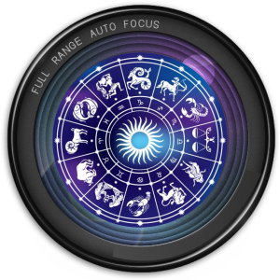Thus, when we earnestly ask a question, we may know that already the unconscious mind has imaged the picture in its “finder.” Unless there are compelling circumstances, if our inspection shows the light to be bad, the background poor, too much movement, or for any cause the composition to be unpleasing, we may decide not to make the exposure – not to do the thing which the horary chart has been erected about – because we recognize that the picture would be a poor one. How good it would be, or how bad, requires a careful weighing of the astrological factors in the chart, and the passing of judgment as to their relative value, as the woman in tarot Arcanum 8 is doing. If, however, the exposure is to be made in spite of the conditions, the “finder” of the unconscious mind, as accurately mirrored in the horary chart, shows just what the developed picture will look like; and the raised sword in the tarot woman's hand quite forcefully drives home the fact that no wish, no hoping it will be otherwise, can change the final picture, the actual event, if action is taken as contemplated when the matter was present in the mind.

The inexorable quality of a properly timed horary figure, explained here by the raised sword, which strikes without prejudice and with no consideration of station, and uninfluenced by sympathy, is still further emphasized by the winged turtle behind and above the seated woman. It is the emblem of repentance, and conveys the thought that those who fail to abide by the steel-cold judgment of the horary chart will live to rue their folly.

And this brings us to the yet remaining unexplained symbol, the crowned and winged being behind the woman; this is a Messenger of Light, a divine being, who represents the almost unlimited vision and the vast powers of the unconscious mind. It is because of its special abilities not only that the picture is properly seen in the “finder,” but also that the question relating to the matter was asked just at the time when the planets in the sky map what the unconscious mind “finder” sees.

When two or more thoughts receive, at the same time, strong stimulation from planets prominently situated, there may be enough energy present to amalgamate them into a plan. If the relation between the planets thus stimulating the thoughts is harmonious, as shown by their aspect, this would favor a harmonious alliance between the thoughts; and a plan that is harmonious in all its part would result. But if the relation between the two planets thus stimulating the thoughts is discordant, through their being in bad aspect, a discordant condition would be present between the thoughts; for the energy received would be inharmonious and disintegrative.

When sets of thoughts thus amalgamate into a plan, or into a definite desire for specific knowledge, if there is sufficient energy present, they rise from the unconscious mind into the objective mind. In the objective mind they generate electrical charges in the gray matter of the brain; but except when there is accessory energy of a similar nature from the planets to intensify the electrical charges which make for objective thinking, the plan is not clear and there is no deep desire for a correct answer to a question.

Thus we may feel quite certain that whenever a plan has been completely formulated, or there is a deep desire for a correct answer to some question about our affairs, that the state of mind so stimulated is due to additional energy, received by the mental factors then brought to our attention, from their corresponding planets. The fact that these mental elements have the power to intrude themselves into objective consciousness so disturbingly indicates that they have acquired, just at this time, an accessory energy supply.

And we may be sure of another and even more important thing: that the relation of the mental factors thus stimulated by planetary energy, is the relation of the planets thus stimulating them into activity. Consequently, by a study of the relationship between the planets at the time a question or proposition becomes clearly defined in the mind, we can learn the relation of the mental factors that are most active at the time.

To make this somewhat easier to understand, let me state the matter somewhat differently: A question, for instance, may be present in the mind in a hazy sort of way for days and weeks; but when the planets in the sky reach stations where they hold the same relation to each other that these mental factors do, these mental factors receive enough additional energy, each from its corresponding planet, to give it clear and precise form in the objective mind. If, therefore, a chart of the heavens be erected for the exact moment a serious question takes complete form, it pictures the relation of the various mental factors within the unconscious mind of the person asking the question. Such is the implication of the Messenger of Light standing behind the woman in the Arcanum of The Balance.

The first factor that gives reliability to horary astrology, therefore, is that an earnest desire to know something indicates that the unconscious mind – the Messenger of Light – or the person asking the question has been focused upon the problem, and has perceived the various images relating to it, as they exist in the four-dimensional realm. These images, which are apprehended by means of the superior senses of the astral body, are of astral records of the past, of present interrelations, of past and present relations moving toward combination in the future, or having already combined on the inner plane, but having as yet had insufficient time to externalize.

The problem, however, does not present itself to the objective mind when the unconscious mind first turns itself to it, because it does not have enough energy to link up with the images in objective consciousness. Anything to get objective recognition must conform to the Law of Association, and connect itself through either Resemblance or Contiguity, with something already before objective attention. Thus, just as a photographer awaits the appearance of the sun from behind a cloud before attempting to see how a picture appears in the “finder,” so likewise, the image of the factors shadowed in the unconscious mind at first lacks the power to make itself felt strongly in the unconscious mind. But when the sun shines rightly in the case of the photographer, and when the planets reach the proper positions in the case of one who unconsciously is pondering a question, energy of sufficient intensity then becomes available to give the image distinct objective form.

And thus do we come to the second factor which gives reliability to horary astrology; which is that a question or proposition that is present in the unconscious mind – that the Messenger of Light carries – does not rise clearly into objective consciousness until the planets and signs are so situated that they correspond to the various elements of the matter, and thus add sufficient energy to them that the Being of Light pictured in the Arcanum is able to deliver his message, and the matter is thrust into the objective mind. Therefore, is it that a proposition or serious question is never born in the objective mind until the planets correspond to its various elements and relations; no more so than that a child will be born and live until the astral vibrations set up by the planets correspond to the astral vibrations within its astral form.

We can consider a horary chart, then, as a map of three distinct, but sympathetically related things: It is a map of the heavens at the time and place a question is clearly formulated; it is a map of the most active mental factors within the mind of the person asking the question at the time the question is asked, just as a birth chart is a map of the more permanent and powerful mental factors which constitute the character; and, because these mirror the various conditions relating to the question as perceived on the four-dimensional plane by the unconscious mind, it is a map of the various factors involved in the question.

But if the picture in the “finder,” that is, the horary chart, is to be the sought-for view, instead of mirroring something else, the time must be precisely ascertained. Properly, this is the moment when a question or proposition first is clearly present in the mind. If a proposition of any kind is presented, either personally or through the mail, the moment its import becomes clear – as explained by the sphinx at the side of the weighing woman – is the time for which the chart should be erected.

In case this time cannot be ascertained it is customary to use the time when the question first becomes clear to the astrologer. The experience of a host of astrologers indicates that this latter method is reliable in a general way; for at this time, also, the matter considered is supplied with energy sufficiently to make it manifest strongly. But when the time of its first clear formulation in the mind is known, this is the time that invariably should be used. It is the true birth of the question.

Thus, precisely timed – for the sphinx contains within its complex form the lion, the eagle, the man and the bull, the quadrant constellations which mark time's passage – a horary chart becomes a map from which an astrologer, through a careful comparison of the harmony, discord and other relations, that exist between the factors, can discern the nature of the past, present and future developments of the matter asked about. This is what the woman in Arcanum 8 is doing; she is weighing each relation against the others.

As she holds the scales, so the astrologer has before him a map of the heavens; but this is also a map of certain related things as they exist on the four-dimensional plane. If he discerns, from this map, that several objects are moving toward a given point, he becomes aware from their rate of movement that in about so long a time they will meet. And from the properties of these things, their velocities, and the angle of their approach, he discerns whether they will meet harmoniously or discordantly. From this he can predict, with much certainty, the various results.

Now it may be that the one making the inquiry is under obligation to take and develop the picture, so to speak. It may be necessary for him to embark upon a certain enterprise whether it is pleasant or not. Or it may be that he has an option in the matter, and need not take the picture unless it is apt to prove pleasing. Therefore, the astrologer should be able to give him an accurate preview, that he may know in advance just what the finished picture, or venture, will be like.

Furthermore, in case he is so situated that he cannot avoid taking and developing the picture, even if in the preview it appears distressing, the astrologer should be able to show him all the details that will help him get the best results from a poor view. The astrologer has watched the taking and developing of so many pictures that have been mapped by planetary positions, that he should be able to advise whether or not the venture is worth the attempt, if attempted what the result will be, and how to get the best result if the attempt be made.

The lion, which also is at the weighing woman's side in the tarot of The Balance, is the emblem of Will, or, to state it astrologically, the key-phrase of the sign Leo is, I will. Placed as it is on this symbolic design, it signifies that some element of choice always is present, and that by using the will, rather than being blindly pushed about, an individual always in some respects can better his fortune. Not that he can warp the external circumstances which will develop, as revealed in a horary chart, if he persists in going ahead with some matter asked about. But usually, seeing what is ahead he can refuse to take a venture, or if he must take it, he can arrange his own affairs so that they will be less seriously damaged by such misfortune as is shown will befall the enterprise.

In other branches of astrology, the same weighing of astrological positions, one against another, is required that is so essential to horary astrology. That is, the balances are needed just as much. But not so much dependence must be placed upon the Messenger of Light which, standing in the rear, spreads its wings until their tips enfold the weighing woman. For in horary astrology, one must depend upon the prompting of the unconscious mind to get the proper timing of the matter to be studied.

In natal astrology, the birth of a child can be timed with a stop watch; and in mundane astrology, mathematics can be used with unerring precision to get the exact moment a heavenly conjunction takes place, or by declination a planet crosses from south to north of the celestial equator, thus starting a new cycle which will have its influence upon world affairs. But in horary astrology one must depend for timing upon so evanescent a thing as recognizing when a thought first became clear in consciousness.

Yet when a chart is properly timed, be it relative to natal, mundane or horary astrology, the factors are there mapped which reveal what will transpire. But to interpret these factors, the Capricorn faculty of reason must be brought into play. When errors are made, the fault is not that of astrology, but the fault of not recognizing the full import of some factor, of not giving it the proper weight, when it has been placed in the scales, such as the woman in Arcanum 8 holds in her left hand.

**Aquarius and the Sage**

**Elbert Benjamine**

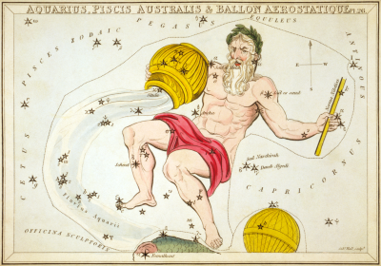

More closely associated with astrology than any other zodiacal sign is the section of the heavens which Uranus rules, Aquarius. To portray among the constellations the application of the stellar science to human life and its problems, it is pictured in the sky as a man, one who gives the impression of having a more than ordinary degree of intelligence. With his left hand he raises the 24-hour gauge to the vaulted dome above, measuring, in connection with time, the various relations or aspects between the heavenly bodies. With his right hand he pours down upon the children of the earth the influence of the stars and the knowledge of their power from an urn which rests against his shoulder.

Such is a clear symbolical pictograph which explains that all things here below are influenced by streams of energy flowing down upon us from the stars; and the wavy nature of this stellar tide, depicted as water flowing from an urn, suggests the influence that thus inundates man and other creatures is of a vibratory nature. And the raised gauge, held by the Man of the zodiac, gives most explicit instruction that the highest function of that intelligence which the Man is used to symbolize, is in measuring these vibratory forces, especially those from the stars, and from these measurements and compiled observations formulating a science which shall be the surest guide of human conduct.

When those who thus traced the high significance of stellar wisdom in outline among the stars desired to indicate the same general thought in brief hieroglyph, what more natural than that they should choose an emblem which at once suggests the means by which the orbs of heaven exert their influence! The wavy lines by which we indicate Aquarius, the astrological sign, is as definite a picture of vibrations as it would be possible for anyone to draw.

Yet there was more which was well worth explaining which is not apparent in the constellation, as unusually informative as it is, and which is not more than suggested in the wavy-line hieroglyph. And to give expression to, and to perpetuate to a far later posterity the most important of these thoughts, the old-time Masters designed Major Arcanum 9 of the tarot cards. It is called The Sage.

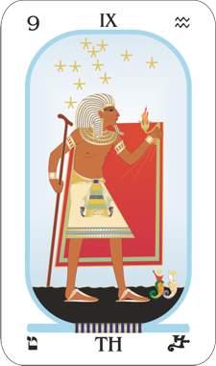It depicts a man of age, who has travelled widely and seen much. This wanderer, an old explorer of Nature’s mysteries, leans upon a staff. The staff, which presents the serpent’s form, is no less a symbol of vibration than are the wavy lines of the Aquarian hieroglyph, for it is through an undulating movement that all such creatures travel. Thus, do we have explained to us that the Sage, at the end of all his researches, has learned to place sole reliance upon the science of vibration; and it is counseled that those who also wish to live in wisdom shall likewise lean upon it and employ it in all their knowledge-getting travels.

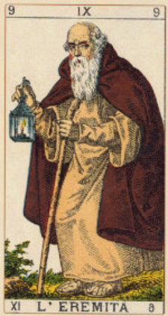The cloak which this wise man wears is of square form, symbolizing the physical world in which man experiences that which he calls good and evil. The lamp which he holds is the emblem of intelligence, shedding its rays over the past, present and future. Being concealed by the mantle indicates the limitations which the physical three-dimensional plane places upon his powers of perception. To the extent he can lift his intelligence above these cloaking limitations, and observe the actions which take place in the four-dimensional realm, does his knowledge of the underlying reality of things increase.

Now let us see just what the ancients intended when they thus gave counsel that wherever man’s footsteps might lead him in the search for knowledge, he should ally the Aquarian knowledge of the stars with the science of vibration, on which the pictured Sage is wont to lean. It is true that the planets in their courses influence man through the vibrations of four-dimensional astral substance. These planetary broadcasts are picked up by individuals according to the aspects which, in the birthchart or by progression, map aerials tuned specifically thus to gather particular vibratory rates. How the individual responds to the vibrations thus reaching him depends upon the thought-cell composition of his unconscious mind. And this in turn is mapped by the signs and planets in his chart of birth.

But planetary vibrations are not the only ones which when they reach the thought-cells within man’s unconscious mind give them the added energy which they need to work from the four-dimensional plane to attract some event of corresponding harmony or discord into the life. Events out of the ordinary, as has been demonstrated in thousands of lives where the birthchart is known and the progressions have been calculated, are only attracted into the life when additional energy of the required kind is added to the thought-cells responsible for attracting the specific type of event. Yet energies of somewhat less volume, but of greater persistence, are being added to the thought-cells at all times, from other than planetary sources. The character-vibrations of objects and the thoughts of people also are four-dimensional energies which affect those closely associated with them in precisely the way planetary vibrations do.

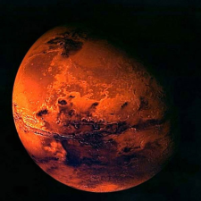Thus, can man, through associating with Mars thoughts, or with objects ruled by Mars, intensify the activity of the thought-cells within his astral body ruled by Mars. And this intensified activity of the Mars thought-cells will reflect itself in his own thinking, in his behavior, and in the type of events which customarily are attracted to him. That is, through their influence upon the factors of his unconscious mind the vibrations from objects and the vibrations from thoughts affect an individual’s fortune in a manner quite marked. But how a certain vibration will affect a given individual cannot be determined from the vibratory rate alone. Additional Mars vibrations, for instance, may be just what one person needs to make him prosperous, while they may attract accident or death to another.

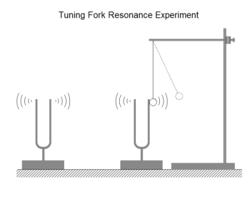If we are to use the knowledge of vibratory influences as the staff upon which to lean in all our research and practical endeavors, we must understand the vibratory quality not merely of the energy added, but also the vibratory quality of that which is affected by it. And this is possible, even as the science of vibration as explained in the tarot is wedded to Aquarius, the sign of astrology, only by in each instance signifying the nature of the vibratory rates in astrological terms.

As an instance of what is meant take numerology: in most systems of numerology the name is used as a divinatory instrument. And because divination may be approached from so many angles and yet give good results, it does not follow that any of the different systems of numerology are valueless. No more so than that Horary Astrology, which is a method of using astrology for divination, is valueless. Divination of various orders has its proper function in giving otherwise inaccessible information. But the use of the name as a vibratory influence that affects the individual wearing it in a particular way is not related to divination. Nor can there be more than one interpretation which is correct, of the vibratory force exerted by a particular name as affecting a given individual. The vibration of a name, or of a number, is a positive thought-force of a definite quality; as much so as that light-vibrations of a certain frequency give rise to the color blue. You cannot correctly call blue red, yellow, green or some other color.

You will note that I am here speaking not of the three-dimensional sound vibration of a name, for the name vibration is quite as potent when it is merely thought as when it is spoken. When people think of us by name, whether that name is spoken, whether it is a matter of reading our signature at the bottom of a letter, or merely that our name flashes into their minds, they usually, at least vaguely, visualize us. Or if they do not know what we look like the reading of a letter from us serves the similar purpose of focusing their minds so that their thoughts travel directly to us.

When speaking or reading our name people think about us, either clearly or vaguely, and the vibratory rate of the name is radiated from their minds to our own. Thus, we receive a thought-wave coming directly because at the moment their minds are trained on us. And whatever the vibratory rate of the name thus wafted to us may be, the impact of it adds energy to thought- cells within our unconscious mind which have a similar vibratory key.

Thus, quite apart from its sound, a name has a definite four-dimensional vibration which is radiated to the individual by everyone who thinks of him by that name. If different people think of him by different names, they thus bombard him with different types of thought-vibration. But because an individual usually thinks of himself by the name he customarily uses as his signature, and because the thought-vibrations of the person wearing the name probably have more influence upon him than the combined thought-vibrations of all others who think about him, the way an individual signs his name becomes very important as a vibratory influence in his life.

If such a signature were something unalterable this would be an interesting but not very useful fact. But as a matter of observation, it is quite common for people in all walks of life to use a different signature at different periods in their life: using an initial instead of a given name, dropping the use of a middle name or initial, or even changing the spelling of the name. A woman when she marries, and therefore coincident with a marked change in her fortune, commonly changes her name. Others also, who change the spelling of their names, or alter their signatures, are discerned to change in fortune coincidentally. A change in name is nearly always accompanied by a change in life.

Writers quite commonly use a pen name, and actors more frequently than not use a stage or screen name. And these names by which they are known to the public not only influence them according to the key of the name, but also from a divinatory standpoint often markedly differentiates their public life from the private life in which they are known by another name.

Thus, as Arcanum 9 pictographically implies, the practical application of the knowledge of thought-vibrations, character-vibrations and astrological-vibrations is in selecting those invisible influences which assist to bring into the life the things which are desired, and which prevent attracting events and conditions which are undesirable. Yet one cannot know, by a positive method, what types of astral vibrations will prove beneficial and what types detrimental, and in what way this benefit or detriment will manifest, without a map of the unconscious mind such as is furnished by the astrological birthchart. But with the astrological birthchart at hand it can at once be seen just what the effect will be upon the life of stimulating into unusual activity any particular section of the astral body, or any particular group of thought-cells within the astral body. Even the connecting aerials, or aspects, between such groups of thought-cells are there clearly shown, so that the effect upon other departments of life through secondary influences can also be determined in advance.

A scrutiny of an astrological birthchart will reveal to anyone who has even a slight acquaintance with astrology just what zone of the astral body, or what thought structure, it is advisable to give added force. If the individual wishes to attract favorable conditions in some special line, a glance at the birthchart will reveal what influence there shown most pronouncedly is beneficial to it. Then by stimulating this influence, by using a name having the same key-tone, and by having things in the environment which radiate the same key-tone, the activities of this favorable influence can be built up in a manner that will markedly attract the condition desired into the life.

The changing of the name, it will thus be seen, if the change causes the name to vibrate to a different thought-key, adds the thought-energy of all those who think of this name in connection with the individual, to some different section or center in the astral body, and this causes a change in the fortune commensurate to the transfer of energy thus affected. Unless the individual wishes specially to stimulate some one thing in his life in a favorable manner, the best plan in selecting a name or the objects and people of the environment is first to find what influence in the birthchart is most fortunate. It may be desirable to give the added intensity to a section of the astral body not occupied by a planet because the department of life it rules may be deemed more important. When this is the case, the favor or disfavor that may be expected from such stimulation is determined by the strength and harmony of the planet ruling the sign governing the zone thus selected. Thus, in seeking what influence will conduce most to the general good fortune the best planet in the chart should be selected.

If possible, the name should then be spelled, abbreviated, or otherwise altered, so as to have the same key as the best planet or zodiacal sign thus selected. If the sign is occupied by a planet, however, accentuating the sign chiefly increases the influence of the planet in the sign, and the influence of this planet should thus be given first consideration. Usually without much alteration a name may be given such spelling or abbreviation as to cause it to vibrate to the key which has been selected as most desirable. And while at first thought it may seem that using a name in business, for instance, different from that conferred at birth is exceptional other than in a few professions, yet a little reflection will indicate that most people in business abbreviate, or otherwise alter the name, in using it as a signature.

And because people become familiar with this signature it becomes more strongly associated in their minds with the person using it than any other name. The person signing himself in a given way, because he writes his name thus, and both makes and sees the signature, comes to think of himself according to the signature as written. And the name by which an individual thinks of himself, because his own thoughts are more powerful to influence his life than others’ thoughts, is commonly the most important name of all.

Therefore, because the business signature determines the thought- vibrations sent him by those who see this signature, and the thought- vibrations which he generates when he thinks of himself by name, it should be selected with an end in view of stimulating some department of life as desired in a favorable manner. This is done by selecting for a business signature a name the vibratory key of which corresponds to the sign or planet in the birthchart most favorable to the department of life it is wished to strengthen.

The vibratory key of either an object or a thought is the same as the vibratory key of one of the twelve zodiacal signs or one of the ten planets. Although the ancients were unable to see the three upper-octave planets with their physical eyes, they nevertheless maintained, and fully recorded in the tarot and in their mythological stories left to us, that there were ten distinct influences in the planetary chain. The tenth planet, Pluto, however, closes the previous sphere of influence and commences a new gamut. Neglecting this transitional influence of Pluto, there are 9 root planets.

These 9 root planets express themselves also by virtue of overtone qualities, in keys that are denoted by the 12 zodiacal signs, in addition to the transition function of Pluto. Thus, the principle expressed by Venus expresses also in a distinctive manner through two other key influences, the sign Taurus and the sign Libra, and the principle expressed by the Moon expresses in another key influence, through the sign Cancer. But the number of such key influences is not unlimited, as shown by the fact that all things which we are able to discern can readily be correlated to one of 22 distinctive keys. That is, everything we contact, including names, numbers, colors, birth stones, people and environments, correspond in vibratory rate to one of the ten planets or to one of the twelve zodiacal signs.

It is true that the vibration of a planet has some influence on the department of life mapped in the birthchart by the signs it rules, and that the vibration of a sign has some influence on the department of life mapped in the birthchart by the house containing its ruling planet. But the chief influence of either a thought or the vibration of an object which belongs to a definite astrological sign is upon the section of the astral body mapped by that sign; and the chief influence of either a thought or the vibration of an object which is ruled by some planet is upon the thought-cells mapped in the unconscious mind by that planet. Therefore, the ancient wise ones who designed the tarot pictures to explain how astrological forces operate, while recognizing 9 root influences, insisted that due to what we call overtone effects on the four-dimensional plane, which is the plane from which thought-vibrations, planetary-vibrations and the character-vibrations of objects exert their influence, there are 22 distinct keys.

Consequently, to determine how any four-dimensional vibration will affect a given individual it must be determined to which one of these 22 vibratory keys it belongs. Then by an inspection of the birthchart it can be seen from the harmony or discord of the thought-cells of the same key within his astral body, as mapped by a sign or planet, what the effect will be of adding more of their own kind of energy to them.

This four-dimensional vibratory key, which is that of the sign or planet ruling them, is known for a great many things. Research is from time to time adding to such knowledge. We know, for instance, that the key of New York is 18 (the sign Cancer), that the manufacturing section of any city has a key of 13 (Aries), that the key of the country France is 19 (Leo), that banks, safes, vaults, cash registers, and places where money and securities are kept have a key of 14 (Taurus), and that land devoted to grain fields, orchards or other crops has a key of 2 (Virgo). Any definite train of thoughts, can by one versed in astrology, be allocated its particular key. Those of love, for instance, belong to the key of 6 (Venus) and those of war and destruction belong to the key of 16 (Mars).

But when we come to names of individuals and to such abstractions as numbers, we can determine their keys only by reducing their component parts, not to a number relation below 10, but to permit of the overtone effect on the four-dimensional plane, to a number relation below 23. The square formed letters of the Chaldeans and the square formed letters of the Egyptians were numbers as well as letters; and these numbers and letters had had their vibratory key determined by those who first used them. In fact, the 22 letters of those alphabets were designed to form characters which should express in writing the influence of the 12 zodiacal signs and the 10 planets of the chain.

The letters of modern languages have their equivalents in these old square-formed letters and numbers, so that we can, without difficulty, determine to which sign or to which planet any letter belongs, and this gives us it vibratory influence. Or in the case of a name, by adding the numerical equivalent of the letters, which due to the function of the decave is not so arbitrary as it appears, and perhaps adding the digits again, until a number is obtained below 23, the vibratory key of any name can be obtained. Or by repeatedly adding the digits of a number until a number is obtained below 23, the vibratory key of the number may be had.

In this place I am not attempting an explanation why this is true; merely pointing to the method which should be followed. Furthermore, tones, colors, minerals and various other things also have an influence through their four-dimensional vibratory rates which can be determined by their vibratory keys.

And in addition to relating this unusually important matter of the vibratory key, through which human life is influenced, each one according to the vibratory factors already incorporated in his character, to the astrological sign Aquarius, these wise men who designed the picture of the Sage most appropriately also correlated it with the number 9. For, as will be explained in the next article, it is through the peculiar attributes of the number 9 that the key for such intangible things as names and numbers can be calculated.

**Uranus and the Wheel**

**Elbert Benjamine**

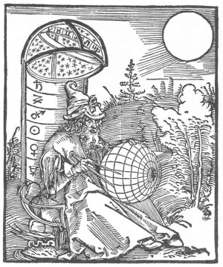

To what extent the ancients were aware, even through psychic channels, of a planet beyond the orbit of Saturn is difficult at this time to determine. But that they knew there was a special principle and an influence, such as modern astrologers attribute to that planet, is quite certain from the fact that they portrayed the mythological character of Uranus as possessing the most outstanding characteristics of the planet of that name.

In birthchart analysis, the most commonly recognized influence of Uranus is that pertaining to the plane occupied by the department of life ruled by the planet. Relating to the things ruled by the house in the birthchart occupied by Uranus, the individual tends to have advanced ideas, or at least ideas that are quite different from those by whom he is surrounded.

One could mention outstanding people in every profession and almost every occupation who have broken from tradition, and have made unusual contributions to the line in which they were interested by some quite new method of procedure, who have Uranus exceptionally prominent in their charts of birth. And one could also cite the charts of cranks, eccentric characters, and would-be reformers, as indicating the influence of a prominent* Uranus in the chart of birth to impel the individual to seek a different mental level from that held by most; for the level on which the Uranian functions may be either above or below that occupied by the average.



Furthermore, it is common astrological observance that the progressed aspects to Uranus bring changes into the life which leave the individual, when the aspect has passed, on a quite different plane than he occupied before. Either in station or in mental attitude, after a strong progressed aspect to Uranus, one’s life is never the same as it was previously.

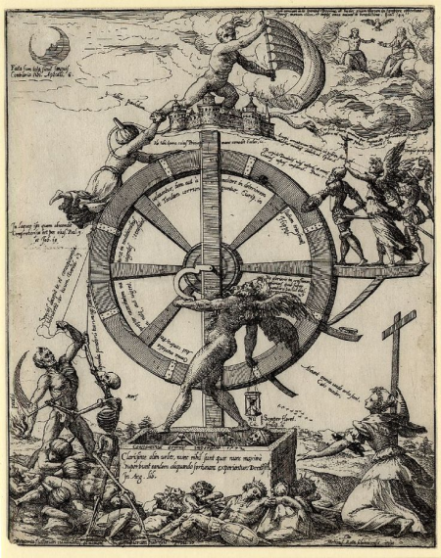Observing a heavenly influence which gave rise to abrupt changes, after which life always functioned on either a higher or a lower plane of existence, the old-time masters of astrological science designed Major Arcanum 10 of the tarot with intent to give it, in terms of symbolical pictograph which should not change with races or the passing of years, a rather complete explanation. This Arcanum, called The Wheel, portrays the influence of the planet we know as Uranus, and the universal principle which that planet rules.

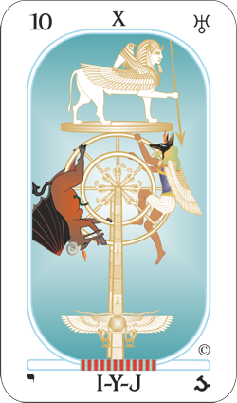The four-fold sphinx, on a platform above the wheel of change, as embracing the Lion, the Eagle, the Man and the Bull, and thus the four revolving quadrants of heaven which measure duration, indicates the passing of time. The circular platform on which the sphinx is mounted represents the zodiac, through which the progressing planets move as time so passes. The javelin clasped in the paw of the sphinx makes an angle with the zodiac, and is poised in the attitude of being ready to strike, either to the right or to the left, much as the progressed aspects, consisting of angular relations between the planets, move events in our favor or in opposition to our wishes. Uranus, as has been determined by The Brotherhood of Light, in a study of the birth charts of 100 outstanding astrologers whose time of birth is known, more than any other planet, gives an interest in astrology. It was prominent in all 100 charts.

The two serpents and the two wings at the base of the column supporting the wheel, imply polarity; a division into positive and negative. And more than any other planetary influence, Uranus tends toward one extreme or the other, often reversing the mental attitude, or the trend of life, when a progressed aspect to the planet forms. It rules electricity, and especially relates to alternating current.

The platform of the zodiac on which stands the sphinx, quite definitely also is a plane, or level of existence. And as the javelin held by the sphinx makes new aspects, due to the passage of time, it impels the wheel to turn, lifting either the genie of light or the genie of evil, which are pictured on the circumference of the wheel, into supremacy, and thus placing the life on a new and entirely distinct level, represented by the zodiacal platform above. And this, as I have taken some pains to illustrate in connection with the lives of certain remarkable people, is precisely the influence a strong progressed aspect to Uranus has on human life.

But there is far more in the wheel than that. There is far more, as a matter of fact, explained in this Major Arcanum than we with our present knowledge of occult matters can comprehend; for much of that set forth in symbolical pictograph relates to the properties of things and forces on a higher, and four-dimensional, plane. People with the planet Uranus prominent, at times are able to see clairvoyantly, which is by means of four-dimensional sight; and they frequently become interested in the astral, or four-dimensional, plane. But our capacity for understanding four-dimensional existence, due to our restricted contact with any but the three-dimensional plane, is necessarily limited; and this Arcanum 10 goes far beyond such limits.

Even our most erudite electricians’ express ignorance of the explanation of some of the properties of alternating electric current, which Uranus rules, and it is merely on the boundary between the three-dimensional and the four-dimensional plane. They can devise certain formulas which permit them to predetermine what results will follow certain definite conditions, even as we can devise certain formulas which will permit us to determine, for instance, the effect upon an individual of a given number or a given name. But this is quite a different thing from understanding the details of the process involved.

A current of electricity flowing over a wire develops an electro-magnetic field of force at right angles to the direction the current is flowing. When the current ceases to flow, the field of force closes back on the wire. None of the energy is radiated into space. Nor with alternating current, such as is used to carry power to distant points over wires, is any of the energy of the field of force lost by being radiated into space. It all folds back on the wire when the current ceases flowing. But increase the frequency of the alternating current sufficiently, and for some reason, which electricians do not attempt to explain, some of the energy of the field of force keeps on going, and assumes the form of waves such as are used in radio transmission.

I mention radio waves here because, like a life which has experienced a powerful progressed aspect to Uranus, they occupy a plane, or level of existence, quite distinct from electrical fields which have not thus had the frequency of the currents which are responsible for them, intensified.

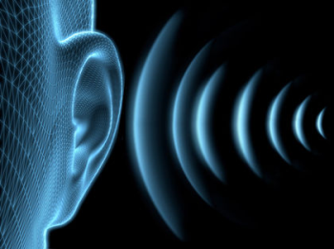

The levels of expression which relate to sound and the things more commonly contacted in three-dimensional life, repeat on a sequence of eight. That is, the gamut of physical existence seems to be complete in seven, the eighth note, or octave expression, merely sounding the same tone on a higher level. But this is not true on the mental or four- dimensional plane; as Arcanum 10 clearly sets forth. In that realm, where planetary energies and thoughts are the potent factors, the gamut consists of nine tones, the tenth, or decave, expressing the same tone on a higher level.

In the tarot design, we see the upright post representing the figure 1, and the wheel, which is circular in form, representing the 0, which by itself stands for nothing, but in proximity to the 1, gives the number significance of 10. That is, a four-dimensional root tone, such as is expressed by any one of the 9 digits, when sounded on the next higher level, represented by the platform on which stands the sphinx, is then indicated by adding to it the cyclic symbol, or 0.

According to the doctrine handed down in the tarot, for there are 22 Major Arcana, one explaining the influence of each sign and each planet, there are ten planets in the chain. One, however, exerts a transitional function; and neglecting this, represented by Pluto, there are 9 root planets, just as there are 9 numbers before the addition of the 0 shows the influence of one of them carried to the next higher decave.

That is, the system of numbers in common use is based upon ten fundamental principles, the tenth influence closing the cycle, and starting a new gamut of existence. The 0 shows the completion of the cycle, and the 1 indicates that the first influence has been carried to a new plane, or phase of being. Thus either with planetary influences or with numbers, each essentially a four-dimensional vibration, we work with 10 separate characters, but there are only 9 root influences.

Any number above 9 is merely some root number, to which 9 has been added a given number of times. The number of times 9 thus has been added determines the plane, such as that occupied by the sphinx in the picture which stands above the post and the wheel, signifying number 10. This adding multiples of 9 to some number is called Theosophical Evolution, not because it derives from any particular group of people, but because Theosophy means Divine Wisdom, and because in its particular function the number 9 is the key to Divine Wisdom so far as numbers, cycles and four-dimensional influences are concerned.

Due to this particular function of the number 9, when a number higher than 9 is given, instead of dividing it by 9 repeatedly until a remainder less than 10 results, and thus obtaining its root, the same result may be obtained merely by repeatedly adding the digits of the number until there is but a single digit. Thus the process used by numerologists is not so arbitrary as it appears, but is based upon sound mathematics and the relations of four-dimensional vibrations. That is, the adding of the digits is but a short-cut method of dividing the number by 9.

Dealing thus with numbers, we are considering mere abstractions. But when man thinks of a number, a name, or anything else, his thought is not an abstraction, but a definite astral vibration radiating outward. The astral counterparts of objects also radiate definite astral vibrations. And astral vibrations, as well as physical vibrations, and those vibrations of the ether known as light and radiant heat, have an influence upon the things they contact.

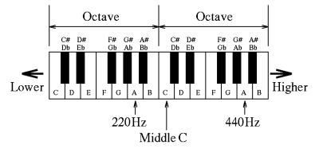

The tones of musical instruments are other vibrations with which we are even more familiar, and which have many parallels to the astral vibrations of thought. For even as a musical composition has a key, so every train of thought has its key and influences its surroundings according to this key vibration. And each simple thought is a definite vibratory rate of physical substance.

With physical tones, if the vibration is increased to a certain degree, the same sound repeats itself on a higher level. Raising the vibration still more causes the tone to be produced on each of many higher levels. We commonly call each of these higher levels an octave expression of the tone, because it was customary to use the diatonic scale in which the interval between one tone level and the next was divided into seven divisions, so that the eighth (octave meaning eight) repeated the tone on a higher level.

Now a thought has a vibratory quality very similar to a tone, except that it expresses in four-dimensional substance, that is, in astral substance; and a thought can be sounded on different levels, just as a tone can thus be sounded. But it has been found convenient, and more in conformity with natural principles, as explained by Arcanum 10, to divide the interval between one thought-tone level and the next, not into 7, but into 9 divisions, so that the 10th shall express the same tone on the next higher level. The Arabs, from whom we derive our numerals, were at one time the outstanding students of stellar science, as witnessed by most of the stars bearing Arabic names. And our system of numbers, based on ten, is the most convenient for handling stellar influences and thought vibrations. Therefore, following the instructions given on Arcanum 10, instead of calling the interval between a fundamental thought and its expression on the next higher level an octave, we call it a decave (decave meaning ten).

In the notation, analysis, and charting of thoughts as vibratory tones which possess a power to influence human life, therefore, we have 9 root tones. But even as in music overtones play an important part both in composition and in the effect produced, so with thought-tones, there are peculiar over- tone effects that make it necessary to employ not merely 9 fundamental characters to express accurately all thought-effects; but to consider as distinct factors certain dominant overtone effects that observation shows to occur in the levels just above the 9 root tones. Thus to chart a train of thoughts it may be necessary to employ as many as 22 different characters.

Because thought-tones are vibratory rates in the fourth-dimension, we cannot follow the comparison with physical vibrations in too great detail. New properties are present in four-dimensional substance. But we can point out that with a thought-vibration the overtone quality is dominant from 1 up to tone 22, and that not only any one of the 9 root-tones, but any one of the 22 types of thought-vibration, can express its individuality on a higher vibratory level, or Decave.

Thus, as Arcanum 10 teaches us, in considering not merely thought- vibrations, but character vibrations and astrological-vibrations, because these are all four-dimensional vibrations, we cannot confine ourselves merely to 9 root tones, but, due to the peculiar overtone properties of astral vibratory rates, we must give full tone value to 22 different qualities, which properly can be called four-dimensional keys.

Every thought, every train of thought, every individual, every influence from the firmament and every force in nature, therefore, because its astral nature is thus tuned, vibrates to one of these 22 four-dimensional keys. And because each of the 22 key-tones may sound on various higher vibratory levels, or Decaves, in order to find the key to which the thought of a number, for instance, vibrates, it is necessary to reduce, or involve it, by subtracting multiples of 9. This may conveniently be done by adding the digits together until a number is obtained which is less than 23. This number is the key of the number considered, and in turn is allied to one of the 22 astrological vibratory rates, from which may be determined the kind of influence it will exert upon anything associated with it.

**Neptune and the Enchantress**

**Elbert Benjamine**

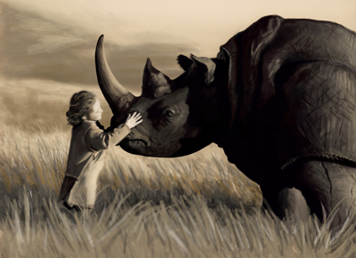

Ideals are ruled by Neptune. They imply a use of the imagination. And no others can exercise their imaginations for weal [well-being] or for woe half so potently as those in whose birth charts the planet Neptune is unusually prominent. Such have the ability not merely to image things vividly in their own minds, but also possess an exceptional power to convey such images convincingly to the minds of others. By the power of mental images, so conceived as to give the proper suggestion and otherwise unreinforced, Neptune minds are able to manipulate the desires of those they contact and thus control their actions.

Uranus, which is prominent in the birth charts of all orators, as determined by The Brotherhood of Light in an analysis of the birth charts of jury lawyers and politicians of the speech making type whose hour of birth is known, sways people through the electromagnetic field of force such persons radiate from their high-tension nerve currents. These etheric energies invade the nervous systems of those in their presence, generating similar electric currents in them, which for the time being dominate their thoughts. More subtle methods may, or may not be used, but the chief avenue by which an individual of the Uranian type influences the thoughts and conduct of others is through magnetic control.

Pluto, when prominent in a birth chart, generates electrical energies of higher frequency and shorter wavelengths than either Uranus or Neptune. They are specially adapted to long distance transmission, or even to communication between the astral and the physical plane. But they rely on vigor and force to accomplish their result, rather than upon the infiltration of some image such as Neptune commonly employs. And all too often, whether between planes or merely between those on the earth, the demands of Pluto are accompanied by a threat. Too frequently there is the implication: “You do this, or else!”

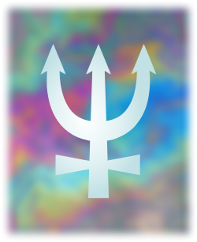

Neptune, however, operates in a very different manner. He conveys, either to the conscious mind or to the unconscious mind, an image which by its power of suggestion shall enlist the desire-energies of the unconscious mind and by diverting them toward the realization of this image, brings about that which has been decided. Neptune uses no violence and no display of force. It relies upon the quiet power of suggestion, which often is conveyed from one mind to another without the recipient being aware that his actions are being influenced.

The fifth house of the natural chart is the house of love affairs and pleasures and it is ruled by the sign Leo, symbolized among the constellations as a Lion. Thus, the Lion became a universal symbol of desire and is so used repeatedly in the Bible. When the desire was spiritual the king of beasts was represented in his beneficial sense, as when Christ is termed a Lion of the tribe of Judah; but when the desire was gross, such as leads to destruction, the beast was shown antagonistic, as when the devil is mentioned as a roaring Lion.

When, therefore, Samson, in love with a girl, was met by a young lion which roared against him it is to be inferred, especially as his parents disapproved, that he was beset by passions which raged within. But as is set forth at considerable length, his life up to this time had been without blemish in thought or action, his mother being carefully instructed even before his birth. Thus was the young lion easily conquered and whatever his thoughts for the moment may have been, they were quickly vanquished by suggestive images of a more spiritual kind.

Whatever house of the birth chart Neptune occupies, the department of life thus ruled is in some manner dramatized; and dramatization is due chiefly to suggestive appeals to the imagination which enlist the desires and thus give rise to emotion. People who have Neptune in the house of business, for instance, have ability as promoters, because they can convey the images of hoped for results effectively to the minds of other people and enlist their desires, symbolized by the Lion of Arcanum 11, sufficiently to cause them to invest money.

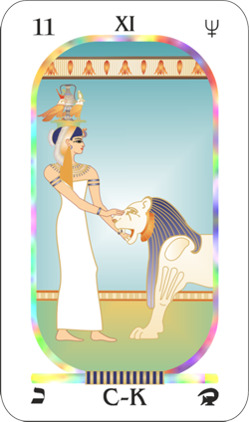

When the ancient masters of stellar science, recognizing this principle, which we now know to be mapped in a birth chart by the planet Neptune, decided to hand down some explanation of it to far distant posterity through the language of symbolical pictograph, to indicate the mildness of suggestions which have almost irresistible power, they pictured them as a maiden.

Neptune is the higher octave of Venus, the planet of love. Therefore, is the crown which the maiden wears surmounted by a vase, which is a symbol of the affections. And as Neptune tends to idealize and to bring a renunciation of the lower aspects of sex, this vase of the affections is still further crowned by eagles to indicate the trend which Neptune imparts toward spiritualizing love.



The eagles are two in number, to indicate the longing which a prominent Neptune stimulates, especially when in the house of love or the house of marriage, for an ideal mate. These inner longings which Neptune gives when his influence is felt in reference to affectional matters, often are not fortunate in this practical workaday world; for such inner promptings give a feeling that somewhere is a true spiritual mate and could he be found that soul would respond to soul in ecstatic harmony and quite apart from expressions which are physical.

Yet we live in a physical world and if we are to be successful in it we must adjust ourselves to its requirements. But regarding those things in our lives which Neptune by its house position in our chart of birth rules, we are apt to live in an imaginary and ideal world. If Neptune is in the house of marriage, for instance, we endow the partner-to-be with all the attributes which we desire he should possess, we build an ideal image and worship at its shrine. And because we have expected so much our disappointment is proportionally greater when harsh reality intrudes and we find that which we had deemed to be perfect, full of imperfections.

The world of physical reality, with its sharp corners and jarring contacts, often becomes too painful to the supersensitive nerves of those with Neptune unusually prominent in their birth charts. Weary of the conflict to adjust themselves to conditions which to them are full of pain, they flee from that which has become so disagreeable. The typical introvert always has Neptune prominent in his chart of birth. And when the mental planets also are afflicted such an individual in his flight from reality may suffer a nervous breakdown, develop some peculiar phobia, or even live so completely in a world of his own creation that he becomes quite helpless and a burden on society.

Those who become nuns and monks, who renounce the world and its temptations for what they deem to be a spiritual life, usually have a prominent birth chart Neptune. Not only must one have ideals to become a saint, but one must, through the suggestive power of those ideals, strongly influence the lives of many others.



Progressed aspects to Neptune, even those considered harmonious, frequently bring some renunciation or separation. The individual, seeking some more ideal condition, or grown tired of the sensual and gross, leaves the environment he previously has occupied. Perhaps he separates from old-time friends, renounces love in its more physical aspects, retires from business or makes something of a hermit of himself. It is seldom that a strong progressed aspect to Neptune passes without some renunciation. The new energy received by the thought-cells within his unconscious mind mapped by Neptune give them greater activity and they express it through increasing the desires for that which is Utopian in reference to the things which Neptune rules in the chart. To realize that which the individual at the time believes to be more ideal he must relinquish less satisfactory things which he already has.

When the desire-energies are enlisted in a cause, as they are the motive force behind all organic activity, action for the cause necessarily follows. And nothing seems so potent to divert desire-energies into a decided-upon-channel as properly applied suggestions. The Lion pictured in Arcanum 11 is the symbol of desires. And the maiden in this tarot picture called The Enchantress is portrayed as opening and closing without effort, with her hands, the jaws of this angry lion. Thus, did those who designed the picture convey the information to those willing to read that the power of Neptune, working through suggestion, lies in the proper manipulation of desires.

Let us consider this power in the light of recent investigations; for we now know that the desires of the thought-cells and thought organizations within the astral body are not merely the source of our three-dimensional behavior, but also of those four-dimensional activities which attract events into the life. To the extent they are energetic do they attract the attention of the unconscious mind and to the extent the attention is thus called to those images by which they can be realized, are their energies released in that direction.

For instance, a sensation arriving from the external environment, an emotion released by a thought, a statement received as a suggestion, associates with certain thought-groups already in the astral body, giving them temporarily new energy, and temporarily thus increasing the power of the desires in the group to such an extent that action, both three- dimensional and four-dimensional, results. That is, whatever desire is temporarily dominant determines what images shall be presented to the attention. Desires which at the time have less energy, perhaps through not connecting up with some external source such as an objective thought or visual image, receive proportionately less attention.

Now let us consider that throughout its biological past the unconscious mind has been conditioned, or trained, to release desire energy in the direction of the image or thought which was the focus of its attention. In fact, attention is the focusing of desire energies. To the extent past associations permit the thought-cells and thought organizations within the astral body to be connected up with the image then present, are there desire energies temporarily diverted into an attempt to fulfil that image.

Thus, it is that whatever image is the subject of attention, both the three- dimensional activities and the four-dimensional activities tend in its direction. They strive for movement to make the picture a reality, whatever it may be, because throughout all its past the soul has given orders to its various parts and to its physical organs and functions by using the language of such pictures.

Few things are of greater importance than that which The Enchantress design teaches, not only in the application of suggestion but in the use of thought for any purpose: to realize that to the extent a given image is able to attract the attention of the unconscious mind, is there three-dimensional and four-dimensional movement toward that image.



The desire energies are diverted into the image irrespective of whether it is something beneficial or destructive. It is not for the thought-cells and thought groups of the unconscious mind to discuss the merits of the matter. They have been trained to release their energies in the direction of whatever was before the attention, and this they do. Only to the extent other and contrary desires are able to capture some portion of the attention of the unconscious mind are they able to release their energies in activity. But if they are strong, they keep continually tugging to get some share of the attention and thus enough supplementary energy to enable them to work.

Resemblance closely associates opposite images. Black is thus associated with white, sweet with sour, pain with pleasure, moving forward with running away. So that unless a suggestion is applied with some consideration for the manner in which the unconscious mind already has been conditioned or trained, instead of bringing the suggested image or course of activity, to the attention, the previous associations may readily bring before the attention the opposite image. Suggested bravery thus may bring to the attention of the unconscious mind the image of cowardly actions that have been taken in the past and still further condition the individual in the direction of cowardice. Suggested health may bring before the attention of the unconscious mind the various images of illness in the past and Condition the individual still further in the direction of illness.

Therefore, in the application of suggestion, that it may not have the opposite effect from that intended, a technique must be employed that will ensure that the attention is directed to the proper image. This technique should be such that little conflict is developed. And it should as completely as possible hold the image vividly and persistently before the attention of the unconscious mind. It is because people with Neptune prominent in their birth charts see such images more vividly than other people do that they respond more readily to suggestion, and have the power to influence others through the mental pictures they encourage.

The most satisfactory condition for getting the complete and undivided attention of the unconscious mind to an image or idea is when, through some process, the objective mind is placed in a state of quiescence so that the reasoning process is stopped. Reasoning brings a succession of images, the process requiring a weighing and comparing of different viewpoints. To the extent therefore, that the critical faculties are thus active, is the attention moved from one image to another.

Furthermore, in reasoning, the energies of the unconscious mind – the desire-energies of the thought-cells and stellar organization pictured by the Lion whose mouth the maid in Arcanum 11 manipulates – are connected by energies with the brain cells and flow strongly outward. This outward flowing of the energies, commonly called being positive, is unfavorable for permitting any image to impress itself upon the thought organization.

That is, when the energies are flowing strongly outward, as they tend to do in objective thinking, that activity hinders the reception of a thought or image by the unconscious mind. But when the objective mind is relaxed, the thought or image meets no such outward energy. The person then is said to be in a negative state, and the image or thought, meeting no resistance is able strongly to impress the unconscious mind. Thus, it attracts a large amount of the unconscious attention.

It is not necessary that a person should be asleep or hypnotized to be open to suggestions. The hypnotist gives his commands, once his subject is asleep, in a positive and forceful tone of voice. And because they are thus positive and forceful, they the more surely register and attract the attention of the unconscious mind. Yet when a person speaks to himself in such a forceful manner, he is almost sure to be exercising his objective mind. That is, his energies are radiating outward, and he is not in a state of reception.

Instead of being so vigorous, if the individual will relax and permit himself to become drowsy, or at least in a dreamy state of consciousness which is on the borderline of sleep, and repeat the suggestion to himself in a droning sing-song voice, or think it over and over with barely enough energy to keep the thought present and thinking of nothing else in particular just let the mind drift, he will be using the best method to cause the suggestion properly to register.

At night, just before going to sleep, while in that state when objective thought has almost entirely ceased, or in the morning while between the sleeping and the fully awakened state, is commonly the most convenient time to attain this negative condition in which the unconscious mind is most receptive to suggestion. As long as thoughts about the day’s work flow through the mind, or as soon as they commence in the morning after waking, the energies are radiating outward and the receptivity to that extent is hindered.

Clinics where suggestion is employed therapeutically have found that suggestion commonly can be applied quite as effectively without inducing the hypnotic sleep. And by observing the necessary conditions, such as avoiding statements that set up conflicts or such as encourage an image which is the opposite of the effect sought, and by applying the suggestion while the mind is free from radiating thoughts but instead is on the borderline toward the sleeping state, the individual can apply suggestion to himself quite as effectively as it can be applied by another.

Suggestion, to which Neptune people are peculiarly susceptible, and which they also most effectively can apply, gains its force through the age-old habit of the unconscious mind to divert as many desire-energies – symbolized by the Lion in the picture – as possible into the performance of the act, or into the establishing of the condition, which is held before the attention.

To the extent other images or desires claim the attention of the unconscious mind is energy drained from the one image into them. Thus, the proper application of suggestion requires a technique in which the image decided upon is presented to the unconscious mind without connecting up, or bringing to the attention, images or desires which are opposed to its realization. The more completely the image is able to dominate the attention of the unconscious mind, the more desire-energy from non- opposing thought groups is made available for its use. Such are the teachings, set forth in a modern language, which the ancient sages sought to depict in reference to Neptune, by The Enchantress who so easily makes the Lion do her bidding.

**Aries and The Reaper**

**Elbert Benjamine**



Those of the olden time, as well as investigators more modern, had become convinced that life is an unending succession of experiences in constantly evolving new forms. The destruction of the old was, in reality, also the commencement of the construction of the new; and both destruction and construction, in their more active expressions, were ruled by the same planet, Mars. This is the planet of energy, relating to war. But it equally relates also to the healing art and to surgery, by which those who otherwise would perish may be given opportunity to live.

This is not just a theory derived from symbolism and tradition; for The Brotherhood of Light, in the analysis of 100 birth charts of people whose time of birth is known, and who also know the date when they suffered some rather serious accident, found that at the time, all 100 of them had a progressed aspect to Mars in their charts. And the analysis of the progressed aspects presents when people undergo surgical operations, irrespective of whether they recover or not, reveals that at the time, there is practically always a progressed aspect to this planet Mars.

Mars energy may express as life or it may express as death. But even when it thus does result in the dissolution of one form, a new form immediately springs into existence. Those of an ancient day watched the passing of the seasons. In the autumn they witnessed the grass dry and wither, and many trees lose their foliage. But with the coming of another spring, the earth that had appeared so dead, again grew verdant, and the bare-looking trees put forth new leaves. These things coincided with the annual progress of the Sun.

But their interest was not confined merely to existence in the physical. They traced the advancement of life also upon the four-dimensional plane. Their psychic perceptions witnessed there the continuation of the life-form which through physical death had passed from the earth.

On this inner plane it underwent a period of gestation, and after further experiences with four-dimensional life, it returned to earth to occupy some higher form for which its experiences now fitted it; or in case of a human soul, to an interior realm in which the opportunities for expressing its ideals, thoughts and emotions were immensely greater than it could ever hope for under the limitations of an environment of only three dimensions.

Thus, the ancient masters came to look upon what we call death as merely the completion of one cycle of life, which was also the commencement of a new cycle of existence. Birth into a physical body resulted when a cycle of four-dimensional experience had been completed by the life-form. And, as they had amply demonstrated that the vitality of the body, and therefore its recuperative power, is ruled by the Sun in a birth chart, they correlated their teachings about the cycles of life with the cycles of the sun.

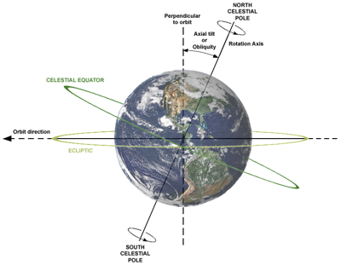

The celestial equator, coinciding on earth with the earth’s equator, divides the earth astronomically into north and south polarity. And it has been found experimentally that the relation of the sun to this division of the earth determines the relation of the earth to the various sections of the field of force through which the planets move. In other words, the signs of the zodiac owe their peculiar vibratory quality to the definite section of the heavens they occupy relative to the positions of the sun and earth. And the determining factor in this is the distance along the apparent path of the sun from the point where it crosses the celestial equator, and thus changes polarity.

The sun each year apparently moves north from the southern celestial hemisphere to the northern celestial hemisphere, bringing with it the summer season. It does this because its path, the ecliptic, is inclined at an angle of 23 degrees, 26 minutes, 51 seconds [changing slowly over time, 23 26 05 at May 2015] to the plane of the earth’s equator, the projection of which in the sky becomes the celestial equator.

That is, as the ecliptic and celestial equator are not identical and not parallel, they must meet and intersect each other. The line of their intersection is called the equinoctial colure. The points where the sun, following its path, the ecliptic, crosses the celestial equator are called the vernal equinox and the autumnal equinox. They are called equinoxes because when the sun reaches these points the nights are equal in duration to the days.

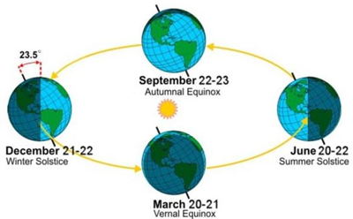

While this may seem a bit technical, everyone is familiar with the changes of the seasons from winter to spring and from summer to autumn. These are caused by the sun changing polarity in crossing the equinoctial colure, crossing from the southern celestial hemisphere to the northern celestial hemisphere about the 21st of March each year, and from the northern celestial hemisphere to the southern celestial hemisphere each year about the 23rd of September.

Of these two points, it was noted by the ancients, as well as by moderns, that the one where the sun crosses the celestial equator in spring is the most important, and constitutes the commencement of the zodiac. Although it is a circular belt in the sky along the apparent path of the sun, the zodiac thus has a definite starting point. This starting point is not determined by any of the stars or constellations, but by the place among the stars and constellations, during any given year, where the sun crosses from south declination to north declination.

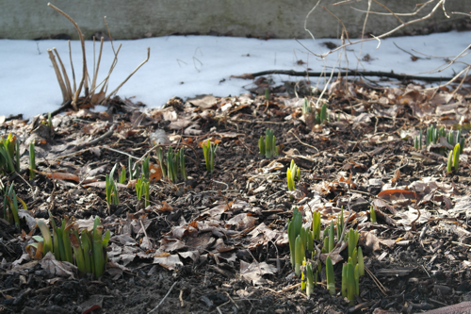

This is called the vernal equinox, and also the First Point of Aries. As the beginning of the sign Aries marks the change of polarity of the sun which ends one astronomical year and commences another, and as the sun was known to be the ruler of the vital forces of life, the ancient wise ones who designed the tarot felt it appropriate to explain, in association with this sign of the sun’s annual birth, their findings that the death of one form always constitutes the birth of another.

Furthermore, as the most important cycle influencing the events which happen to cities and nations is mapped at the exact moment the sun changes polarity, and thus enters this sign, in the tarot design relating to the sign Aries, they also sought to convey knowledge regarding the influence of cycles in Mundane (Global) Astrology.

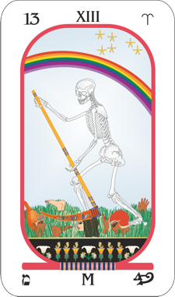

Circling the zodiac, the sun each year returns to the commencement of Aries. Its crossing the celestial equator to enter this sign, cuts off the old cycle of its life, even as in tarot Major Arcanum 13, The Reaper cuts down with his scythe the ripened grain. Aries is a Mars sign, and the cutting of the harvest by the grim skeleton, portrays in the language of symbolical pictograph, the destructive influence of Mars upon the vitality of the cycle of the sun just completed. Death, as pictured by the skeleton, inevitably claims its own.

This, however, is but one aspect of the picture. The other shows the bow of bright promise in the sky; while in the wake of The Reaper there are human hands, representing works, human feet, representing understanding, and human heads, significant of thoughts. Here we have, not merely the destruction by Mars, but the promise also of its constructive power. The sun, entering the Mars sign, Aries, has had the vitality of its previous life-cycle cut off; but this gives birth to a new cycle of life, birth to new thoughts, birth to new understanding, and birth to new works, which the sun now has commenced to vitalize.

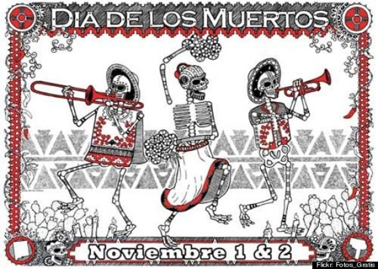

**Mundane Astrology**

Thus, is there pictured in Major Arcanum 13 a philosophy which denies that death is the end, and which gives to the thoughts and works of man a significance in the realms of the future. Not only will the vital forces represented by the sun acquire a power and increase when the individual is born through so-called death into the afterlife, but it will be springtime also for thoughts and understanding, and for the work which he will start in that region.

But in addition to a philosophy regarding the life of the soul being a succession of cycles, each in a more progressive form, Major Arcanum 13 also explains the important factors which should be used in the practice of Mundane Astrology. The death and birth there pictured relate not to one individual, but as plainly indicated by various types of human heads, to groups of people. And Mundane Astrology is the science of the influence of the heavenly bodies as they affect the world, nations, cities, communities and other groups of people.

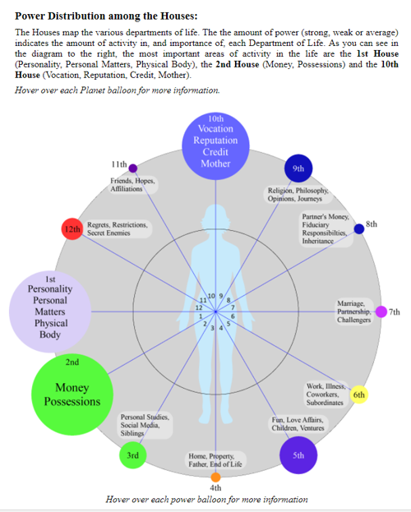

Graphic demonstration of house influence in the USA natal chart.  
Produced using Horoscope Report Generator Version 3.1.

Any organization of individuals functioning under a common governing authority constitutes an entity. As such it attracts to itself fortunate and unfortunate events in a manner quite similar to that in which like events are attracted into the life of man. Both have birth charts which, if known, correctly map their characters; and both are influenced by picking up, radio fashion, four-dimensional vibrations through changes in their finer structures, such as are mapped by progressed aspects.

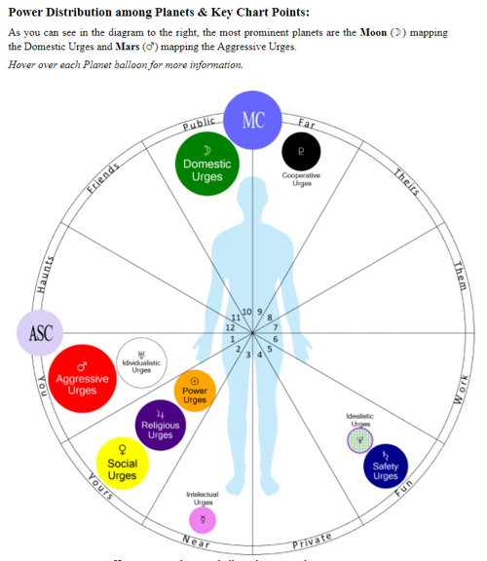

Graphic demonstration of planetary influence in the USA natal chart.  
Produced using Horoscope Report Generator Version 3.1.

As indicated by the heads in Arcanum 13, the individuals are the thinking units within the body of the community, even as the thought-cells are the intelligent units within the unconscious mind of man. And when, through progressions or other positions of the heavenly bodies, certain of these units receive an additional energy supply, this causes them to be proportionally more active, and thus pronouncedly to influence the thoughts, the behavior, and the events attracted, into the life of the individual or group of which the units form a part.

The community birth chart indicates the character of the community as a functioning whole. As progressed aspects form to the birth chart and progressed planets in this community chart, thought trains are released. These link certain individuals of similar motives and ideas together in a manner that enables them, and the thought-forms they generate, to perform the same function performed by a temporary stellar aerial stretching across the astral body of individual man. Through this thought-chain, and those persons who act as receiving terminals, because they have so completely tuned in on certain planetary vibrations, additional planetary energy finds its way to various members of the community. These feel in a particular way in reference to community effort, depending upon the type and harmony or discord of their respective characters, and the type and harmony of the new energy thus received from the planets.

It is according to the way they feel and think and act, in response to the new energy thus picked up from the planets, the determines whether the event attracted through their activities is harmonious or discordant. And the department of life, which becomes the object of their thinking and activity, is the one that is that is chiefly affected, instead of some other.

Yet a nation, or a section of the country, responds so pronouncedly to Cycles, such as Arcanum 13 indicates, that even when the birth chart of a nation is known, these should receive special consideration. And as the correct birth-charts of most countries and cities are unknown, in the astrological determination of the events which will transpire in relation to them, we are compelled to rely upon the current planetary aspects in the sky, the charts erected for major conjunctions, which have an acute and precise influence, but only over a very limited period of time, and upon the cycle charts of the various planets.

The cutting off of the old influence and the birth of a new regime, as pictured by The Reaper, takes place in so far as the sun is concerned when, through passing from southern declination to northern declination, it changes magnetic polarity. It does this not because it enters the sign Aries, but because the sign Aries ever must start at the point in the heavens where the sun thus changes polarity.



The rainbow above in the picture shows the promise of that which is to come, and in so far as things in general are concerned, a chart erected for a given place for the moment the sun crosses to north declination, about March 21, reveals what will happen affecting a city, nation or other group entity whose governing authority is at that place, during the following year. Thus, also each house of this chart, as representing a different department of national life, could be considered in turn and the whole summed up as the different general trends of events during the year.

But the bow of promise in this pictographic explanation of the influence of cycles is clearly not confined to the action of a single planet. There are really seven distinct lines in the bow, showing that each naked-eye orb, at least, must be considered as having a cyclic influence of its own. And other than the moon, which revolves around the earth and commences its Cycle when it makes the conjunction with the sun, observation proves that each of the planets, as well as the sun, commences a cycle when it crosses from south declination to north declination.

The sun and moon and the things they rule are so important in human life that from the Sun Cycle for each year and the Moon Cycle for each month it is possible to determine much of what is going to happen in a country or city. But if dependence is placed exclusively upon the Ingress Map (as the Sun Cycle commonly is called), and the Lunation Maps (as the Moon Cycles often are termed), some of the most outstanding events will be overlooked; for these relate chiefly to the influence of things ruled by some other planet.

Unlike the Cycle Charts of the sun and moon, the Cycle Chart of one of these other planets does not indicate the influence of a wide variety of things on the affairs of the locality for which erected. Its influence is narrowly confined to that which it is there possible for the things ruled by the planet for which the chart is erected to exert.

A Mars reveals the influence exerted by mechanics, by manufacturing and the military profession, and by aggressive action; but it does not reveal the influence of orthodoxy, of land and basic utilities, of conservatism, or of the farmer and miner. Such a Cycle Chart is the birth chart of the type of influence indicated by the planet for which it is erected. This birth chart continues effective until the commencement of the next Cycle of the same planet. The commencement of a Cycle also tends at that time to stimulate the influence of the things ruled by the planet for which the chart is erected, upon the affairs of the world.

This, or any other Cycle Chart affecting groups of people, is like a birth chart of definite influence over a stated period, revealing the events that will transpire due to that particular influence, but not due to those of other types. And as in the birth chart of an individual, the time when the indicated events will happen is revealed by progressed aspects. But unlike the progressions in a birth chart, the only planet progressed is the one for which the chart is erected, and only as it moves forward by transit to make aspects to the positions the planets occupy in the Cycle Chart.

A Mars Cycle, however, does not indicate the events which relate to safety, economy and poverty, or to the influence of ultra conservative thought, strictly orthodox religion, or to the power in politics of the farm and miner. For these, and measures relating to security, we must look in particular to the Cycle of Saturn. And during this period the outstanding events due to cautiousness, conservatism, economy and fear coincide with the aspects Saturn make as it moves through the sky, to the positions of the planets in this Cycle Chart.

It will be seen that no difficulty should be experienced by anyone who becomes even slightly familiar with the use of progressed aspects in Cycle Charts, in foretelling with precision the times when widespread interest in events of each planetary type will be exhibited, and within a day or two, when important events of each planetary type will come to pass. In fact, by also considering the New Moon Cycle, or Lunation, such events can be predicted to within twenty-four hours of the exact time they actually transpire.

At the commencement of a Cycle the influence is more pronounced while the planet is close to the exact line between north and south declination. But because the physical environment, by its resistance or lack of it, may require accumulated planetary pressures to manifest a given event, the condition indicated by the changing polarity pictured in Arcanum 13, may develop somewhat before, or somewhat, after, the exact moment of change of declination. There is an orb, therefore, of one degree of movement by declination, within which events signified by the Cycle may take place before the Cycle actually starts. [Approximate time to move one degree of declination: Sun, 3 days; Mars, 4 days; Jupiter, 12 days; Saturn, 21 days; Uranus, 49 days; Neptune, 70 days; Pluto, 72 days.]

In a like manner the progressed aspects which form to the places of the planets in the Cycle Chart, also have an orb of one degree from the perfect aspect, within which the event signified happens.

In the Moon Cycle, which is set for the conjunction of the Moon with the Sun, and not for change in declination, because the Moon moves so rapidly, an orb of 24 hours is allowed within which the event signified by the progressed aspect of the Moon happens. Any event which transpires outside of the orb of one degree from perfect, or in the case of the Moon, more than 24 hours before or after the perfect aspect, should not be attributed to the commencement of the cycle or to the aspect.

The detailed application of this knowledge in predicting the events which will come to pass within a community or nation, of course, presupposes a knowledge of common astrological practice; that the progression of the planet through a house causes its influence to be felt in a certain department of life, rather than in others, and that its progressed aspect to a planet in a certain house, causes the things represented by that house to be affected. It is to be recognized, also, that the influence of a progressed aspect to one planet is different than that of a progressed aspect to another planet. These matters, however, are common knowledge to those who practice natal astrology.

But in addition to that which pertains to natal astrology, the ancients, through Arcanum 13 of the tarot, laid down for us the principles of using Cycles in Mundane Astrology. They associated the start of such Cycles with the pictographic explanation of the sign Aries, because the most important Cycle, that of the Sun, commences when that orb enters Aries. And they indicated by the seven promises of the bow, that each of the other planets could be used in a manner somewhat similar.

**Taurus and The Alchemist**

**Elbert Benjamine**



In spring of the year, when the sun crosses the vernal equinox and enters the sign of its exaltation, Aries, represented by tarot Arcanum 13, the forces of nature commence to move and new processes are set in motion within the laboratories of Isis.

Yet the solar force in Aries is not alone capable of regenerating the world; for such regeneration, or any other regeneration, requires also that feminine forces shall be mixed with the masculine. That is, either the alchemy which constantly we witness in nature, or that produced on any plane by man, requires a combination of positive and negative forces, such as astrologically are typified by the sun and moon.

To perpetuate the knowledge of this fact, the ancient masters not only explained it clearly in the language of symbolical pictograph, on tarot Arcanum 14, but they also incorporated it into a religious holiday. It needs to be pointed out that the transmutation of Nature’s forces is not celebrated at the time of the vernal equinox, but on Easter, which cannot occur until after the full moon has brought a partnership and exchange with the sun, from the natural sign of marriage.

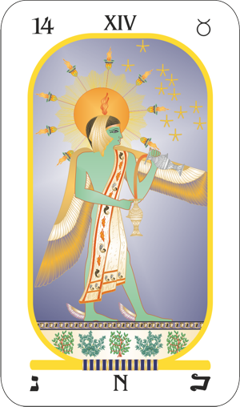

The process, started at Easter, is carried forward as the sun enters Taurus, the exchange of the finer forces fecundating the earth (Taurus) to bring forth the grass and flowers. For while Aries is the exaltation of the sun, Taurus is the exaltation of the moon; and the sun moving thus into the exaltation of the moon after the partnership has been formed, carries forward the process of fructification. This process by which fecundity is assured, is pictured in Arcanum 14 by the genie of the sun holding a golden urn and a silver urn, and pouring from one to the other the conducting fluid of life. Taurus, the Bull, also is the symbol of fecundity.

We are not to believe that those who in ancient times designed this picture understood photosynthesis, by which the green coloring matter of plants when exposed to sunlight (Sun) are able to combine water (Moon) taken by their roots from the earth (Taurus) with the carbon dioxide of the atmosphere, in the production of those carbohydrates upon which all animal life depends. The process is not merely chemical, in the commonly accepted meaning of that word, for there are interchanges of electrons involved, somewhat after the manner of the action of light upon a photographic film.

Yet by this process, inorganic elements are transformed into organic substances fit for food. Chemists are hot upon the trail of making artificial chlorophyll, but the problem has not as yet been solved. And until it has, as no creature can subsist on minerals, all animals on the earth are dependent upon the green leaves of plants, such as appear most abundantly when the sun moves into Taurus, to perform the alchemical work by which alone food can be procured.

What the ancients had in mind, undoubtedly, was not the actual process of photosynthesis; nor was it the union of the newly discovered electric particle, the positron, with the electron, by which it is now believed the material universe comes into existence or is destroyed; but a universal principle which they believed to be applicable on all planes, and within every sphere of existence.

They gave the pictured genie a crown of flame to indicate it to be a spirit, or principle. They placed wings upon its feet to signify its rapid movement. And nothing observed by physical science moves faster than light, which is here represented by the rays of the sun behind the genie. This sun exhibits eight rays to signify that the positive, or masculine, forces of the universe are, on the whole, exactly equilibrated by the negative, or feminine forces. The cloak over the shoulder of the genie indicates the perpetual fecundation of matter, which Taurus, as the most fixed of all the earth signs represents, by the sun, symbol of spirit.



This material world, which thus the sun fecundates, and upon which the soul must depend for its experiences with physical life, which are a necessary phase of its total evolution, it is now known, is itself an exemplification of the union of masculine and feminine forces such as tarot Arcanum 14 was designed to explain.

Material science has known something about the existence of the electron, the ultimate electrical unit, which Dr Millikan succeeded in isolating and measuring, for some time. Dr Millikan calculated that it would take 50,000 of these electrons in a line to make a length equal to the diameter of an atom. And it would take about 300 million atoms in a line to reach a distance of one inch. Or, comparing the size of an electron with that of a baseball, if the baseball and the electron were magnified at the same time until the baseball were as large as the earth, the electron still would be too small to be visible under the most powerful microscope.

The importance of these electrons, or negative electrical charges, lies in the fact that they form one of the factors of all material substance. At the center of all atoms of matter are protons, or positive charges of electricity, having a mass 1,840 times that of the electrons which revolve in orbits in the outer structure.

Just as at the present time the energy radiated from the planets has not been isolated and analyzed, which, impinging upon the astral body, or unconscious mind of man, stirs him to thoughts and behavior which, within limits, can be predicted, so science once had no definite knowledge of the cosmic rays which so powerfully pelted the earth and its inhabitants, night and day.

In terms of their effect upon human behavior, and upon the events attracted to an individual, we have fairly accurate estimates of the energies exerted by the various planets when differently situated and aspected in a birthchart or by progression. But we have as yet no measure in terms of physics of their power; no more than material science had as to the energy of the cosmic rays. The tremendous energy exerted either by cosmic rays or by planetary forces was no assurance of their recognition by the physical senses. Dr Millikan estimated that the most penetrating cosmic rays observed up to his time, had an energy of at least 500 million electron-volts.

In a lecture William D. Harkins, Chicago University physicist, stated that atoms are being altered through the impact of cosmic ray electrons which have energies as high as one-hundred billion volts each. That is, the elements of matter are being transformed through the alchemy of these cosmic rays.

These electrons are negative charges, and hence could be well represented by the fluid which The Alchemist pictured in Arcanum 14 pours from the silver urn in his left, or negative, hand. But if, as the picture explains, transmutation is brought about, not by a negative force alone, but through the united action of positive and negative what about the masculine equivalent of the feminine electron?

It was found that the mathematical formula known as the Dirac Electron-Equation solved many difficulties but also led, when followed to its logical conclusion, to quite peculiar ideas.

This equation requires that electrons under certain conditions should have less than zero energy and weigh less than nothing; and Dirac considered each point in space, including a perfect vacuum, to be crowded with an infinity of such negative energy electrons. They were unobservable, and it was a property of free space that they should be there.

The peculiar logical conclusion this assumption led to is that if one of these electrons should be removed, the ‘hole’ in space that remained would manifest itself as an electron of positive electrical charge and of positive mass and energy.

According to the well-known mathematical formula, with which most of us wrestled when taking algebra in high school, if less than nothing be taken from nothing, or empty space, it is the equivalent of placing something there. And according to Dirac’s theory, this something would be a positive electric charge with a mass and energy similar to the electron. Then came the discovery of the positron, which is a positively charged particle having the same mass as the electron, instead of 1840 times as much, as has the proton. And strange to say, this positron performs very much as Dirac’s theory holds it should.

This theory holds that when a positron meets a negative electron, both particles will suffer the fate of complete annihilation, and that in their stead there will be a pair of corpuscles of radiant energy. This radiation resulting from such annihilation of the positive and negative building-blocks of matter has actually been observed by the French physicists, Joliot and Thibault. However, it is believed that a positron, if removed from a region densely populated by negative electrons, instead of perishing immediately, may live a billion years or more.

These most recent theories and discoveries of material science are set forth here in connection with the explanation of the general principles of alchemy which have been left to us on the tarot called The Alchemist, because such processes now are being applied in various university laboratories, based on the discoveries mentioned, to convert energy into matter, to convert matter into energy, and to manufacture by alchemical processes not less than a score of chemical elements out of other chemical elements. Yet alchemy and astrology, until recently, were twin outcasts, alike open to the ridicule of narrow minds.

Ions are atoms which have lost one or more electrons by a proper kind of impact. Such impacts take place in the ordinary neon light, and in the sparks of an automobile system.

Because they are thus electrically charged, if such ions enter a space where there is a high voltage, the action of the electrical force is to acquire high speed, and thus also great momentum and energy.

If such a stream of ions – atoms charged through loss of one or more electrons – is directed at other matter, those ions which happen to be heading directly at the nucleus of an atom of this other substance will come close to it. But, because both ion and nucleus are charged with the same kind of electricity, there is a tendency for it to be deflected so that it does not strike the nucleus. Yet if the speed of a stream of ions is sufficiently great, instead of being deflected, they will plough through the electrical resistance of the nuclei and add themselves to these nuclei, as direct hits are made, thus becoming part of an entirely different element synthetically formed.

To give streams of ions – atoms charged through loss of one or more electrons – the speed required of them if they are not to be deflected from making head-on collisions with the nuclei of atoms of other substances at which the stream is directed, the cyclotron was developed. By this instrument the ions are accelerated again and again by the same electric field so that, even when but 10,000 volts are used the effect upon the speed of ions is that of 2,000,000 volts. Thus, so far as material substances are concerned, have the dreams of the medieval alchemists been far more than realized.

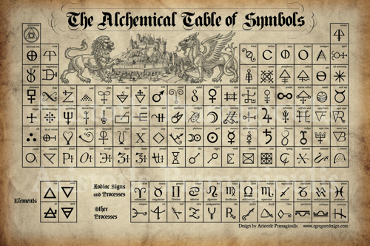

But as anyone familiar with alchemical literature is well aware, the transmutation of physical substances was only one, and not the most important, phase of the contemplated alchemical work. The more important changes desired were those relating to man’s character. Through using the experiences of his life, and the proper application of thought, the old alchemists believed man could change his inner character; and the inner structure of the unconscious mind, as we now call it, thus changed, would also alter his destiny and enable him to rule his stars.

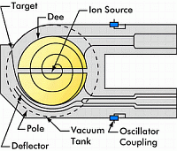

While the ancient wise ones who designed tarot Arcanum 14 probably never even remotely dreamed of a machine like the cyclotron, which through adding ions to atoms would change their chemical substance, they did picture the general process in association with the earthy sign Taurus. And this same general process, evidently, is the one which must be applied to alchemy on any plane, such as in the transmutations within the unconscious mind of man, by which alone he can alter his destiny upon the physical sphere.

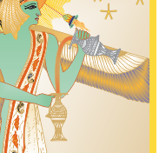

But the energies which correspond to ions, if they are to alter the unconscious mind, must be those of thought. And if they are to have power enough to make worthwhile transformations, they must use, instead of a cyclotron, the dynamic force of emotion. It is emotion, feeling, which gives thoughts the power to accomplish work.

What those alterations within the unconscious mind must be to change the trend of destiny in the direction desired, of course, depends upon what thought-elements and combinations already are within that unconscious mind, which are mapped by the planets in the birthchart; and upon the energies reaching and giving power to these mental factors at the time, as indicated by the progressed planetary positions.

When we speak of ruling the stars, we do not mean that we can prevent the aspects that form in the sky, or that we can prevent planetary energies reaching us. We do not prevent the activity of the various forces of nature, whether they be ocean currents, flowing streams, glaciating ice, or the ionizing cosmic rays. But through our knowledge we are learning to adapt ourselves rather successfully to these and other environmental forces. And while we cannot prevent the planets from radiating the energies they most certainly do, we can learn what those energies are and how they influence human life, and then take proper steps to utilize them so that they will work, not against us, but in a direction that will be to our advantage.

We can easily demonstrate that each planet broadcasts an energy of a special type. Yet such energies are not responsible for the character with which the individual is born nor for the events which later enter his life. He comes into human existence at the time the planets accurately map the more active mental factors within his unconscious mind, which are the outstanding qualities of his character, in obedience to the line of least resistance. As it is easier for a chip to float downstream instead of up, so is it easier for him then to be born than at any other time.

Nor are the progressed planets responsible for the events that come to him as life continues. It is true that they determine in great measure the astral environment at a given time; but how that invisible environment affects hint is not determined thus, but by his reaction to it.

Thus are two things involved in every condition and event of the individual’s life: the organization of the thought-cells within his unconscious mind, which constitutes his character, and the environment to which the character reacts. Even though the environment remains the same, even under the same progressed aspects, for instance, if the thought-organization of the unconscious mind upon which these energies act is changed, that which happens will be different.

What is explained in tarot Arcanum 14 is that if the thought structure of the finer body is changed, whatever is indicated by progressed aspects, and by the birthchart, is proportionally changed, and that through the proper application of Mental Alchemy, energies that otherwise would be coincident with misfortune can be diverted into channels so that they will attract good fortune. That is, The Alchemist associated with Taurus contemplates doing with planetary energies, through changing the character upon which they act, what man to some extent has done with tide and wind and rain. As once destructive winds now are made to drive his ships, and uncomfortable rains to grow his crops, so explains this Alchemist, through proper understanding, can man make the once fear-begetting aspects work for him.

It is true, as one who studies astrology long must be convinced, that what usually is attributed to chance is never such; but the working of a hidden law. And the law which governs the events and circumstances that enter every life is that which relates to the release of desire energy on the four-dimensional plane.

Each thought-cell of the unconscious mind has within it energy under tension, and each thought-organization has still other energies stored and under tension. These energies strain for release. And when they gain enough additional energy, through more thought or planetary vibration, they spill over into unusual action. Nor is such action confined to the physical plane. It works in an equally potent fashion from the four-dimensional plane to attract into the life those conditions which are the objects of the desires of these thought-organizations.

What the thought-cells and thought-structures of the unconscious mind attract into the life with such energy as they possess is determined by the way they are conditioned. This applies not only to those with which the individual was born, but also to all that have been added by subsequent experiences. The thought-elements enter into discordant psychoplasmic compounds when they are conditioned by feelings of distress, and into harmonious psychoplasmic compounds when they are conditioned by feelings of pleasure. How they have been conditioned is revealed by the aspects between the planets in the birthchart.

Arcanum 14, which shows the Alchemist pouring new thought-elements into the cup representing the unconscious mind, or astral body, explains in the language of symbolical pictograph, that if an individual expects to attract to himself events that are more fortunate than those indicated in his birthchart, he must change the conditioning of the thought compounds in his unconscious mind which those birthchart aspects merely map. To the extent he can do this will more fortunate events come to him.

This old tarot picture explains that harmonious thinking and feeling about the things mapped by discordant planets in the birthchart rearranges the thought-elements in the stellar-cells related to these things, much as the cyclotron rearranges the electrons and positrons within an element of matter to make of it a new element. And when the factors of the unconscious mind are thus conditioned through Mental Alchemy, they attract a different set of events under the same progressed aspects.

In other words, The Alchemist sets forth that any condition within the astral body shown in the horoscope of any individual in the world, either in the birthchart or by progression, could be built into any other person’s astral body, if enough thought-energy could be acquired.

It is true, just as it is true that gold in commercial quantities has not been manufactured by using the cyclotron, that physical life is too short, with the thought-energy most people have, to build into the astral body those thought-cells and organizations that express as genius or that attract world recognized power.

But to the extent they do build into themselves the same thought-cells and thought-cell relationships possessed by genius or men of world-wide power, others also must inevitably attract to themselves similar external events.

The planets furnish the energy with which the thought-cells work. But the kind of work done by the planetary energy thus utilized is entirely determined by the desires of the thought-cells and stellar organizations. That is, we build our fortune, as well as our abilities, through our experiences and how we mentally react to them. If we want a different kind of fortune, the only way we can get it is through the process indicated by tarot Arcanum 14, which is by pouring in such thoughts and feelings as will build thought-cell compounds and structures into the astral body having such desires as will attract it.

**Saturn and The Black Magician**

**Elbert Benjamine**

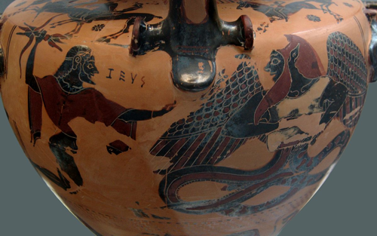

Although the writings of medieval astrologers show little appreciation of the advantages conferred by the influence of Saturn, when prominent in a birthchart, it is probable that those of more ancient times were well aware of them. Yet because the principle he rules in human life and the influence of his vibrations always find their foundation in self-interest, and self-interest more than any other one principle is the source of human misery, when they sought to portray the relation of this Saturn power to life on earth their symbolical pictographs represented the adverse side.

To indicate the more commonly observed motives of Saturn they employed as the central figure Typhon, the spirit of cruel Greed. This horrible monster, borrowed from the Egyptians, is a familiar character of Greek mythology, frightening Venus and her son Cupid so that they jumped into the River Euphrates to escape him and transformed themselves into the two fishes of Pisces, which can be seen as a constellation in the sky. In the language of universal symbolism this legend explains that, when the self-interest of Saturn is present, Love, represented by Venus and Cupid, must depart. It also reveals Pisces as the sign of exaltation of fair Venus.

Saturn, in the pursuit of its object, not only is motivated by self-interest, but unlike Mars, for instance, it works in darkness and through cunning, rather than facing the full light of day. The use of mental powers is typical of all methods to secretly acquire an unfair advantage over others. And when the power of thought is sent against another to destroy or to compel them to do things against their own interests, it is called Black Magic. The one using such iniquitous methods is termed a Black Magician. Thus, the ancients, in portraying their teachings relative to the influence of the planet Saturn, not only employed the picture of evil Typhon but presented him in the role of the Black Magician.

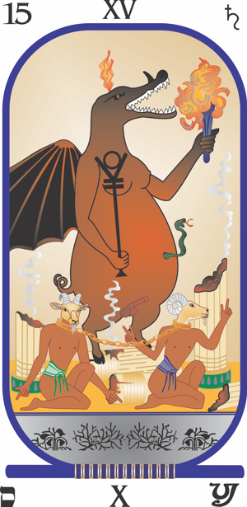

Major Arcanum 15 of the tarot, here illustrated, shows Typhon standing triumphantly over the ruins of a temple. That is what the world today is facing [1930s]. Greed for power, the greed of the few within the nation to dominate and control its resources, the greed of military nations to gain for themselves, even at the cost of destroying civilization, control of world commerce and world resources. The ruins of the temple, as pictured on The Black Magician tarot card, now can be seen in actuality in many countries.

Why is it that the medieval authors were so stout in their affirmation that Saturn afflicted in the house of honor (tenth) brought a rise followed by certain downfall? Not because such a position created the inevitability of such precipitation from fame for some few with this position are able to curb its unbounded greed for more and more power. If one keeps reaching for more and more, always there is a grasping for that which is beyond the reach and then the customary fall.

The ancient Masters were at some pains to explain its influence when not curbed thus: Typhon, the emblem of greed, is pictured holding in his right hand a scepter surmounted by a circle resting between two divergent bars. These spreading bars signify the inversive forces that hem and hamper the influence of the spirit, represented by the circle. It is the emblem of that hatred and division which has led in many lands to the persecution of those of different race or of different religious views.

In the other hand this creature of Arcanum 15 is pictured as holding the torch of destruction, whose blaze has been applied to the ruins of the temple, even as today the homes of hundreds of thousands have been destroyed. He is crowned with flame to represent that he is influenced from the invisible world, and he has the wings of a bat to indicate that because of such influence he is a denizen of the realm of darkness. The horn on his nose signifies stubborn rebellion.

The breasts of a woman and the organs of a man indicate him to be hermaphrodite, which because devoid of love is the emblem of self-centeredness.

The body is that of a hog, especially to denote greed. The feet are those of a goat, to indicate the sign Capricorn, the home sign of Saturn, or Satan; and the sign most devoted to material ambitions. And the beings chained at the feet of this monster of chaos also have goats’ heads, indicating that their intelligence has been used exclusively to further material and selfish ambitions.

This malignant picture of an afflicted Saturn’s influence has the head of a crocodile, symbol of cruelty. The snake emerging from his body, instead of from his brow, indicates the use of creative energy, not for high mental purposes, but for the gratification of purely physical ambitions. It also, through its negative implications, represents mediumship, rather than conscious control; for the chief center of power in disintegrative mediumship is the solar plexus.

The two men with goat heads chained by the neck at the monster’s feet represent the certain fate that awaits all who use magical power to attain selfish or purely material ends. Sooner or later, they become the slaves of the very forces that they have used and are finally completely destroyed in body and mind; and even after passing to the next life these black magicians are chained by their evil deeds in the underworld.

All such evil entities, of this plane and the next, survive by preying on the ignorance and credulity of others, as shown by the sign of sorcery they make with their hands. They are the racketeers and gangsters of both planes; and the picture as a whole indicates the bondage and the fate of those who follow the inversive path and become dominated by the spirit of selfishness.

Arcanum 15 certainly explains the extreme influence of an afflicted Saturn; but when we consider that there are millions of people in these United States who are able to work and who want to work, yet are unable to find employment; and when still further we observe the chaotic despoliation in progress in other parts of the world, and recognize that these are expressions of an afflicted Saturn, we cannot believe this portrait handed down to us by the ancients is much overdrawn.

Saturn also has a highly beneficial side, one without the due influence of which an individual will remain in obscurity or may even perish from the earth. But before considering this more constructive side, let us take less extreme examples than those pictured in The Black Magician and show how and why it is that too much Saturn influence in a birthchart so often tends to defeat the individual in the aims he seeks.

Perhaps the best way to indicate this is through contrasting the Saturn attitude with the more luck-attracting influence of Jupiter. The influence of Jupiter on everything he contacts is in the direction of expansion. He is the salesman whose goodwill and joviality enable him to sell his wares or his services at the highest price. Large and generous by nature he spends no time in petty haggling over small differences in cost. His customers will buy from him, even if they must pay a little more than elsewhere, because he is such a good fellow.

This disregard of small imperfections in others, the tendency to forgive transgressions and the spirit of give and take which is so essential in life if frictions and antagonisms are to be avoided, may well be symbolized by the belts of Jupiter which may be seen through a small telescope: ever-shifting zones of various colors formed by changes in the planet’s atmosphere. Here there is no suggestion of restriction, of self-interest or of coldness, but rather an impression of a benign and genial giant.

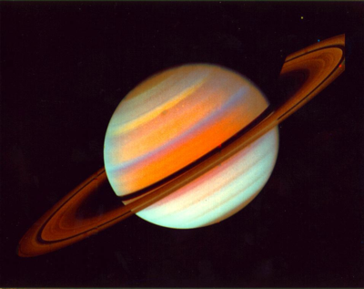

Now look at Saturn through a telescope. There comes a very different feeling. Its cold white is slightly tinged with yellow, but it lacks that glowing warmth which the steadfast yellow light of Jupiter seems to pour forth to cheer his neighbors in the sky. Instead of the somewhat careless disregard of Self which the larger planet seems to indicate, Saturn has built a ring completely around himself to protect his possessions. And this is just what a person with a prominent Saturn in his birthchart is apt to do.

In his cautious and Self-Centered desire to ensure that nothing from himself is given to others and that even in the smallest way no one outdo him in bargaining, he has fenced himself and his possessions in. That which the prominent Saturn person constantly overlooks is that a wall which prevents anything from getting out acts quite as effectively to keep anything from getting in. Jupiter gives and spends and makes pleasure for others; and this generous attitude awakens a like response in them. They in turn, feeling a sympathetic glow of generosity, give Jupiter more than he asks and go out of their way to see him prosper. But when they come in contact with the cold ring into which Saturn has withdrawn, they recoil from the barrier and think to themselves that such a one deserves no favors and that the best thing is to shun him entirely.

Greed, however, is not the only outstanding characteristic of an afflicted Saturn pictographically explained by tarot Arcanum 15. It will be recalled that it was due to fear that Venus and Cupid jumped into the River Euphrates. The whole picture on the tarot card is so presented as to give the impression of something greatly to be feared. And many persons who are generous and free even from the slightest tinge of greed, are veritable slaves to this other dominant trait of Saturn which we name fear.

Back of fear and the other thought-elements which Saturn rules, lies a biological heritage as long as that of life upon the earth, a heritage which at every step was influenced by the energies emitted from that cold and yellow orb. And not from idle curiosity, but because such research leads to a comprehension of the functions of those trends, impulses and thoughts which in the life of every person are energized by the Saturn vibrations, is time well spent in tracing the broad outlines of that heritage. When comprehended, it will afford information as to the methods of using the Saturn energies constructively and thus form a guide to more successful conduct.

That is, when we know the source of hindrances within ourselves, know when and how at predetermined times these Saturn factors will be stimulated by planetary energies reaching them, and how to divert such energies as the ancients pictured in The Black Magician into channels that instead of destruction, are completely constructive, we possess a tool by which we can make life more spiritual, more successful and more happy.

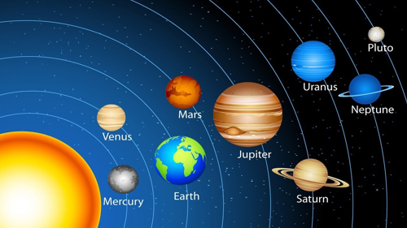

Survival in the Universe is based upon Orderly Movement

These Saturn thought-energies which become more active within us when stimulated by planetary aspects to birthchart and progressed Saturn have their foundation in the struggle of the evolving organism to find Safety. They express painfully in human life as fear, greed, envy, grief, worry and forms of self-centeredness. Yet through developing the proper habit systems, the individual can divert them and make them express through some of the pleasant Saturn channels, such as careful planning, system, order, perseverance, elimination of waste and willingness to do hard work.



When it is said that self-preservation is Nature’s first law, this is an acknowledgment that the Saturn-ruled desire for safety cannot be prevented from finding some adequate expression. All life forms, from the first, have been beset with dangers. And the ability to escape from enemies, to avoid harmful conditions and to provide for security is essential if the individual is long to survive.

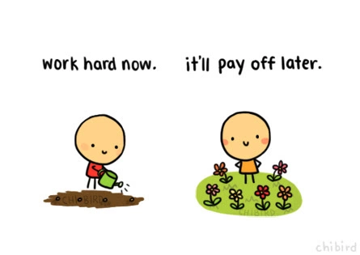

If he does not survive the period of immaturity, because the Saturn thought-cells were not active enough, he leaves no offspring. Thus, from the very first living cell upon the earth, down to present complex surviving species, plants and animals that have lived to propagate their kind have had within themselves a strong desire for safety. Or to state it astrologically, we can say that forms of life unable to respond sufficiently to Saturn’s vibrations have become extinct; and that every plant or creature on the earth today has inherited from all its ancestors back to the very beginning, considerable ability to receive and express the energies picked up, radio fashion, from the planet Saturn.

Now the competition of catch or be caught, of kill or be killed, between the ability to use the planetary energies of Mars and the ability to use the planetary energies of Saturn, among mammals has developed two little glands, which because they each sit like a cocked hat astride one of the kidneys, are called the adrenal glands. It is their function when stimulated by an emergency – real or imaginary – in which the emotions relating to either the destructive thoughts of Mars or Saturn are present, to mobilize the forces of the body for instant and quick action.

The thought of fear or anger, worry or irritation, greed or lust, generates an electric discharge which follows a nerve from the brain directly to the adrenal glands. This squeezes adrenaline from them into the blood stream, which in turn is followed by highly complex reactions which put the body immediately on a footing of fight or run away. Which the creature or man does, depends upon whether the images before his attention are those of combat or of fear. If they are of the Saturn type, the emergency is met by using the mobilized forces to seek safety.

Fuel must be present in abnormal quantities to support unusual activities; therefore, sugar for that purpose which has been stored in the liver is released into the blood. That all the energies may be used in fleeing, digestion and other activities of the alimentary canal cease. That the predator, or feared opponent, may not get a good grip, the skin becomes moist and greasy and the hair stands erect. To frighten him away, the pupils dilate; to prevent bleeding if he does receive an injury, the blood tends more quickly to clot; and to give the maximum speed and strength in the organs of flight, blood is squeezed from the blood lakes of the liver and spleen and diverted to use in the limbs.

Such instant mobilization of blood, fuel and electrical energy when a danger presented itself was a decided advantage to any creature not having the power to reason or plan. The instant and violent reaction to fear enabled it to live in an environment fluid with dangers, and its instant and violent reactions to the feeling of greed enabled it to maintain itself in a region of dearth when other creatures starved.

Unlike civilized man, wild animals turn their attention promptly to other things as soon as a danger has passed. Even the caveman, once the dying embers of the fire grew dim and shadows no longer haunted him from his cavern walls, probably drew the bear skin which served as his only garment closer about him and forgot the weird shapes until he lit the fire another night. At least during the day, as he had no stored food supply and hunger drove him on, he was altogether too preoccupied with the chase to harbor fears except when danger actually was by his side.

But as man advanced in civilization and learned more and more to use his brain, his nervous system became more and more refined, more and more responsive to mental images. And the emotions arising from such mental images, in proportion to the increased delicacy and sensitiveness of the nervous system, more and more perfectly tuned it to pick up corresponding planetary energies in volume.

The physical body can stand the strain of mobilization occasionally to meet a real or imaginary emergency in response to fear. Anxiety and worry, however, present an almost endless train of fear images. They tune the nervous system to pick up discordant energies from the planet Saturn in volume, adding them to the energies of the unconscious mind. And they keep the body on an emergency basis.

Blood is taken from the liver and spleen, digestion and assimilation cease; the liver is caused to release its sugar into circulation. As a result of the type of foods attracted by the discordant Saturn thought-cells in the unconscious mind, food is partaken which lacks either in mineral salts, vitamins, or other essential elements. From this and from the inactivity of the organs responsible for assimilation, the body suffers from one or more of the chronic deficiency diseases.

It is doubtful if primitive man and wild animals suffer often from diabetes. Their imaginations are not lively enough. But the civilized man who worries tunes his nervous system to pick up Saturn energies and to release adrenalin into his circulation. One function of adrenaline is to release sugar stored in the liver through counteracting the insulin which holds it there in the form of insoluble glycogen. When through worry, or repeated fear images, adrenalin is persistently released, sugar in the blood cannot be converted by insulin into the insoluble glycogen; and instead of being stored is promptly washed out of the system. The individual then has diabetes.

Brotherhood of Light research work has determined that only people who have a prominent and afflicted Saturn in their birth charts may develop cancer. And we who have analyzed many charts all know from observation that a prominent and afflicted Saturn indicates a predisposition to grief, worry, fear and the other typical Saturn thoughts. Research work also has brought out that at the time cancer develops there is always a progressed aspect to Saturn, within one degree of perfect; and very frequently a progressed aspect from the Sun. And from observation we know when people come under a progressed aspect to Saturn, especially if Saturn is prominent and afflicted in the birthchart that responsibilities or losses are attracted which, unless some other trend of thinking is deliberately cultivated, brings fear, worry or grief.

We are justified, therefore, especially in view of the effects of the abnormal adrenaline secretions upon the humours in which the body cells are bathed, in stating that fear, worry, self-pity and the other discordant Saturn thoughts are the cause of cancer and the typical deficiency diseases. Let us admit, therefore, realizing the effect of fear and greed upon the individual as well as upon society, that the ancients were justified in picturing the destructive influence of Saturn as The Black Magician. At the same time let us recognize that the energies of any planet can express either destructively or constructively.

Whenever the individual, therefore, begins to feel fear, worry, anxiety, greed, envy, grief or self-pity, let him substitute for them and with as much pleasure as possible, thoughts of order, system, careful planning, persistence, elimination of waste and a willingness to progress through hard work. Thus, the energies of Saturn, diverted from any avenue pictured in tarot Major Arcanum 15, will be utilized and assist him to a more bountiful life.

**Mars and The Lightning**

**Elbert Benjamine**

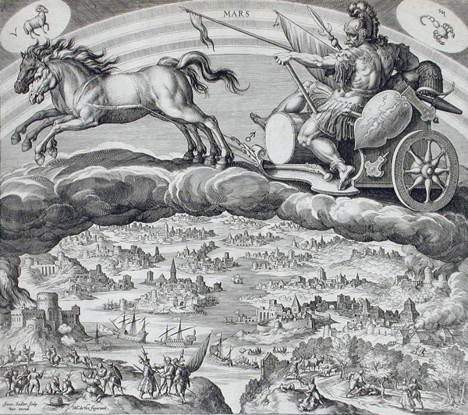

In picturing what might be expected from Saturn the ancients portrayed only his most malign influence, but when in designing the tarot they came to the symbolical and pictographic explanation of Mars, in addition to his malefic power which they emphasized, they also indicated less conspicuously his beneficial attributes. Yet to read the works of the astrologers preceding the twentieth century is to become impressed with their belief that all the good in the world derives from Jupiter and Venus and all the misfortunes of man are to be traced to the influence of those two malefics, Saturn and Mars.

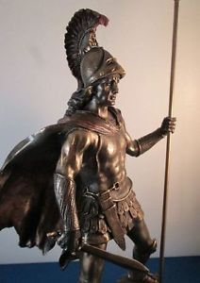Nevertheless, one could almost issue a challenge for them to produce the chart of any person who had accomplished noteworthy work which had given him wide recognition, in which both Saturn and Mars were not prominent. To accomplish almost anything unusually worthwhile one must have more energy than is at the command of the average run of men and this alone Mars can give. Also, to accomplish some high purpose that energy must be directed persistently, systematically and diligently which can be done only by those with a prominent birthchart Saturn.



However, the ancient Masters were quite correct in explaining the more commonly recognized influence of the planet Mars in tarot Major Arcanum 16 as *The Lightning*. Research has revealed that in 100% of accidents at the time they happen there is a progressed aspect in the birthchart to the planet Mars. Accidents also occur when there is a progressed aspect either to Uranus or Saturn, but with far less frequency than when there is an aspect to Mars.

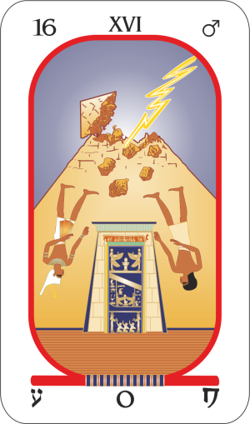Thus, outstanding in the tarot explanation of the Mars energies there is pictured a pyramid decapitated by a thunderbolt. And as a result, a crowned and an uncrowned man are precipitated from a platform, falling down with the rest of the debris.

Now a pyramid is the most stable of solids, is the symbol of the earth and also represents the climax of earthly security. As composed of four trines, which are its sides, corresponding to the houses of a birthchart, it symbolizes the horoscope of physical life. And thus, lightning demolishing the top of the pyramid indicates the violent end which the energies of Mars so often bring.

That the common man and the ruler alike are destroyed indicates not merely that Nature is no respecter of persons and that her cataclysms kill the high as well as the low, but also that those rivalries which today are so common among men and nations take their toll of life among all classes.



Destructive Mars: Earthquake  
Constructive Mars: Helping Victims

Yet the energies of Mars need not be expressed in war, in fire, in accident or in other forms of destruction, for Mars is also the builder. And thus, those who designed Arcanum 16 were careful also to indicate, for within the pyramid and safe from harm are depicted several chambers in which are those who apparently are devoting their energies to constructive pursuits. All creative expression depends upon the energies of Mars. We may suppose, therefore, that some of these thus represented as using Mars constructively are artists, some are surgeons and healers and some are engineers. All of these require the thought-cells mapped in their birth charts by Mars to be unusually active.

Were we to conclude that rapine and strife, arson and murder, were the only expression of the Mars thought-elements stored in the astral body of man, not only would we misinterpret most birth charts but we would miss the real significance of the vibrations received from the little red planet, such as the interior of the pyramid explains. For observation of birth charts in connection with people’s lives shows conclusively that in any field of useful endeavor in which there is high competition or in which there is creative effort only those attain the top who have the Aggressive thought- cells unusually active in their lives, as mapped by a prominent birthchart Mars.

To be more specific, because of the fabulous salaries reputed to be paid there are few occupations in which the competition is so keen as in acting for the screen. One might think that the first essential of a movie actor would be dramatic talent, such as ruled by Neptune, or that originality, mapped by the planet Uranus in the birthchart, would rank first. And movie stars do nearly always have these two planets prominent in their birth charts. But Brotherhood of Light Research, based on a careful analysis of the birth charts of 100 of the most prominent movie stars, revealed that a prominent Mars was a more constant factor than any other in their birth charts.

Mars, no doubt, lends a certain vivacity to the actor’s performance. But its even greater significance seems to be that to get into pictures requires more aggressiveness and initiative than most people possess. And to stand the strain of the high-pressure methods used when a production is under way makes a demand upon courage and fortitude such as are possessed only by those in whose astral bodies the Aggressive thought-cells are unusually powerful.

Or take vocal musicians: here again Mars leads all the planets in being most often prominent in their birth charts. To follow this profession successfully not only must there be a good voice and persistence to develop it, but there must be initiative to forge to the front in spite of difficulties and rebuffs that would completely dishearten one of less militant disposition. To read the biography of almost any nationally known singer or unusually successful screen star is to be amazed at the pluck with which, in spite of terrific adversity, he fought on and up and finally reached the top. And what is true in these professions is true in some degree wherever strenuous competition exists. It requires Aggressive Urges, such as are mapped by a prominent birthchart Mars, to meet the impacts and still carry on.

Furthermore, as revealed by an analysis of 150 birth charts of people who had lived beyond 70 years of age, there is no birthchart relation which tends so powerfully toward length of life as an aspect from Mars to the Sun. The Sun maps those mental factors within the unconscious mind that cause the individual to strive for significance and thus cling to life which allows that significance to express. An aspect from Mars to the Sun, therefore, shows these Power thought-elements have combined with the Aggressive thought-elements. And nothing so increases the vitality as does this addition of the energies of Mars.

If the thinking, or experiences, which have built the Mars thought-elements into the unconscious mind were discordant, as indicated by Mars in the birthchart in discordant aspect to the Sun, it does not prevent contracting infectious diseases and it does not prevent serious accidents entering the life. But it does give a recuperative power, an ability to battle with disease and to triumph over the effects of a wound or accident, that those do not have who lack the powerful aggressive thought-elements within their makeups.

These Mars thought-elements were developed through experiences in a long evolutionary past. Plants learned how, by photosynthesis, to use the sunlight in extracting carbon from the carbon dioxide of the air. That is their chief food supply, although for structural purposes and to generate the electricity which is at the foundation of their life they also needed, as we do, various mineral salts. These they took from the soil.

But acquiring food from the soil and air is a rather slow and laborious process and also one, as the ground became densely populated, in which there developed keen competition. Those forms which were more aggressive gradually crowded out those which were more retiring. Thus, many early types became extinct. More aggressive forms, those with Mars more prominent in their birth charts, shoulder to one side those with the Aggressive Urges less powerful in their astral bodies.

Nor is the appropriation of the food supply, which in human life often is represented in terms of money, a new thing in the world. The robber barons of the Middle Ages did not invent the process. Some early single-celled life-form came in contact with another and less aggressive form and ingested it, using what the other through so much labor had acquired for its own selfish purpose. And this method proved so pleasurable and so highly successful – for it eliminated all the drudgery of gradually and painfully taking nutriment from the cruder source – that a powerful incentive was present to repeat the process. Thus, was alimentiveness, which Mars also rules, aided by predatory action.

Mars is the planet of energy which leads to action. So long as an organism is sedentary and does not move from one spot, its opportunity for appropriating the food supply of others is confined to such creatures as chance its way. But if it can move to where these other creatures live its opportunity to acquire such possessions is tremendously enhanced. And in response to the desires of the Aggressive thought-cells within the unconscious minds of primitive simple organisms there was developed various methods of locomotion: swimming, crawling and in a later age when organisms became more complex, running and flying.

Such locomotion is dependent upon muscular action or its equivalent. That is, the muscular system which enables a highly developed predator to capture its prey and kill it and which enables grazing animals such as sheep and cattle to find food already manufactured by plants and appropriate it, is an expression of the thought-cells of the unconscious mind into which have been built Aggressive thought-elements. It is quite appropriate, therefore, that the muscular system should be ruled by the planet Mars. This means not only that those possessing vigorous muscles must have Mars prominent in their birth charts, but that diseases affecting the muscles, such as rheumatism, are expressions of discordant types of Aggressive thinking.

Or to put it another way, only people with Mars and Saturn afflicted in their birth charts have rheumatism. And an afflicted Mars signifies that the individual has discordant Aggressive type thoughts. The disease makes its presence first felt only when there is a progressed aspect to either Mars or Saturn within one degree of perfect. That is, those who suffer from rheumatism habitually think Mars and Saturn types of thoughts; and at the time the disease manifests, one closely associated with them could notice that one or the other of these types of thinking was more in evidence than commonly. It affects the muscles because they are expressions also of the Mars Aggressive Urges.

The predatory propensities developed by some creatures made it necessary for other life-forms to develop defensive methods successfully to cope with them. As life evolved, to be able to survive, it became necessary for those forms which were to persist not only to possess the ability to avoid antagonistic entities, but also to meet and defeat them. Such desires of the Aggressive thought-cells thus in time caused the cacti to grow spines and the rose bush to bear thorns. They gave to the bee and the wasp their stings and caused Triceratops, the ancient dinosaur, to grow armor plate above his shoulders and three long pointed horns from his head.

In his day not merely, aggressive weapons were required for security, but protective armament as well. He was almost as large as a locomotive, but there were predatory reptiles even larger. In fact, it was the age when fighting machines grew larger and more formidable than any time since the world began, until man became mechanically minded. Think of a toothed monster 47 feet long, weighing as much as an elephant and standing 18 to 20 feet high! The great jaws were set with teeth from 3 to 6 inches long and the feet were armed with great sharp claws. Such was Tyrannosaurus Rex. Yet with all his power, all his ability to destroy any other monster of his time, how insignificant he seems in comparison with one of our modern engines of destruction.

But back in those times the Aggressive thought-cells found other problems to solve. The increasing aridity of the Triassic Period placed a premium upon the ability to travel far and swiftly in search of food and water. As vast areas turned to desert, regions where lush foliage had bordered flowing streams became barren of grass. Water holes were far apart and, as cattle must do in the desert region today, much country must be covered to get sufficient forage for a meal. As a consequence of the desire for action and high speed and in response to the Aggressive Urges, certain reptiles learned to fly and a large group of dinosaurs learned to run on two legs, just as today in arid regions modem lizards often tend to this mode of locomotion.

Food seeking and the effort to escape or capture enemies, as competition thus increased due to changing environment, undoubtedly caused some of the smaller dinosaurs to take to the trees. A dinosaur running swiftly over the ground on its hind legs would be helped immensely in its speed by using its arms as does a human runner, especially if these became broadened to resist the air on the backward swing. This release of the desires of all Mars thought-cells for greater and greater speed seems responsible for changing fore limbs into wings.

This much is certain from the records of the rocks: some species did go into the trees. And it is probable they learned to perch there out of the way of predatory creatures below. They had, judging from their descendants, three long fingers provided with large claws which were used in climbing, even as a modem bird, the Hoactzin of British Guiana, still retains such claws on its wings for this purpose. The pursuit of their prey would lead them to jump rapidly from one limb to another and if possible, from one tree to another.

The desire thus to move rapidly through the trees without descending to the ground, which was full of peril, if the Aggressive desires were intense enough would act upon the astral form of the offspring, modifying it in the attempt to find a method of accomplishing the sought for results. Or, if we wish to consider something not so dissimilar within our own experience, we can review the development of aviation and observe how it was aided by World War I.

That millions of dollars were spent on ships which would not fly is incidental. Each side, to harass the enemy and protect their own people from air attack, had before it the necessity of building airplanes which could travel faster, out-manoeuvre and carry more potent methods of destruction than their adversaries could manufacture. And as a result of the urgency of this military necessity, aviation advanced more from 1914 to 1918 than it would have advanced in peace time during a period of fifty years.

And again, as was the case in the creatures which learning to fly developed into birds, we perceive that the energies mapped by Mars may become a source of destruction or equally potent in construction. The military planes of speed and the engines built to empower them gave technical knowledge and equipment which have made possible present-day aviation.

Because those who have a prominent birthchart Mars, as close association demonstrates, take a more aggressive attitude and more habitually think aggressive thoughts than do others, and because they likewise attract the Mars type of events into their lives, it is easy to believe there is a direct relation between the type of thinking done by those who have the Aggressive thought-elements so powerfully entrenched in their astral bodies and the Aggressive type of events which they attract.

But it requires no unusual effort on the part of one who customarily thinks and acts in the Mars manner, to direct both his thoughts and his actions not in the direction of destruction, but toward building something. This is what the doctor commonly does in his practice. And doctors who are successful always have Mars quite prominent in their charts of birth.

Whenever anger, lust or irritation begins to be felt, if the individual will train himself to do so and have something on which he can express the surplus energy constructively, he can not only make better use of his external behavior, but he can recondition the thought-cells within himself in such a way that in time they will cease to attract accidents and antagonisms and instead will attract events of a more fortunate nature. Yet it should not be overlooked that the energies thus aroused are creative and must express in creative work of some kind.

And when anger or irritation in an unguarded moment does get the mastery, which it more easily will do when there is a progressed aspect to Mars within one degree of perfect, as the Aggressive thought-cells then get more energy with which to work, it should be realized that the body has been mobilized to meet a definite kind of emergency. The emotion, which is an overflow of the Aggressive energy of the thought-cells in a disturbance of the electric currents flowing over the nerves, releases adrenaline into the blood stream. This is followed by a whole train of bodily reactions, including drawing blood from the digestive tract, pouring additional fuel into the blood stream and increasing the circulation, which gives the feeling of heat, giving the blood ability to more readily clot, etc., just as under the influence of Saturn fear.

But in addition, if the person has Mars quite powerful in his chart and thus picks up, radio fashion, sufficient of the Mars energies, the emotion is of the type which also releases cortisol (cortisone) from the cortex of the adrenal glands. To the extent, when the body is mobilized for fight or flight through adrenaline in the blood, there is also present cortisol in the circulation, are the actions courageous and combative rather than those which use the mobilized energies to take the individual in flight from the region of the danger. Except for the addition of this typically Mars chemical, the person who fights is mobilized for emergency action in the same way as the person who runs away.

Yet when the body is thus mobilized to meet an emergency, it is not sound policy to sit and simmer. There is fuel in the blood stream that should be used; and if it is used, as well as the mental energy stimulated – for blood then reaches the brain in excess volume – the individual will suffer much less from the chemical imbalance produced by the emotion. Instead of remaining inactive he should as quickly as possible find some constructive work to do. Hard physical labor in which the thoughts must be applied to the work is a good way to expend such energy, or concentrated application to some mental problem that needs solution. That is, an attack on some physical object or mental problem which when defeated will prove beneficial is substituted for the attack on a human enemy. And when the obstacle is defeated, whatever it is, to get the energies in future to express constructively it is well to cultivate a glow of triumph.

**Gemini and the Star**

**Elbert Benjamine**

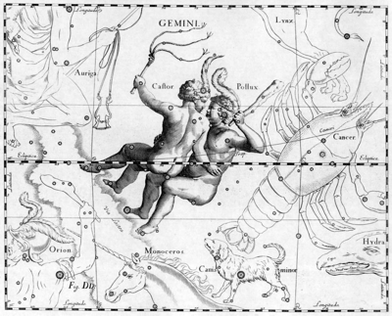

Because it is the most dual of all the signs, the symbolical pictograph by which the ancient Wise Ones explained to their contemporaries, and to later generations, the significance of the influence of Gemini, was made to portray that duality conspicuously. This explanation is the substance of the design which constitutes Major Arcanum 17 of the Egyptian tarot, commonly called, The Star.

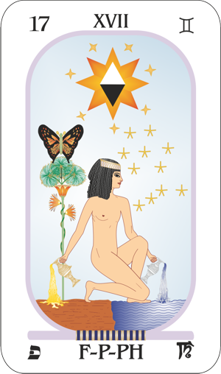Conspicuous in the pictured design is a large star, surrounded by seven smaller stars; these to represent the septenary of naked-eye astrological orbs. They are above the kneeling figure of the one seeking truth, and the implication is, not merely that she is influenced by them in her search, but that through a better knowledge of their function in the universal scheme of things, and of their power, she will be tremendously aided in truth’s acquisition.

This seeker has one foot upon the land, which represents the physical world; and one foot upon the sea, which represents the more mobile astral realm. That is, if she is really to know the Truth, she must understand not merely the appearances of external life, but also the more potent influences of the invisible realm. Her feet symbolize understanding. But characteristically enough of the one who acquires complete knowledge, she places very little weight, or dependence, upon the physical and instead relies for the most part upon the realm of invisible energies which are more potent to bring things to pass.

Powerful among these invisible energies, as indicated by the conspicuous stars above, are those which reach the minds of men from the planets, and which give a trend not only to human thought and endeavor, but also relate in vibratory nature, and thus have an influence over, all objects and forces of the physical world. Thus is the seeker after truth admonished first of all to turn her attention to the study of the influence of the stars.

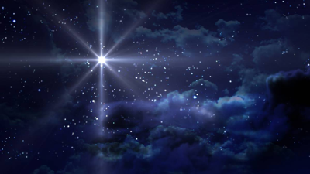

An unusual thing about this seeker is her absence of attire; for she is presented completely nude. Garments are a hindrance to freedom of action, even as prejudices are a hindrance to freedom of thought. Thus is the seeker told, if she would be successful, she must investigate not merely both the visible and the invisible world but, unlike much of scholastic authority, she must divest herself of prejudice and preconceived opinions.

The greatest failure of modem scholasticism is not its inability to devise tests by which facts can be shifted from fallacy; but its stubborn refusal even thoroughly to investigate matters which the present theories it holds fail to explain. Most of its prejudice against astrology has arisen from the fact that it cannot understand how planetary energies can affect human life. Therefore, it is determined not to investigate whether it does affect human life.

The seeker resting one foot upon the land, and the other foot and knee upon the ocean, betokens a realization that truth is dual: the truth of appearances and the truth of reality, the truth of the practical and the truth of the ideal. And to indicate that the loving, emotional side of man’s nature must be nourished if he is to grasp the inner truth, she pours a fluid from a silver cup into the sea; while to indicate the necessity of cultivating the positive, reasoning intellect if the external truth is to be possessed, and to use it as a check against the reports of the inner senses, she pours a fluid from a golden cup upon the land.

Here we have expounded the height of wisdom; that man has two sets of senses and two processes of the mind, both of which should be used in his search for truth. The two conspicuous stars that mark the constellation Gemini — which in turn portrays in the sky through another pictographic design the attributes of the zodiacal sign bearing the same name — are named Castor and Pollux. And in the legend concerning these Twins, the Greeks of old portrayed their knowledge that the mind has two types of processes, such as now we call objective thinking and the thinking of the unconscious mind.

As the story runs, these brothers fell in love with the daughters of Leucippus; but as these fair damsels already were betrothed to the sons of Aphareus, resentment was expressed by these earlier suitors. At last, the rivalry ran so high that a battle took place, in the course of which Castor was slain.

Unlike his brother, Pollux was immortal. Yet so great was his attachment for his brother that he walked up and down the earth, disconsolate and filled with sadness. Interest in life had departed, and he also longed to die.

From his Olympian heights, Jove perceiving the great distress in the heart of the surviving Twin, took pity and made it possible for Castor to share his brother’s immortality. But on one condition: that the two could never be on earth at the same time. While one walked the earth, always the other must remain confined in Pluto’s dark realm.

The mind of man, after the manner indicated in this legend, and after the manner pictured in the Major Arcanum of the tarot explaining Gemini, is now acknowledged to be two, the objective and the unconscious, linked inseparably, like the Twins, so long as life shall last. The objective mind, being dependent upon the physical brain for expression is, like Castor, subject to the forces of death. But the unconscious mind, persisting in the astral realms after the dissolution of the physical, like Pollux, is immortal.

The conscious or objective mind, embraces those states of consciousness, thought, feeling, and visual images which, through the etheric [electromagnetic] energies that connect the astral form with the physical form, impress themselves on the physical brain. Thus, is Castor mortal because when the physical brain ceases to function, he exists no more.

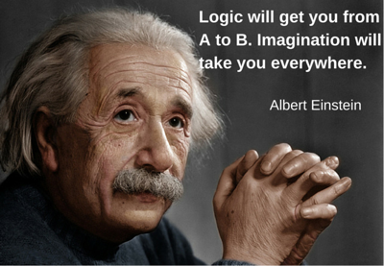

Furthermore, when Castor is on earth, when the objective mind is active as in the fully waking state, the unconscious mind, or Pollux, is below the threshold of consciousness, unable to express except imperfectly on the physical plane. And due to astrological research since the discovery of that planet we now know that Pluto is the planet which rules invisible forces and the invisible, or astral, realm. Thus, in fact, while the brain is active, is the unconscious mind chained in Pluto’s dark domain.

Yet when Castor, the objective mind, finishes his daily sojourn, and departs from the realm of brain activity in the process of sleep — which permits the brain cells, which are miniature batteries, to recharge themselves — and thus enters the realm of darkness, it is then that Pollux holds full sway. In dreams the unconscious mind finds experiences such as it desires, visits the halls of learning, and weaves a pattern of fantasy which, more frequently than not, is all that memory brings back into the waking state.

Occult students have held that in addition to the physical senses which report the happenings of the physical world to the objective mind, there are also corresponding psychic senses which report the happenings of the invisible world to the unconscious mind. And as things physical have astral counterparts in this invisible world, these psychic senses can be used not merely to gain information about the inner plane of being, but also to acquire knowledge of the physical world.

Experiments conducted by Psychical Research Societies, among whose membership were men of international scientific fame, have offered evidence for the last fifty years of the existence of the ability of the human mind to acquire information which could not be gained through the use of the physical senses. But as scholasticism deemed that such evidence was contrary to its theories, this mass of evidence, gradually accumulating over the years, was shoved to one side. The attitude was that if it was unexplainable, it must be untrue. And as it is still unexplainable according to scholastic conceptions, even as is the influence of planetary energy, both are largely conveniently ignored.

But at Duke University mass experiments were conducted to determine if the mind, as occult students and psychic researchers have held, actually has the power to acquire information not available to the physical senses. Hundreds of thousands of these experiments were conducted. Because of the success of these experiments, not less than a dozen other universities took up similar experiments on a gigantic scale. And in the universities where such experiments were conducted, it is now generally accepted — although disputed by many who have not conducted experiments and are unable to explain them — that clairvoyance and telepathy are demonstrated facts.

This faculty of the mind, through which it perceives things at a distance, is able to name the symbols in proper sequence on shuffled cards without them being visible to physical sight, and which at times looks into the future to witness things yet to happen in all their detail, has been abbreviated and is conveniently referred to as ESP, meaning Extrasensory Perception.

Those who are conversant with the reports of the various universities on their ESP experiments will have had the opinion presented to them that telepathy and clairvoyance and other exhibitions of ESP power are one and the same thing. And this may seem to imply that the occultists who have held there were a psychic sense of sight, the exercise of which gives rise to clairvoyance, a psychic sense of hearing, the exercise of which gives rise to clairaudience, a psychic sense of feeling, the exercise of which gives rise to psychometry, etc., were in error.

But this is not necessarily the case. After all, in a strict definition, there is but a single physical sense, the sense of feeling. But organs have been developed which specialize in feeling different things, and reporting them precisely to the physical brain. The eye specializes in nerves which feel all the different gradations of light which makes vision possible. The ear specializes in feeling all the variation in sound vibrations which give rise to distinguishing the different tones and volumes of sound. The tongue and olfactory nerve specialize in a type of feeling which we call the sense of taste. Yet all, nevertheless, are feeling.

It is probably true that the unconscious mind also in a stricter sense has but a single faculty of perception, such as now is known as ESP. But it also seems permissible to divide the specializations of the ESP faculty into the one which gives the individual the impression of witnessing by the sense of sight something not perceptible to the physical eyes, the one which causes him to believe he hears the voice of a friend or loved one warning him, even though the person so warning is hundreds of miles distant, and the one which enables him to pick up, radio-fashion, the thoughts of some person, and to explain those thoughts to others.

But aside from these details, the existence of a faculty of the mind which is able to gain information through other means than the physical senses can no longer be doubted by any unprejudiced person who will read the account of the work done at Duke and other universities, or who will take the pains to investigate himself. And it was the existence and proper use of this ESP ability, as now it is called in scientific circles that the ancients explained in the Gemini Major Arcanum of the tarot.

Truth was not to be apprehended merely by the use of the ESP, although as the seeker rested far more largely upon the waves than upon the land, the scope of investigation through such psychic avenues was far wider. But, as pouring a fluid, and partially resting, upon the land, it was indicated that the reports of the physical senses and the process of logical reasoning should not be ignored.

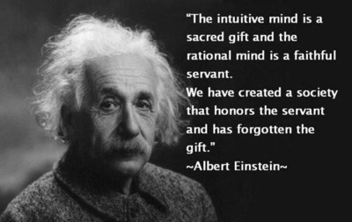

Even the conventional symbol of two joined uprights, by which Gemini is denoted, indicates that the two processes of the mind, and the two sets of senses, should be united, and one weighed against the other, to get the total facts. Objective experiences should be analyzed in the light of psychic perception, and psychic experiences should be checked as to accuracy and significance by objective experience and reason.

This weighing — which will be more obvious in its import when the significance of Major Arcanum 17 of the tarot is understood — of the inner against the outer, and the below against that which is above, is more fully indicated by the eight-point star above the seeker. The two united trines, one white and the other black, that form a part of this eight-point star, in particular point to the old Hermetic Axiom, “As it is below, so it is above.”

And this star of weighing the things of the external world against those of the invisible realm, being surrounded by the septenary of smaller stars to indicate planetary influences, points still further that in her search the seeker shall ever link her finding to the principles of astrology. That is, as all on the external plane, and all in the invisible realm, are linked indissolubly to astrological vibrations, a study of these relationships will prevent the seeker from being led astray.

Yet even in astrology two methods of approach must be recognized. And both have their own value, although Major Arcanum 17 indicates that the best results are to be obtained by a union of both.

The external method is the scientific approach, in which statistics are employed. This also has been the method by which university men have ascertained the existence of ESP. In astrology, for instance, when the birth charts of a sufficient number of aviators are collected, and an analysis of these charts shows that practically all of them have the planet Neptune either in an angle or in close aspect to Sun, Moon or Mercury, I believe we are warranted in considering a prominent Neptune a Birthchart Constant of aviators. And this would signify that in selecting a vocation for some young man, if Neptune were not in an angle, and not closely aspecting Sun, Moon or Mercury, we should be warranted in discouraging him from taking up aviation as a vocation.

Yet an astrologer who had never analyzed the birthchart of a single aviator, but who had an active ESP, as certain astrologers certainly do, might also take one look at the chart of the same young man, and advise him not to take up aviation. He might give a totally different reason for so deciding, but his decision would be quite accurate, none the less. Yet this would not make the finding, as The Brotherhood of Light has done, that Neptune is prominent in the charts of those who make a success of aviation, invalid. It is merely getting the same answer through a different process.

Nor does it invalidate the findings of thousands of people who have had remarkable psychic experiences, that they have not submitted those experiences to the rigid requirements of the scientists who now are investigating ESP. These university men are merely making a different, and more critical, approach; checking their findings by carefully devised external methods.

Major Arcanum 17, however, is not confined to explaining the two types of information-gathering powers of the mind. The flower in the background, with three open blossoms, relates to the efflorescence, or highest types of experience, on each of the three planes: physical, astral and spiritual. The butterfly hovering over these flowers explains that through the power of thought, which Gemini rules, the soul is able to bring about those changes in the form it occupies — comparable to those by which the grub passes through the chrysalis stage — which enables it to demonstrate the high types of experiences symbolized by the blossoms.

That is, the mere acquisition of truth, no matter how comprehensive, has little significance unless used as a basis of action. To understand all that astrology, for instance, can teach, or all the information that can be acquired through the ESP, brings no change in human fortune until that knowledge is acted upon.

Astrology, better than any other science, affords a correct and complete diagnosis of the forces which bring each condition and event into an individual’s life. It reveals the type, and the harmony or discord, of the chief invisible energies received by the individual’s thought-cells at a given time. And it shows which groups of thought-cells are at this time receiving the energy and therefore what departments of life will be influenced. The birthchart itself maps the normal activity and the normal harmony or discord of the thought-cells thus given new energy. There is at hand, therefore, a very good guide as to how the thinking and behavior will be influenced at a given time by unseen energies, and what events the new activities of the thought-cells, acting upon the external environment, will then attract into the life.

Yet acquiring such knowledge, according to Major Arcanum 17, is only half the function of thought. The other half is through its use to attract into the life, not the events that otherwise are indicated, but such as the individual may select, with the end in view of leading on and upward, to taste the nectar of this and higher planes.

The ESP power of the mind, especially when it gives warning of a disaster in the future which can be avoided, seems truly marvelous and in such cases is most useful. But the mind has, in addition to its information-gathering ability, an event-attractive and environment-molding function. All the schools of mental and spiritual healing, all those who through the power of mind teach it to be possible to demonstrate desired conditions, use this executive power of thought.

Undirected, and unconscious so far as the individual is concerned, the thought-cells of the unconscious mind all the time are doing such work of demonstrating conditions. But the conditions they demonstrate, the events they bring into the life, are those demonstrated by the thought-cells which at that time receive an unusual amount of energy from the planets. That is, a section of the unconscious mind acquiring new energy in quantity through a progressed aspect, demonstrates the condition and event in precisely the same manner that the Metaphysical Practitioner, New Thought Advocate, or Divine Healer demonstrates a condition or event into the life of an individual. The only difference is that the new planetary energy reaching the thought-cells often causes them to demonstrate things the individual does not desire.

They demonstrate accidents, disaster, sickness and other misfortune because the individual is unaware of what they are doing, or cannot check them in the work of demonstration they feel impelled to undertake.

It is only through astrology, unless the ESP faculties are cultivated to a high degree of reliability, that we can become aware of what our unconscious mind at a given time is working to demonstrate. Astrology is the one commonly accessible method of knowing what is going on among the thought-cells.

But when the diagnosis is made, something else is required. The manipulation of the external environment to make it easy for the thought-cells to demonstrate favorable conditions, or to make it difficult for them to demonstrate indicated adversity, is a part of this work. But even more important, according to the explanation given in the Gemini Arcanum of the tarot, is the application of thought energy to the thought-cells made particularly active at the time by the planets, to direct them away from their tendency to spontaneous demonstrating, and give them the required impetus to use their energy to demonstrate instead, that which the individual desires.

**The Moon and the Awakening**

First printed in *American Astrology Magazine* July 1938

**Elbert Benjamine**

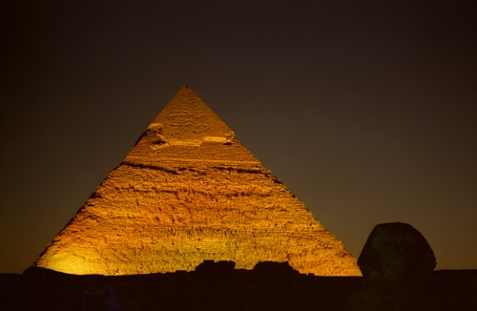

*The original material has been edited for accuracy  
and to improve ease of reading.*

Even at the present day when arbitrary forms of speech have long since displaced the more primitive use of symbols—like those employed by the tarot—to convey ideas, it is not uncommon to refer to the highest point as being nearest to heaven. This highest point in the zodiac is the place for which pyramids and mounds were erected not only in Egypt, Chaldea and India, but also in ancient America. Such pyramids form a conspicuous feature of the symbolical pictographs used by the ancient Wise Ones who designed the Egyptian tarot to explain the influence of the zodiacal sign Cancer.

The highest point in the zodiac—so far as we of the northern hemisphere are concerned—is the place where the Sun attains its highest northern declination, just as it moves across the solstitial colure from Gemini into Cancer. The Great Pyramid of Egypt was so constructed that at noon on the day the Sun thus entered the sign Cancer, this symbol of spirit and deity appeared to those looking up the northern side as a ball of fire resting on the apex of this representation of the twelve houses of earthly life. And to indicate this same spiritual idea of the earth at times being in direct contact with the realm of spirit, on the night of the summer solstice fires in olden times were lit and kept burning on the tops of the pyramids of Mexico.

Even on the pyramids which so long have remained concealed beneath the great mounds in the Mississippi Valley, some of which recently have been unearthed, there is evidence that such fires periodically were lit on their tops. It seems that even in these, although more crudely expressed, there was an attempt to embody the same formulas, astronomical proportions and cosmic knowledge, which in greater detail and finer precision are incorporated into that most wonderful of all monuments of stone, the Great Pyramid of Egypt.

We do not know just how vast was the range of information possessed by those who built these pyramids in various lands, because as scientists of the present day make new discoveries regarding the structure of our universe, it becomes apparent that at least as general conceptions, such also are included in these monuments to the Wisdom of the past.

So far as we have evidence to indicate, however, it seems that in the work these ancients usually contemplated they had no need for, and did not use, the minute precision which marks the work of present-day laboratory scientists. Their knowledge of astronomical ratios and cosmic relations was derived from applying the Law of Correspondences with the aid of their finely developed psychic faculties—such as the sign Cancer facilitates in the highest degree—rather than through the use of refined mechanical contrivances such as are employed at the present time.

They were interested in the forces and entities, seen and unseen, with which the universe abounds, as they relate to human life and destiny, here and hereafter. And in addition to leaving rules for the safe and successful use of the psychic faculties, it is to their everlasting credit that they worked out a mathematics and formulated methods of procedure, which were adequate to meet their practical astrological requirements.

These ancients held that the commencement of Cancer represented the gate to heaven.

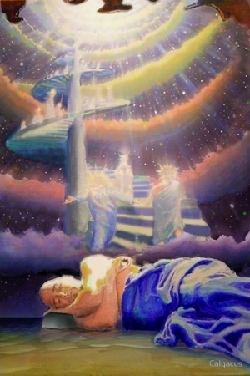Jacobs' Ladder

The degrees of the zodiac are not unlike the rungs of a ladder which arches the firmament, extending from earth to sky. And thus, was it that Jacob dreamed of such a ladder set up on the earth, and the top of it reached heaven; and angels of God were ascending and descending on it. In this manner do the Sun and various planets move higher and higher in the sky until they reach the first of the sign Cancer and then start their descent to lower declination.

Angels more commonly are considered not to be going up to heaven and returning, but to be coming down from heaven to visit earth and then going back to that higher plane. Yet in Jacob’s dream they were going up, as the Sun ascends to reach the sign Cancer and then coming back to earth, as the Sun again descends after it reaches that family sign.

Such a going up and coming down as the Sun is observed to do each summer evidently signified to those who traced the starry pictures in the sky and gave to each a story, such as the one that has come down to us in Jacob’s dream, a going up and coming down which was suggestive of the movement of those intelligences which have no physical form and which, for want of a better term, may be called angels.

That is, it was their belief that the Soul made progress by gaining experiences in one physical form, passing at its dissolution into the astral world, as Jacob saw the non-material beings do in his dream, and after a period of experience and assimilation in the astral world, descending, as Jacob saw them do, to occupy another, but more complex, physical body on the earth. Each such form occupied constituted one rung in the Soul’s evolutionary ladder.

Every physical cell, every germ or shoot which develops into bacterium, plant or animal is dependent upon parenthood for its existence. And thus, until at last it has gained experience in a human form and by virtue of the development of human consciousness, is free henceforth from descending Jacob’s ladder to the earth, it must have parents who provide it opportunity to gain a new physical body. And such parenthood is more closely associated with the home sign Cancer than with any other zodiacal position.

This coming back to earth for new experiences until the human form has been reached, and the coming back of the Sun toward earth in declination, is suggestive of the movement of the Crab. This creature does not move directly forward as other creatures are wont to do but has a backward side-wise gait. Its movement thus most fittingly represents the backward motion which is adopted by the Sun so soon as it enters this domestic sign.

Yet the coming back to earth by forms of life lower in the evolutionary scale than man for the purpose of gaining those experiences which fit them for a human form, which in turn will fit them for life on a higher plane; and the passing to the inner plane by such lower forms, or the more permanent transition to a higher plane by those who have experienced human life, are not the only passings through this zodiacal region which anciently was called the Gate of Heaven.

Of all the signs Cancer is most sensitive to its environment, be that environment physical or astral. More than any other sign its mediumistic quality facilitates contact with the denizens of the inner plane. Thus, in their heritage to future generations, those who drew the tarot pictures evidently felt that their information relative to mediumship should be set forth in the design of Major Arcanum 18, depicting the attributes of the sign Cancer.

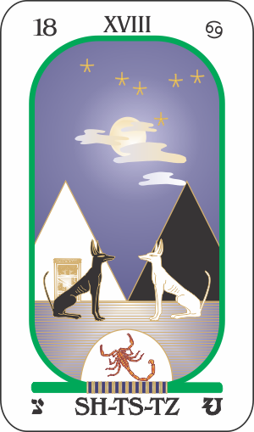The design, here illustrated, shows a highway**\***, symbolizing that the instructions relate to a road that may be traveled. And conspicuously in this road, so placed as quickly to catch the eye, there is a scorpion, the symbol used among the constellations to designate the sign Scorpio, which is the natural ruler of the house of death. Obviously, therefore, this is a highway through which in some manner the individual contacts death, or those who already have passed through the Cancerian Gate of Heaven to dwell in the invisible realm.

***\*****The reference to a road is based upon imagery from a tarot deck Elbert Benjamine used while writing this article. At the time of writing, The Brotherhood of Light Egyptian Tarot cards had not been developed. The card pictured here is from The Brotherhood of Light Egyptian tarot, developed under Benjamine's supervision in the early 1930s. Applying Benjamine's text above to the image he developed is difficult to reconcile since there is no road in the Brotherhood of Light Arcanum XVIII. What is important to keep in mind is that both the above text and the pictured card represent times when our surroundings and/or the path we travel feels unfriendly, uncertain, changeable, with only dimly perceived information for moving forward and making decisions.*

*For a detailed description of The Brotherhood of Light Egyptian Tarot, Arcanum XVIII, see Course 6,****The Sacred Tarot****by C. C. Zain*

This road also holds two other creatures. They are dogs, the traditional companions and friends of people. Thus, they give information that in that realm so aptly designated by the eighth-house sign Scorpio, there are companionable intelligences, those which at least pretend to be friends. And some of these pictographically are shown to be kindly, truthful and benevolent; faithful to the interests of the traveler of that road, and loyal to their welfare. This symbolism is portrayed by the dog of white.

White contains all wavelengths of visible light and is symbolically associated with harmony and enlightenment. By contrast, black is the absence of light, absorbing all the colors of the visible spectrum, reflecting none of them back to the human eye. Symbolically black represents darkness, ignorance and malice.

The invisible realm is the home of departed loved ones and therefore populated by true friends and helpful intelligences. This dog of black symbolically indicates that in that region there are also evil, lying spirits who treacherously pretend to be friends, but who, given the opportunity, work diligently for selfish purposes and to the seeker’s undoing.

Why this is true is explained by the pyramids in the background. Such a pyramid has four sides, each side presenting the form of a triangle. From the square base of matter these triangles slope to a point above, where life takes off from the physical to enter existence on a higher plane. These four triangles which thus lead to a higher phase of existence represent the houses of the chart of birth:

* One triangle relates to the **Trinity of Life**: The First House represents the life of the body; the Fifth House represents the life of the Offspring; and, the Ninth House represents the life in Philosophy or Religion.
* One triangle relates to the **Trinity of Wealth**: The Second House as wealth in Personal Possessions; the Sixth House as the Labor by which wealth is acquired; and, the Tenth House as the Business through which wealth is made available.
* Another triangle relates to the **Trinity of Association**: The Third House represents the association with thoughts and brethren; the Seventh House represents association in marriage and partnership; and, the Eleventh House represents association with hopes and friends.
* And finally, there is the **Trinity of Psychism**: The Fourth House—whose natural ruler is the sign Cancer—represents the influence of the home and the end of life; the Eighth House represents the influence of those who have passed from earth; and, the Twelfth House represents the influence of secret enemies, sorrows and astral entities such as are symbolized by the black dog in the Eighteenth Major Arcanum of the tarot.

All possible human activities are embraced within the departments of life mapped by these twelve houses so aptly symbolized by a pyramid. Each maps a distinct compartment within the astral body wherein are located the thought-cells derived from previous experiences which relate to the affairs of life designated by that house. And it is the unusual activity of the thought-cells mapped by such a house, due to their acquiring new energy in volume through a progressed aspect to the planet ruling the house, that attracts each important event that enters the life relative to the department of affairs the house thus designates.

One of the pyramids shown in the tarot card called **The Moon** is white in color, symbolizing a life of light, harmony and rectitude. The other pyramid is colored black to symbolize a life of darkness, wickedness and dissipation. In the road passing these two pyramids there are two dogs of similar color. The symbolic information conveyed is that an individual’s thoughts, motives and actions—that is, the kind of life they live—determines the type of unseen intelligences attracted from the unseen world. If kindly and true the person will attract those from the after-death life of like character to be invisible friends. But if gross, selfish and wicked they will attract invisible intelligences who are cunning and bent on depredation.

These pyramids at the side of the road which leads to the after-death world also reveal why there are wicked intelligences in the unseen realm as well as those better disposed. Each pyramid reaching its apex to the sky indicates a type of life which at the dissolution of the physical enters its existence on the inner plane. For that matter, as the Sun’s entrance into Cancer interpreted by Jacob’s dream and by the apex of the pyramid implies, not only humans but all forms of life pass to this astral realm and abide there at least for a time following physical death. And people who live a certain type of life and therefore have built certain desires strongly into their characters—that is, into the thought-cells of their unconscious minds—do not change merely because that unconscious mind or character no longer possesses a physical body.

The real character of either a human or an animal is not their physical body, it is the thought-organization of their unconscious mind. And it is because a birthchart maps the thought-cell organization of the unconscious mind that such a chart reveals so much relative to the abilities and character. The physical body of an individual, to be sure, is powerfully molded and influenced by the unconscious mind; but the unconscious mind does not alter its structure greatly merely because, as at death, it no longer can function in association with a physical form. The unconscious mind immediately after physical death is practically the same as before departing from the material world.

It is true that the unconscious mind, or real character, of the individual has opportunity to learn and progress on the plane which Pluto, the planet of Scorpio, rules. But changes of character in that invisible region are no more apt to take place suddenly than they are during the same individual’s sojourn on earth. Therefore, in the invisible region immediately surrounding the world there are the same kind of people that one finds on earth. Some are well disposed and kindly, symbolized by the white dog; and some, such as those who have been gangsters and racketeers while on earth, are alert to force their will upon any unwary person and to use them for their own iniquitous purposes. Such is the symbolic significance of the dog of black.

The type of entities a person naturally attracts, as shown by the color scheme of both dogs and pyramids, is determined by thoughts and motives. That is, provided a person makes no special effort to develop an unnatural relation with the invisible realm.

The road, however, with the Scorpion symbol of the unseen world in it, points to a closer contact with the intelligences symbolized by the dogs, than merely the impressions by which one who is sensitive often is influenced by such entities without being fully aware of their existence. It implies that highways are open by which a closer and more conscious contact can be made with those who have passed to the after-death life.

But perhaps the most important of all that which is explained by this Major Arcanum 18 of the tarot, is that there are two distinct and diametrically opposite methods of coming into conscious contact with such unseen entities:

* The séance room in which control by unseen intelligences is invited and cultivated, is most effective in gaining its objectives when there is darkness, or at least a very dim light, such as is represented in the picture by the Moon hiding its face behind the clouds.
* The other method is achieved when the individual expands their consciousness through volitional effort, until it contacts the intelligence it seeks. In so doing they have as much control as an individual has when they put on their hat and go out to find and talk to a given friend. This method is represented by the circle of sunlight falling upon the road.

Although at times the result obtained is similar, these two methods of contacting the intelligences of the unseen world are as different as day from night, as Sun from Moon, as positive from negative and as integration from disintegration.

Even as the Moon can only reflect such light as the Sun affords, so that form of mediumship which invites the control of some other intelligence can only see, hear, feel and think that which the control is willing to permit. And the process of developing such negative mediumship is the work of abandoning one of the main objects humans have struggled so hard to acquire in their evolution.

Humans, I believe most would agree, are human and not something else because they have learned how to utilize and control very numerous and complex forces and functions. The Soul, which embraces all the various states of consciousness stored in their astral and spiritual makeup, is able to function through the human body on the physical plane only because through a long period of education and effort it has learned how to control such a body.

The process of evolution is a schooling in the capture, storage and release of energy. The whole struggle for survival is but a struggle of the species and the individual to preserve and perpetuate the control of its organism. Any tendency, therefore, to relinquish the control of the human body or permit another to control it tends toward the destruction of the individuality.

As control is gained by effort and practice, loss of control follows lack of effort and practice. Fish that live for generations in the water of underground caverns often lose their sight. The college athlete ten years after leaving college is unable to do many of the things they could easily do while in college. And every form of life, from its birth to its death, must struggle against the invasion of its organism and more or less complete control of it by other entities. When it ceases to resist it soon perishes.

Whenever any form of life ceases to resist invasion, there are always entities eager to use this loss of control to their own advantage. Whenever a person has relaxed their vigilance politically, they have been despoiled. Look at history and weigh this well. Whenever people cease to resist it, religious intolerance takes control. Read history again. Likewise, whenever people relinquish the control of their body and mind to another they are inviting slavery to a master of whose identity they cannot be sure. It may be to an entity such as in the tarot picture is symbolized by a white dog; or it may be to a deceiving entity, or a racketeer, such as is symbolically represented by the dog of black.

The spirit medium who undergoes so-called development by becoming passive and permitting some discarnate entity to take control, is undoing the most important work of their life and of evolution. Instead of resisting invasion they are permitting another entity to build lines of force in their astral body that when strong enough will permit that entity to take possession of the brain and body in spite of its rightful owner any time it desires to do so. They are permitting lines of force to be established that provide an open door by which any other entity, such as the wicked dog symbolizes, on the physical or invisible plane may gain a like control over them.

The teaching of the Moon disappearing behind the clouds of Major Arcanum 18 is that every time a person goes wholly or partially under control of a spirit, a mesmerist, or a hypnotist, they are assisting in the destruction of their own individuality. Permitting such control is irresponsible and disintegrative mediumship. Persisting in such practices bring the unfortunate subject or medium to a state where they are helpless to repel the invasion of their organism by any active entity, incarnate or discarnate. Irresponsible mediumship tends to destroy the Will and the Soul.

The light of the Sun falling on the road to the realm where intelligences that once were of earth dwell, tells a very different story. It points in unmistakable terms to a method of contacting, not just any intelligence which may be attracted to the séance room by the character of the lives of those attending the séance, but such intelligences only as may be selected. And as the Sun needs no help to gain in brilliance, this method is positive, under control and its cultivation strengthens the Will and increases the independent activity of the Soul.

In this positive method of making voluntary contact with selected intelligences, or with any specific selected environment of the inner plane, there are four distinct steps, each of which when properly performed is as much under the individual’s conscious control as if they were going on the physical plane to see a friend and talk with them, or going on a trip to a given locality.

* First of all, inhibit objective thought to the extent there is no consciousness of the flow nerve currents or thinking other than being aware of inner plane activities.
* With this achieved, withdraw consciousness from the physical world and transfer it to the unconscious mind. There will be a feeling that consciousness is functioning on the inner plane.
* Then send consciousness to the person or object that is decided to contact. This does not mean traveling in the astral body, but merely an extension of consciousness and a radio-like tuning in, by which a person comes intimately into association with the person or thing as determined.
* Finally, endeavor to bring as much as possible of the information or experience up into the region of objective consciousness, and apprehend with normal thoughts its true purport.

The unconscious mind at all times resides on the inner plane, and under proper training has access to the intelligences and places of that plane. For each of the four indicated steps, there is a definite training to develop a successful technique. The difference of this method from irresponsible mediumship, however, which is the teaching of **The Moon** tarot picture, is that the individual at all times during each of the four steps is positive, alert, fully conscious of what is taking place and has every factor in the process completely under their own control.

**The Sign Leo and the Sun**

First printed in *American Astrology Magazine* August 1938

**Elbert Benjamine**

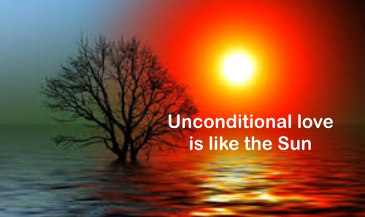

*The original material has been edited for accuracy  
and to improve ease of reading.*

Outstanding characteristics of the sign Leo are the dominating power conferred by its astrological orb, the Sun, which gives to it ability for rulership; and its natural affinity for the fifth house of a birthchart, which maps the mental factors within the individual’s mind relating to pleasure and love affairs. Consequently, when the masters of the past came to design a pictographic explanation of the teachings associated with the sign, it was quite in order they should make the Sun a conspicuous part of the picture, and that those in love should also find prominent place in the portrayal.

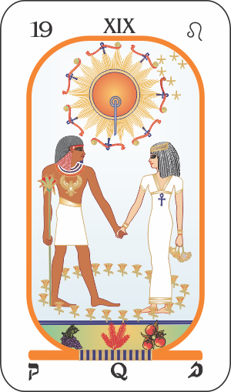That the significance of the teaching should be unmistakable, the ensemble pictures a young man and a young woman holding hands and adoringly gazing into each other’s eyes, and in the Sun above them was traced conspicuously the well-known emblem of union.

Leo is not the sign of sex. It is the sign of love.

The rays of the Sun above are grouped in threes, tied together by an emblem on one end of which is the globe of earth, in the middle of which is the symbol of union so located as to represent the astral plane, and at the other end the head of the solar serpent to signify the spiritual — thus symbolizing perfect union expressed on all three planes — not only the simplicity of garb, but the lotus each figure carries implies the purest of affections. And the flowers springing up about them symbolize the joy and happiness of the domestic circle which more than compensates those thus united in simplicity of life, moderation of desires and purity of thought, for any material hardships they must undergo.

The number 20, as will be explained in the next article of this series, relates to an awakening and resurrection. Thus, the 20 flowers encircling the lovers signify the potency of domestic harmony to Awaken and Resurrect the spiritual flora of the soul; and that pleasure is the determining factor which guides the activities of all organic life even as the Sun controls the planets which circle about it. That is, just as astrologers recognize Leo as the ruling zodiacal sign, so does the science of psychology recognize pleasure, a principle to which the fifth house of a birthchart is closely allied, as the ruling motive of human life. It is also the ruling motive of those activities energized by the progressed aspects of the planets which attract each event of importance that enters an individual’s life.



But if we are to understand how this principle of pleasure operates when progressed aspects form we must recognize that events are the offspring not of one parent, but always of two. Arcanum 19 of the tarot clearly indicates this in picturing the sign Leo, natural ruler of the house of offspring. Not one lover is pictured, but both a man and a woman; and they join hands to signify that what comes to pass is the result of forces interacting between them. Yet there are many people who still believe that events are the offspring of but a single parent, either of the physical world alone or of the invisible world alone, without the aid of the other.

Thus, on the one hand we have the materialist, who sees in the physical world alone all the forces which mold events. He denies even the existence of an invisible world in which mind can and does function. To him the unconscious mind is merely an excretion of the physical body, and the forces of the planets which play upon the finer form of man like streams of water under pressure from so many different hoses, are quite non-existent. The events of life are considered by him to have but one parent, the material world, and when the physical form disintegrates the unconscious mind or soul disintegrates and perishes also. On the other hand, we have the astrological fortune teller. His knowledge of the inner world usually is limited by the inflexible rules on which he believes astrology to be based. He is convinced, and has ample evidence to support his convictions, that the stars constantly influence the life and destiny of every human being. And because experience on the part of everyone who takes the pains to learn the generally accepted rules of astrology leads to a conviction that man is thus influenced, he jumps to the totally unwarranted conclusion that the invisible influence of the stars is the sole and only parent of each event which occurs in an individual’s life. Thus, the fortune teller astrologer maintains that everything indicated in the birthchart and by progressed aspects inevitably must come to pass. To him the planets in their courses predetermine each event and human action.

But if the teachings the ancients explained in the Major Arcanum depicting the fifth sign of the zodiac, Leo, are correct, events — like children — are not the offspring of one parent alone but of two. They come to pass not exclusively through the influence of the inner world, but through the interaction between this Father World and Mother Earth.

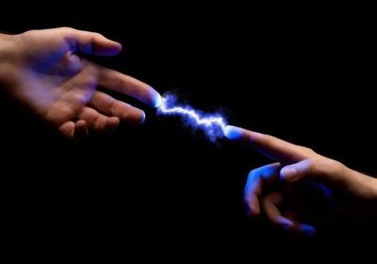

When people clasp each other by the hand, as the lovers in this picture do, there is an interchange of energies. Thus, also is there a constant interchange of energies between the astral world, where the unconscious mind of man resides, and the world of physical happenings. The world of physical happenings adds the energies of the individual’s various experiences to the thought-cells and thought-structures of his unconscious mind. Thus, his physical environment and what transpires in it as affecting him, add energies to his unconscious mind which condition the specific direction of the desires of the thought-cells of his unconscious mind. He starts in physical human life as a babe in whose unconscious mind are stored the experiences of evolution through lower forms. These experiences have organized the thought-cells and structures within the mentality such as are mapped in kind, intensity and the general direction of their desires by the positions of the planets in the birthchart.

The prominence of each planet in the birthchart indicates the volume of energy possessed by the corresponding family of thought-cells within the unconscious mind. Thus, the prominence of Mars maps the vigor of the Aggressive thought-cells, the prominence of Saturn maps the vigor of the Safety thought-cells, the prominence of the Sun maps the vigor of the Power thought-cells and so on with the others of the ten families of thought-cells whose expression comprises the sum total of man’s behavior.

The signs of the zodiac in which these planets are found in the birthchart denote that the Aggressive thought-cells, Utopian thought-cells, etc. mapped by the planets have a basic trend toward expressing in the manner characteristic of the sign in which they are thus mapped.

The department of life involved in the experiences which built these thought-cells before human birth and the department of life they will affect during human life, is mapped in the chart of birth by the house which the planet rules.

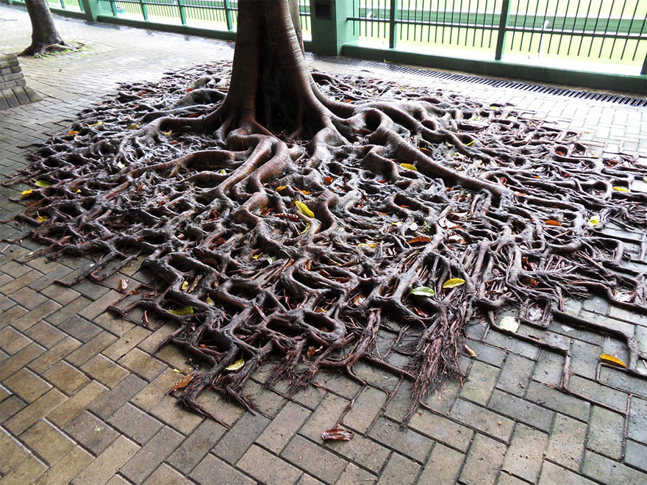It is the *extra-physical power* exercised by the various types of thought- cells and thought-structures of which the unconscious mind, or soul, is composed that attracts to the individual the conditions and events of his life. We must not conclude, however, that the *activity* of the thought-cells of the unconscious mind is the sole determining factor in the events and conditions which an individual experience. They are the *father* of those experiences and the physical environment is the matrix which restricts or expands their ability to bring forth special events; that is, physical environment is the *mother* which gives them form, and no offspring as an event can be born which the *mother* is incapable of providing.

It is one of the most fundamental principles of life that organisms move toward that which gives them pleasure and retreat from that which gives them pain. And desire was developed by the soul as the energy through which it moved toward or away from a condition in its environment. Those conditions it felt to be pleasurable it had a tendency to move toward that it might gain their benefit. And the energy of this tendency, whether simple or complex, was an *attractive desire*.

Those conditions the soul felt to be painful it had a tendency to move away from that it might escape destruction. And the energy of this tendency, whether simple or more complex, was a *repellent desire*.

All the actions of life, including even the manner in which the thought- elements combine in the thought-cells of the astral body and the way the thought-cells unite in groups to form stellar structures, are *conditioned* by pleasure or pain. Thought-cell groups within the unconscious mind that have been *conditioned* by pleasure are mapped by planets in the birthchart which receive harmonious aspects. But thought-cell groups within the unconscious mind that have been *conditioned* by pain are mapped in the birthchart by planets which receive discordant aspects. Thus, the *aspects* either in a birthchart or by progression indicate whether the thought-cells are *conditioned* by pleasure to cause them to desire and exert such *extra-physical power* as they can acquire to attract events such as the individual wants; or are *conditioned* by pain to cause them to desire and exert such *extra-physical power* as they can acquire to repel the events the individual wants, which signifies they work to attract events of the opposite nature.

The thought-cells within the unconscious mind of a child at birth, as indicated by the planets in the birthchart, provide a map showing the relative volume of energy of each family of thought-cells. And whenever such a group of thought-cells receives sufficient energy, as it does through a progressed aspect to the planet mapping it, that it has *extra-physical power* to *demonstrate* an event, the event that then comes into the individual’s life invariably shows the planetary characteristics. That is, if the progressed aspect is to Mars, it is accompanied by strife; if the progressed aspect is to Jupiter, it is accompanied by abundance, etc.

Furthermore, the event or events then attracted while the progressed aspect is within one degree of perfect relates to the department of life signified by the house which one of the two aspecting planets rules. We have proved these things in statistical studies made during the past nine years covering 1,800 separate and distinct events that have actually happened in people’s lives whose times of birth are known.

Furthermore, by considering the basic harmony or discord of the thought- cells as mapped by the aspects in the birthchart in connection with the harmony or discord of the planetary energy added to these thought-cells by a given progressed aspect, a good indication may be had as to whether the event attracted by the *extra-physical power* of the thought-cells at the time is harmonious or discordant to the individual. That is, to the extent it is possible to gauge the pleasure or pain of the thought-cells given unusual *activity* by a progressed aspect, is it also possible to gauge whether working from the inner plane they are trying to *demonstrate* that which the individual desires or something they desire and the individual does not.

Now the astrological fortune teller holds that the birthchart and subsequent positions of the planets not only predetermine the general characteristics of each event which happens — as shown by the aspecting planets, the department of life affected (as indicated by the house rulership of the planets) and the harmony or discord of the event — but also its specific nature. Arcanum 19, however, teaches that the specific event which is thus *demonstrated* by the thought-cells receiving the energy of a progressed aspect, often largely is determined by the resistance offered by the physical environment to various specific events of the general character indicated.

The Church of Light has collected and studied the charts of aboriginal people of the African equatorial region and of those born in Alaska. And while it is true that in the northern regions certain signs tend to occupy more houses, and others to be compressed within certain houses, otherwise the charts of New Yorkers, African Bushmen and Alaskan Indians present the same appearance. In fact, from the birthchart alone none of our students has ever pretended that he could tell if the chart was that of an African Bushman, a Polynesian from the South Seas, a native of the Bronx, an Indian or a Setter Dog.

I have seen dog charts; the planetary positions in which were so nearly identical with those of educated people whose charts I have seen, that the difference was too imperceptible to influence an astrological reading of the chart.

People in Alaska, in New York City and in Equatorial Africa have similar birth charts. And during their lives they have progressed aspects which are practically identical.

At birth they started with thought-cells within their unconscious minds which were similar in the relative volume of energy, which had the same planetary family characteristics, which related to the same departments of life and which were similar in harmony or discord. But in the specific desires developed by these thought-cells they were *conditioned* each according to the physical environment. The Alaskan Indian of the interior region was *conditioned* to take long snowshoe trips in winter, to provide himself with warm garments of fur and to follow the various traditional customs of his tribe. In such environment no birthchart positions and no progressed aspect could cause him to take a daily ride on the subway or do any one of innumerable things a New Yorker commonly does. Nor could they cause the native living in Equatorial Africa to travel on snowshoes or do any one of a large variety of things the northern Indian finds commonplace.

From the large number of births charts I have given detailed study; I have no reason to suppose that people born in the southern United States have Saturn less afflicted as a rule than people born on the border of Canada. Nor that people born in the well-recognized goiter areas of the world have afflictions in Taurus, or Venus and the Sun afflicted, more frequently than people born in the other areas of the world.

Yet it has been found that tooth decay in American school children increases steadily as the distance from the equator increases. This has been attributed to the decreased amount of ultra violet light reaching inhabitants of the northern latitudes. Tooth decay is indicated in the birthchart by an afflicted Saturn. But where the physical environment is more favorable to sound teeth, providing the vitamin D through the action of abundant sunlight and thus increasing the ability to handle calcium, the influence of discordant Saturn thought-cells on the teeth is less inimical.

A predisposition toward goiter is shown by afflictions in Taurus, or Venus and the Sun afflicted. The time when it develops is when by progression there is also an affliction to the planets in Taurus, to Venus or to the Sun. Yet in those regions of the earth lacking iodine in the soil the prevalence of this difficulty — in some areas of Tibet, for instance, affecting one person out of every three — indicates that there it requires far less affliction from either birthchart or progressed planets to bring on goiter than it does in certain other unusually well iodized regions where this disease is practically unknown.

These observations and hundreds of others that could be cited, while quite discrediting the fatalistic view of the fortune teller who uses astrology, in no sense detracts either from the merits or the use of scientific astrology. They simply point to that which the ancients endeavored to explain in Arcanum 19 of the tarot, that the specific event which under a given birthchart and a given progressed aspect is born, is not identical if the mother — that is, the physical environment — is different.

The thought-cells relating to certain broad types of events and affecting definite departments of life, have a basic *activity* and a basic harmony or discord, and these are mapped by the birthchart. It has been definitely proven by psychologists that all an infant’s reactions to environmental conditions — except swallowing, closing the eye when the cornea is irritated, sneezing, response to deep pressure, loud noise, restraint and sudden movement as in dropping — are *conditioned* by the pleasure or pain experienced in connection with subsequent physical situations. And while the thought-cells within its unconscious mind work to *demonstrate* certain physical situations within the environment, they can only utilize that which the broad environment can furnish for such purposes.

An individual with many planets in his third and ninth houses, for instance, may become so *conditioned* by early environment that the events which the thought-cells so mapped constantly endeavor to *demonstrate* relate not to travel, but to writing and publishing.

I have tried this: thrown a birthchart of some person on the screen, and informed the students of all the progressed aspects which were within one degree of the perfect aspect at a time which I had not yet specified in the person’s life. I have shown at the time that the ruler of the fifth house, the ruler of the seventh house and Venus were all strongly and harmoniously aspected by progression. Immediately the students would suggest that the individual must then have married. At this point I revealed that at the time the person was only six years old. The answer was obvious. The fifth house *activity* related to school, the seventh house to school associates and the Venus aspect stimulated such affections as are common to six-year-olds.

Without so informing the class, I have thus used charts of those already happily married and shown progressed aspects favorable to the fifth and seventh house. When they suggested the event attracted was marriage, I would explain such to be impossible without bigamy. That is, progressed aspects indicating marriage to an unmarried person of the right age may indicate the birth of a child and a favorable business partnership to a person already happily married.

The environmental resistance offered the fifth house and seventh house thought-cells to the marriage of a six-year-old child, or to the marriage of a person already happily married, is so great that these thought-cells cannot *demonstrate* this particular event. They thus spend the energy derived from the progressed aspect in *demonstrating* some other event, which partakes of the characteristics of the planets making the aspect and belongs to the same general department of life.

It is even logical to suppose — and there is abundant evidence in support of this conclusion — that the special event which the thought-cells *demonstrate* at the time they acquire new energy from progressed aspects is determined by the general trend of that which gives them pleasure, but within this more general scope the event occurs to which environment offers the least resistance. But even here the Leo principle of pleasure is the determining factor, for in thus seeking the event which within the broader scope of their desires is most easily brought to pass, these thought-cell *activities* which are the *father* of the event, avoid the pain of work which is too difficult, and permit *physical environment*, which is the *mother*, to have a deciding influence as to the specific event which is then born.

**The Moon and the Sarcophagus**

First printed in *American Astrology Magazine* September 1938

**Elbert Benjamine**

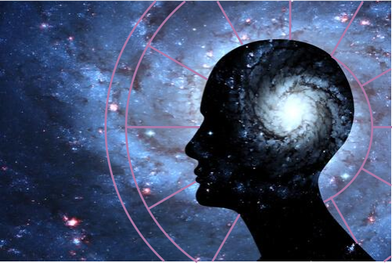

*The original material has been edited for accuracy  
and to improve ease of reading.*

The position of the Moon in a birthchart maps that thought structure within the astral body which affords the most open avenue by which impressions and information find access from the outside world to the unconscious mind. The Moon-sign thus indicates the type of experiences most easily received and most readily assimilated by that unconscious mind. And thus, the general trend of the mental activity is shown by the Moon. But the method and facility with which such thoughts and those arising from the character and the personality express, is markedly determined by the sign occupied and the aspects made by Mercury.

As the birthchart is a map of the soul, or unconscious mind, showing its thought organization at the moment of birth, every planetary position in it and every aspect is significant of its structure. But as the Moon position is the easiest avenue of access to the unconscious mind, when an orb is sought to symbolize this inner plane organization of thought and feeling, which alone survives the dissolution of the physical body, this luminary is the one chosen.

Thus, when the Masters of olden times desired to explain, in the language of symbolical pictograph, that man survives beyond the tomb and that family ties continue on the inner plane, they expressed these ideas in the tarot design of Major Arcanum 20, which is associated with the Moon.

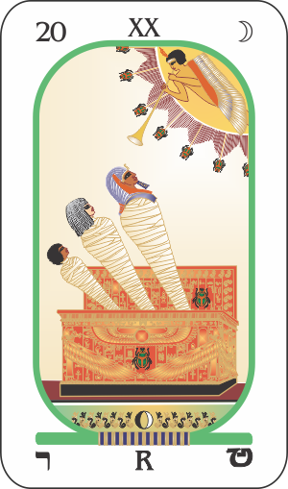The symbolism of this Moon tarot card, which is here illustrated, is simple and most obvious. A spirit in an aureole above sounds the trumpet of resurrection and a man, woman and child, still wrapped in their winding sheets, arise from a sarcophagus. The conspicuous, conventionalized wings indicate the overshadowing of a benign deific intelligence and is commonly used wherever it was desired to express protection by such a higher power.

The only other conspicuous symbol is the scarab. The scarab belongs to a family of beetles whose members are common not only in Egypt but also in America. They lay their eggs in a little ball of filth which they roll along the ground to a deep hole which they have excavated in the earth. They drop this ball, which is a miniature of our terrestrial sphere, into the hole and then fill in the space above it with earth. When the larva hatch, they live on the organic matter of the ball, still deep in the ground, as man born into earthly conditions must gain mental food from sordid as well as more pleasant experiences.



But the grub of the scarab — the American variety of which when they find them in the cow pastures, as they do commonly in spring, the farmer boys call tumble-bugs — does not remain encased in the filth, nor does it stay deeply buried in the dark ground. When it has had enough food to mature it undergoes a change and emerges with wings. No longer is it tied to earth and no longer does it live in filth. Instead, now it is free, like the soul after death, to fly wherever its desires shall prompt.

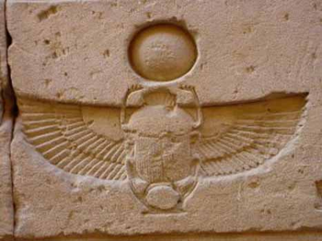

Thus, was the scarab sacred to the Egyptians as symbolizing that most cherished thought: the unconscious mind of man does not perish with the change that overtakes the body in physical death but arises from the earthly tomb and continues life, with all its better associations, in a realm above the scene of its former sorrow and strife.

And although most religions hold to the persistence of the personality after physical death, a curious paradox exists; for most of these believers have set their faces obdurately against anyone who is willing to offer definite proof that such survival is an actual fact. But I need not here mention and list the names of the many outstanding persons in the domain of material science who have taken every precaution to prevent deception and after investigating in a thoroughly scientific manner have publicly announced, even though they knew it meant a certain martyrdom to do so, that they had demonstrated satisfactorily the continuation of conscious life beyond the tomb.

Instead of citing these evidences which were considered proof, it seems better to point to certain things we now know in the realm of material science as indicative of how it is possible for those after life experiences to take place, which are implied by the tarot design of the family being resurrected to continue its functions in other spheres.

Should I mention Einstein and his *General Theory of Relativity*, at once many people will get the impression that I am talking about something that perhaps only twelve people in the world have enough brains to understand. And I certainly am not one of the twelve who understand the complex mathematical equation by which Einstein expresses the general law which he seeks to prove; I do not even know the significance of the mathematical symbols used.

But to understand Newton’s conception of gravitation as applied to the orbs of the solar system it was not necessary to understand the complex mathematics by which he could plot the precise position of a planet in its orbit at any given time. Nor is it necessary to have much mathematical knowledge to grasp many of the outstanding implications of Einstein’s theory. In fact, I feel sure that the average person, with a reasonable amount of study, can quite well grasp the significance of the principles involved in Einstein’s *General Theory of Relativity*.

That theory was formulated in the attempt to explain observed facts in physics which classical mechanics and no previous theory could explain. It may be true and it may be erroneous, but at least it is an aggressive attempt to find a solution to a problem that so far had not been solved by other means. It may be only partly true and thus needs alteration. But we may be sure that man’s ingenuity before long will find methods of testing it more fully in an experimental way, and that as soon as such tests are devised in sufficient number it will become established as a part of scientific knowledge or discarded in favor of some other explanation.

The only excuse for dragging in the controversial name of Einstein is that some of the outstanding factors of his *General Theory of Relativity* coincide with what is known of the inner plane on which the unconscious mind, or soul, of man functions after death. This theory holds that the classical ideas about time, space and gravitation are applicable to that which moves with the more commonly observed velocities; but that as the velocity of light is approached the classical laws of gravitation no longer apply, space no longer has the relations commonly assigned to it and time slows down. A material body, for instance, moving at the rate of 160,000 miles per second, according to the theory, would shrink to about half of its previous length. As a body requires velocity it increases in mass also. And as a clock gains velocity it slows down, until at the speed of light it comes to a standstill.

According to this *General Theory of Relativity*, “A material body cannot have a velocity greater than light. The velocity of light forms the upper limit of velocities for all material bodies.”

Whether or not Einstein’s theory holds up in detail, certain of its implications fit with observed occult experience. The General Theory leads us to expect that if the velocity of light were exceeded conditions would be present not dissimilar to those revealed by our inner plane experiences, in the observed influence of planetary energies upon human life and in the exercise of Extra Sensory Perception.

It is not implied that time, space and gravitation are non-existent on the inner plane, where I believe the velocity is in excess of light; but they certainly do take on characteristics not possessed by material bodies, the velocities of which are less than that of light. In reference to gravitation, intelligences — possessing a thought-built body of inner plane substance — are able to move from place to place almost instantly; and by changing the vibratory rate to ascend to higher planes or descend to those lower. That is, through thought and feeling, beings on the inner plane are able to overcome gravitational resistance.

The Zenith Foundation conducted, in connection with a highly commendable thirty-weeks radio program, a series of tests relative to telepathy and the little-known powers of the mind. They were able to collect a tremendous amount of material and to conduct mass tests, receiving over a quarter of a million pieces of mail. They have issued a little summary of their findings. In reference to time and space I believe it will carry more weight if I quote from this summary than merely to cite personal observation:

**About space**:

That distance and space are not factors in telepathic communications seems definitely indicated by careful analysis of test returns by geographical divisions.

**About time**:

Authenticated personal experiences indicate that time is not a factor in telepathic communication. Possession of the ability to visualize in detail events which have not happened, a phenomenon science calls precognition, seems but slightly less rare than telepathy itself.

**Summing up, this excellent preliminary report points out:**

As a result, listener reports on many of the tests made on Zenith radio programs indicate a deviation from mathematical laws of chance by such a margin as to seem without question to indicate the functioning of little-known mental powers. In fact, the odds against some of the test results being attributable to chance reached the amazing total of 1: 10,000,000,000,000,000,000.

Now if Einstein is correct, or even if his assumption is correct, relative to the velocity of light being the upper boundary of that which belongs to the domain of the physical, this means that light, radiation and electromagnetic waves, which often are classed as etheric energies, and which when traveling in space have the velocity of light, are transitional energies, right on the line between the physical world and the astral world. And all observation indicates that it is only through etheric energies — the generation and radiation of which was explained in some detail in connection with Major Arcanum 1 — which have this boundary-line velocity, that the physical plane can in any way exercise an influence over the inner plane, or that the inner plane can exercise any influence over the physical.

All the physical phenomena of mediumship utilize the electromagnetic forces of the medium and commonly of others present also, to produce whatever results take place. The electromagnetic field of force can be given a consistency, for instance, by which it can be used as a cantilever to move objects at a distance. And every physical type of séance room occurrence**\*** — levitation, etherealization, trumpet speaking, table rapping and materialization — can satisfactorily be explained through the use of this boundary-line energy which, whether the ether really exists or not, it is convenient to generalize as etheric.

\***Note:** *Over time, many of the occurrences have been debunked as theatrical performances. The CofL does have confidence in the ability of the subtle, astral body to send and receive information using non-physical means. In fact, we teach techniques for developing inner-plane consciousness and sensitivity. We do urge balancing what is learned through the psychic senses with what is observed in the physical world.*

Furthermore, all that humans experience is retained by the unconscious mind which is an organization occupying the inner plane. Memory, or the recognition of anything apprehended by the senses of the unconscious mind, requires that the boundary between the two planes be crossed through imparting movements to the boundary-line etheric energies, which in turn imparts them to the cells of the physical brain. And objective thought itself, because it must always utilize factors remembered, makes the crossing between the two planes through etheric energies necessary.

Let us recognize that mind and thought and a duplicate of everything of the physical world — and in addition many objects and intelligences that have no physical world counterpart — occupy the inner plane. And by virtue of the velocities customary on this inner plane that gravitation, space and time are quite different than on the physical.

But, let us not make the mistake of concluding that because they are different that on that plane they are non-existent. It was once thought that the transmission of light across space, from Sun to earth for instance, was instantaneous. No methods of testing it had then been devised. And it is true that such a velocity as 186,000 miles per second could not be imagined a few hundred years ago.

I, along with others, find it easy to speak of the inner plane as a place of four dimensions, because the properties of things there in so many respects are those which another dimension seems to imply. But this certainly does not signify that all who thus speak of it consider time just another fixed dimension, down which our consciousness merely travels its predestined way.

Even material science, when it works with electrons, photons and radiations, has no method of predicting the behavior of individuals. Things with smaller velocities, like the planets moving in their orbits, have a course that can be mapped and predetermined, as instanced by the plotting in advance of the positions of the planets at given moments of time in the astrological ephemeris. But science does not even pretend thus to be able to plot the individual action of particles having the velocity of light. Instead, it resorts to the Quantum Theory, in which statistics are employed to determine from the average behavior of a group of particles the probability that any selected individual particle will behave so-and-so. And as human character occupies a plane where velocities are even greater than light, it should not be expected that the behavior of a particular individual can be positively predetermined. Human conduct itself is not predetermined by the stars or by anything else. But if an individual belongs to a certain astrological classification the probability that his behavior under a definite astrological condition will be so-and-so may be better than 1,000 to 1.

From my own 38 years of astrological study and the 14 years’ work of *The Brotherhood of Light Research Department*, I have become convinced that it will never be possible to predict with absolute certainty that such-and-such an event will happen in an individual’s life. More and more I become convinced that individual liberty exists rather than any predetermined course. But I am equally convinced in regard to innumerable highly important matters of human life, that when the statistics have been worked out as the Constant for a certain event or condition, that the probability of it coming to pass as indicated by the astrological factors is much greater than 100 to 1.

Even when things are seen clairvoyantly, in the manner now termed precognition, they are not predestined. Our experience investigating ESP and inner plane life indicates that the probability may be high that the matter will come to pass as clairvoyantly seen. But we have had many experiences which convince us that even here liberty of choice and action exist, and that up to the moment an event has actually transpired — no matter if powerfully indicated astrologically or perceived through precognition — there often is opportunity to prevent it, or to make it come to pass in a different manner. I should like to go on record, therefore, in this matter of looking down time as a fixed dimension of unalterable events, that I voice the opinion of many astrologers when I say that neither in the birthchart nor in progressions have we ever found anything in support of the theory of predestination or fatality.

It certainly is true that time relations change when the velocity of light is exceeded. Precognition proves that the unconscious mind, belonging to the inner plane, is able to overcome the common limitations of time. But that does not signify that events in time are unalterably fixed, merely that the unconscious mind is able to perceive the probabilities that certain things will come to pass and that these probabilities may be very great.

Space and gravitation also undergo vast changes. Those who have passed through the sepulcher, Arcanum 20, live henceforth on the inner plane. And it is possible for them to clothe themselves through the processes of thought, to use thought to assist in the building of homes and to move about and communicate one with another.

On whatever level of the inner plane, they abide they can walk about much as we walk along the streets or through the gardens of earth. But — and this is one of the reasons why we speak as if there were another dimension — they can also move through great distances, from one location to another, almost instantly through the power of thought.

Strangest of all — and also giving the feel of another dimension — the inner plane life is not lived on a single surface, as is the case of earth. There are innumerable levels of existence. Yet these are not levels in the common three-dimensional sense. Instead, they are vibratory levels.

The principle of resonance is the deciding-factor, not merely on what level an individual will function, but what region they will occupy at a given time on that level. We are no longer dealing with physical objects, we are dealing with velocities, the nearest approach to which we are familiar with are those used in radio. The unconscious mind of each individual, both while on earth and afterward, is both a receiving set and a broadcasting set. But on the inner plane when one tunes in on a condition that implies — because space relations there are different — that a person is actually there.

In the United States there are numerous licensed radio stations. Let us suppose each was broadcasting on a different frequency a program which was characteristic of the refinement or gross tastes of the particular station. This would correspond to numerous distinct levels of the astral world on each of which intelligences live, move and have their being.

If you have a proper receiving set — which in the after-life means basic character vibrations and thoughts — you could tune in on any one of these numerous different levels. And when you had thus tuned in — space and gravitation being different — you would actually be on that level taking part in its life. And while on that level, you would probably be as unconscious of what was taking place on the other numerous levels as you now are of the programs being broadcast by the numerous other radio stations when in your own home you have tuned your radio set to your favorite program. Yet within the limit of your set — that is, in terms of after-death life, within the limits of your spirituality and ability to raise or lower temporarily your thought-vibration — you can shut off the program you now hear and tune in on another. On that inner plane that means that you move up or down to a different level of existence.

The program there, however, is more adaptable to your requirements than that of radio, because on any one level — corresponding to so many kilocycles in radio — you can move about with even more freedom than you do on earth, selecting spots to enjoy or visiting places that are not pleasant. And on any such level you converse with the inhabitants, observe the scenery and have a freedom which the radio does not afford.

I do not think that the ancient wise ones who designed Major Arcanum 20 envisioned the development of radio, had any conception of Einstein’s *General Theory of Relativity*, or had gone into the *Quantum Theory*. But I am convinced, from what they relate on the tarot pictures, that they did not believe in fate or predestination and that they knew much about the conditions of life after physical dissolution.

**The Sun and the Adept**

First printed in *American Astrology Magazine* September 1938

**Elbert Benjamine**

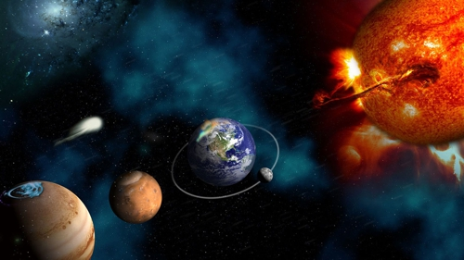

*The original material has been edited for accuracy  
and to improve ease of reading.*

As it is the apparent movement of the Sun which is responsible for the seasons, and as it is the field of force of the Sun in its relation to the field of force of the earth which determines the signs of the zodiac and which give to each its peculiar vibratory quality, it was to have been expected that in explaining the significance of the Sun the ancient masters should indicate signs and seasons in their design. Thus, the upper part of Major Arcanum 21 portrays a circle of twelve flowers, each representing one sign of the zodiac, and outside this zodiacal circle are to be seen the emblems of the quadrants of heaven which designate the yearly seasons.

The Sun also throughout the ages has been the emblem of spirit. It represents the Ego of man, which furnishes the impetus that causes him to struggle to survive, which endows him with ambition and which gives him the aspiration to climb to ever greater heights of attainment. It represents that power which is back of the evolution of the soul. And thus, in the tarot design which portrays the significance of the Sun, within the circle of zodiacal flowers we see the linga, indicating united male and female souls, endowed with wings and soaring upward into higher realms.

As the Sun is the dominant power within our solar system and as those on earth who exercise authority over others, such as bosses and politicians, always have the Sun prominent in their birth charts, the Wise Ones who gave instructions in the language of symbolical pictograph deemed it appropriate to explain Mastership and its attainment on the tarot card devoted to the Sun. The function of adeptship and the principal steps that must be taken to reach that exalted state are the subjects chiefly pictured on tarot Major Arcanum 21.

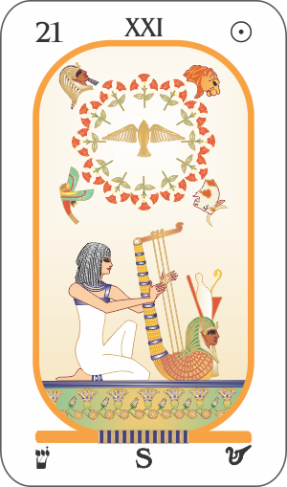A young girl is shown to signify that one who aspires to the perfect type of man called the adept must be pure both in manner of life and in his motives.

The moderation of desires and simplicity of living that must be his are denoted by the plain apparel worn by the girl. Yogis of the fakir type display their powers to the wonderment of the public. They attract attention to themselves and glory in the amazement of the populace. But not so the real adept. True masters live simply, avoid the vulgar glare of undue publicity, refuse to exhibit their powers merely to gain admiration and use their energies for the welfare of mankind.

The girl kneels to indicate that the adept has absolute devotion to the higher laws of nature and that in prayerful aspiration he seeks to his utmost ability to live a spiritual life, in which he consecrates himself to assisting, to the utmost of his ability, the fulfilment of the Divine Plan. He seeks diligently to discern the purpose of the Supreme Intelligence and to cooperate with it in all ways.

The harp which the young girl plays has three strings to signify that the Adept strives to develop harmony of body, emotions and intellect. His study of astrology teaches him that harmony is life and that discord is death. The aspects in a birthchart map factors within the unconscious mind of similar harmony or discord. And he has observed that the events attracted by the action of the discordant factors within the unconscious mind thus mapped are hindrances, obstacles and difficulties; while those events attracted by the extra physical power of harmonious factors thus mapped within the unconscious mind, are those that give him pleasure and bring him an advantage. Therefore, following the precepts so clearly placed before him by astrology, he cultivates in reference to his behavior, his feeling and his thinking as much harmony as lies within his power.

Masters, of varying degrees of power, have lived in all ages and in every clime. They are not confined to any special geographical area. Nor do they bow to the conventional religion of their time. Taking their instruction from Nature and from the wise ones who ascended before their births, the four chief tenets of their belief are to be found not merely in the tarot designs and not merely in the four emblems which mark the quadrants in the sky — and because of this are found so conspicuously outside the circle of flowers in Major Arcanum 21 — but also in huge monuments of stone.

Written records are subject to vandalism. It was possible that even the tarot cards should vanish from the globe. Thus, the utmost precaution was taken that the doctrines signified by the Lion and the Man, the Eagle and the Bull should not be lost to mankind. For hundreds of years during the dark ages of man’s religious history there was a relentless effort to destroy all records, all teachings and even the statuary and monuments of the past. Such records as were too large to be destroyed when possible were buried, as was the famous and most instructive Aztec Calendar Wheel.

But thousands of such monuments were too large either to be destroyed or buried by later people, and still persist. They are of four distinct forms and even as the constellations, the pictures on the suits of the tarot cards and the four emblems around the zodiacal circle of flowers in the tarot card dedicated to the Sun, reveal to one conversant with the language of symbolical pictograph, the ideas attached to them. Each type of ancient stone monument thus reveals by its form the spiritual idea and its astrological association which it was intended to convey to the minds of the people who erected it. As these were fundamental ideas held by adepts past and present, and as a man’s accomplishment is inextricably interwoven with his fundamental ideas, let us briefly review the significance of these religious doctrines so well preserved in stone.

Huge, straight shafts of rock upright like the rays of the midday Sun symbolize the virile, masculine powers of nature.

In the zodiac the sign over which the Sun has special rule is Leo, pictured by a lion; hence the lion head in Arcanum 21 outside the zodiac of flowers. The lion is noted not merely for his courage but for his affection. The house it rules in a natural birthchart is the one concerned with pleasures, love affairs and children. Love and life are closely allied and the upright pillar and the sign Leo symbolize both virility and love.



Fakirs may teach such a doctrine but true adepts never, that asceticism, sadness and sorrow are holy. Pain and suppression of legitimate pleasure are opposed not merely to the teachings of the adepts of the past, but also to the findings of modem psychology. The love of husband for wife and of wife for husband is a most desirable and sacred thing, and is one of the most constructive forces which man can utilize. The love of parents for their children approaches the deific in its sanctity and it germinates the seed of that unselfish love which alone makes immortality possible.

‘Do unto others as you would have others do unto you,’ is one of the most important doctrines ever taught, and is based upon the admonition, ‘Love ye one another.’ It is love that binds together. Love is the universal constructive agent. That which encourages and nourishes true love is blessed and should endure; for when love departs, the vacancy is filled by selfishness.

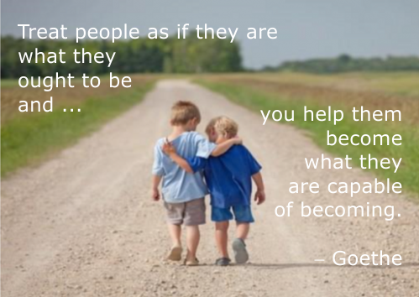

Thus does Arcanum 21 of the tarot, the second quadrant of the heavens which is pictured as a lion, and the single shaft of stone erected in veneration of creative energy, all record the belief of the adepts that love lies at the foundation of all constructive effort.

Massive tables of stone supported by two or more pillars are called dolmens and present the form of a doorway. Yet they are more than doorways, for the conspicuous feature of their structure is the flat, table- like surface presented by the slab held thus high above the ground. It strikes the eye at once as a plane. This plane is obviously one above the earth. It is a higher plane. And the doorway also is to no physical habitation.

A doorway thus connected to a plane higher than the earth can have but one significance in the language of universal symbolism. It is a pictograph, even though of massive stone, signifying that there is a plane of endeavor above the physical and that death is but a passing through a doorway to a life in spiritual realms.

The third quadrant of the heavens is represented by Scorpio, pictured in Arcanum 21 as the eagle’s head outside the zodiac of flowers. This zodiacal sign commonly is symbolized as a crawling denizen of the desert, the scorpion, but as representing another influence of the same sign it is pictured by an eagle, master of the element above the earth. The house it rules in a natural birthchart is the one of death.

Not only then does the huge slab of stone supported by two pillars attest to a belief in the survival of the personality after death, but the tarot card by expressing the relation of man to death as a Scorpion that has now become an Eagle, portrays the conviction of the adepts that through death man ceases to crawl in the dust and soars to a life of greater power and freedom.

A circle of huge stones and within these other circles of huge stones about the same center, portray the orbits of the planets. Such picturing in so many parts of the world of the movements of the planets, at a cost of so great labor would have been undertaken only because it was believed that the movements of the planets thus represented have a profound influence upon the life and destiny of man.

The man of the zodiac, Aquarius, pictured as the head of a man outside the zodiacal circle of flowers in Arcanum 21 — representing the fourth quadrant of the heavens — also speaks in unmistakable terms of the same belief. Water running from his urn flows down upon the earth even as do the vibrations of the planets. And in one hand he holds aloft, as if measuring the influences in the firmament above, a 24-hour gauge, even as astrologers past and present use the 24-hour period as the measure of the influences meted out to man.

Thus we find huge stone monuments, called cromlechs, built long ago yet speaking to us in the simplest form of written language, the pictograph. And these stone structures bring the same message that is revealed in the constellation of the Man and the design of the tarot Arcanum 21. They point to a belief that the planets have an influence over human life and destiny.

One more quadrant of heaven and its emblem is yet to be explained. It is represented among the ancient monuments by dome-shaped mounds. They once were used for magical ceremonies and for initiations. Thus they are used today by primitive peoples, the kiva of the Indians of the Southwestern United States being one of many examples that can be cited.

Such a dome by its shape is a universal symbol of the feminine in nature. It represents the same root that ‘Ma’ does in various languages, that is, it signifies the mother. The Sun, which is the influence we are considering when we read Arcanum 21, is in the sign of Taurus in the month of Ma (y). The sign Taurus also is the exaltation, or highest station, of the mother planet, the Moon. It is an earthy sign, hence the mound while hollow and having a small, low entrance is usually covered with earth.

It is the first quadrant of the heavens which is depicted by Taurus, the Bull, the head of which appears outside the circle of flowers on the solar tarot card. This is the bull with which the mighty hunter, Orion, is pictured in perpetual conflict. Orion wields the club of mental power to combat and overcome the bull which pitches down upon him from the sky. This bull with which the hunter struggles and which mythology and the Bible inform us was thus overcome, signifies the sum total of our environment. The bull is the symbol of the most earthy of the signs, hence represents physical obstacles and limitations to be overcome. Pitching down upon Orion from the sky signifies also the planetary influences that come from above. The club is intelligently directed willpower. Thus, is conveyed the idea that both material conditions and the influence of the stars may be overcome by the use of the mind of man.

It is in these dome-shaped mounds that primitive peoples carried out ceremonies to make them successful in the hunt, to give them a bountiful harvest, to overcome enemies and to enter into communication with the dead. That is, these were the places where they went to ‘demonstrate success’ through the exercise of the mind’s hidden powers.

This sign Taurus, as already indicated, is the best station of the Moon. The Moon is the orb that more than any other rules the unconscious mind, which is the instrument by which thoughts manifest their supreme power. Thus do the mound-shaped dome, the pictured constellation and the head of the bull on Major Arcanum 21 record the belief of the adepts that man, through the proper exercise of his mentality, can control his own life and destiny, here and hereafter.

Flowers represent the coming harvest time, the blossoming of experiences. And while there are but twelve flowers in the adept’s zodiac, as pictured on Arcanum 21, each flower in the circle has three blossoms. To gain the knowledge and experience by which he thus can rule his present life and future destiny it is significant that the adept must explore all three planes. His work and knowledge are not confined to the physical world, but must extend also to the astral and the spiritual. These inner realms he explores through using what now has become the custom to call extrasensory perception.

In the article discussing the significance of Cancer, the most negative of all the astrological influences, it was explained that there are two diametrically opposite methods of obtaining information from the inner planes. One, the method of irresponsible mediumship, is disintegrative and tends to destroy the will and the soul of the one who practices it. The other is positive, under control and may be made to strengthen the will and increase the independent activity of the soul.

Needless to say, the adept in his quest for knowledge and in his exploration of the inner planes where he will dwell after physical life shall cease, never uses the method of negative mediumship. But even in the positive use of the psychic senses the adept employs a technique far superior to that of less advanced positive psychics. And as adeptship implies the efficient use of extrasensory perception and the exercise of extra physical power, some explanation of this should be made while we are considering this adeptship tarot card.

Man’s nervous organization is broadly divided into two fairly distinct systems: the sympathetic system and the cerebrospinal system. At the head of the cerebrospinal system is the brain, which is specialized to give orders and to do certain complex types of thinking.

As indicated in connection with the explanation of The Sarcophagus tarot card, all communication between the physical plane and the inner planes must take place through transmitting motion to the boundary-line etheric energies which have the velocity of light. Even objective thought, because it must call upon the factors of memory which reside in the unconscious mind and thus are on the inner plane, must make use of these etheric energies. But in the development of disintegrative mediumship the individual cultivates the generation in his nervous system of electrical currents which have a large volume and low potential and therefore are easily manipulated by some other entity.

The positive psychic, however, through raising or lowering the vibrations of his nervous system — chiefly of his sympathetic nervous system — is able to use the electromagnetic field of the electric charges he generates to tune in consciously on objects or entities of either plane, so that he can see, hear, feel and otherwise perceive them. When the nervous system or some ganglion in it is made sensitive enough so the etheric energies associated with it can be raised or lowered in their frequency in a manner corresponding to the tuning in of the astral body on some condition, the nervous system or ganglion then becomes a receiving set to convey to objective consciousness that which the unconscious mind has seen, heard or felt. The ordinary positive psychic thus trains his nervous system and particularly his sympathetic nervous system, to bring through into objective consciousness whatever he desires upon which to tune his unconscious mind.

No fault is to be found with this method so long as the psychic develops the ability to tune off that which he does not wish to hear, see and feel as readily as he tunes in on the things he does wish to contact. But commonly those who develop the psychic senses, even in this positive and completely controlled way, become so sensitive that the necessary impacts and discords of the physical world cause them no end of discomfort.

Furthermore, while creatures lower in the scale of life than man commonly make great use of the nervous system other than the brain to guide their actions, man has developed a special capacity to handle information with his brain. And by using his brain efficiently he can apprise himself not merely of things which are pleasant but of things which are distasteful without feeling these things intensely.

Some people, it is true, cannot think about a surgical operation, an illness, or other disagreeable thing without tuning in on it and feeling pain. Whatever they apprehend, they feel the condition within themselves. They live largely in the sympathetic nervous system.

Other people, who when they desire to tune in on something harmonious are quite as capable of enjoyment, are able to hold their consciousness so exclusively on the intellectual level that they can see others in pain, can perform surgical operations, or do tasks where there is great environmental discord, without themselves feeling the discord or pain. They apprehend these things with the intellect and have trained themselves not to tune in on them sympathetically.

The unconscious mind, to apprehend a condition, has no more need of tuning in on it than has the objective consciousness. It has the power of seeing and hearing and can observe what is taking place on the inner plane from the intellectual level and can even take part in what is taking place, without feeling the condition, just as a well-trained surgeon can observe an operation or take part in it on the intellectual level without himself suffering any of the distress of the patient.

Furthermore, the brain can grasp this information as it is transmitted from the unconscious mind to it as memory, without feeling the condition intensely. And thus, the adept, instead of sensitizing his nervous system to feel the conditions by tuning in on them, trains his brain to bring up into objective consciousness that which he directs his unconscious mind to apprehend intellectually. In this manner he is able to extend his consciousness to the inner plane and witness its affairs, or see clairvoyantly what is transpiring at a distance on the earth.

When he wishes thus to exercise his extrasensory perception he does not think about the condition or information he wishes to contact in a sympathetic way, so that he tunes in on it. Instead, he makes it a practice to keep his nerves tuned chiefly to the vital vibrations ruled by the Sun. The Sun rules the type of electrical energy generated in the body cells and nervous system that furnish vitality, stability and the power to rule and control. And as it is the adept’s object not to be influenced by other things, but himself to control and direct, he cultivates no high tensions or unusual sensitiveness of the nervous system. Instead, he maintains his nerves and body in a state of normal health and vigorous vitality. Thus, does he prevent his nervous system from picking up, as does a radio set, the vibrations of that which he thinks about in an intellectual manner.

To exercise his extrasensory perception, instead of tuning in he temporarily arrests the flow of objective thought, turns his attention to the inner plane and directs his unconscious mind to extend its consciousness to apprehend the condition or information sought. The unconscious mind, using its senses, sees, hears and otherwise contacts the conditions desired, but does it from an intellectual standpoint, with no more sympathetic response to it than a scientist exhibits while watching some interesting chemical experiment in his laboratory.

That which thus was observed or learned by the unconscious mind, functioning on its own plane of substance and thus without the space and time restrictions common to the physical plane, then is raised into the region of objective consciousness as if it were a dream or memory; and in fact, it is a memory, a memory of an actual inner plane experience.

In thus bringing the result of the extrasensory perception into the domain of objective consciousness, the border between the two planes must be crossed through the use of the electromagnetic energies generated by the cells of the brain. But the brain has been specialized, as in the case of ordinary memory to do this work and to do it on the intellectual level, rather than on the sympathetic level such as psychics use who as yet are far removed from adeptship. The adept, cultivating rather than relinquishing, the vital and electric controlling force ruled by the Sun, is able intellectually yet personally to explore the realms symbolized by the three blossoms of each sign of the zodiac of flowers pictured in Arcanum 21, and to do it through an extension of his consciousness and not by tuning in.

**Pluto and the Materialist**

First printed in *American Astrology Magazine* November 1938

**Elbert Benjamine**

*The original material has been edited for accuracy  
and to improve ease of reading.*

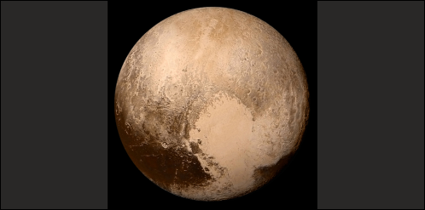Photo via **Good Free Photos**

Until the discovery of Pluto was announced to the world on March 13, 1930 [discovered February 18th] Major Arcanum 22 of the tarot was a mystifying paradox. It always was considered as possessing an alternative interpretation. It was thus either number 22 or the no-numbered card represented by zero.

Sometimes it was viewed as the person who recognizes the impermanence and worthlessness of the dross, tinsel and outward display for which many devote the energies of their lives. Renouncing all such show and physical gain is spiritually wise; however, it does seem materially foolish.

More often it was considered the reverse of this — as the person who turns their back on the light of spirit, believes the physical is the all of life and thus is on the plane of the predatory brutes, struggling only for material advantage, with no mercy to those who stand in their way. Considered from this view the card has come to be known as *The Materialist*.

Its astrological correspondence was given as the unknown planet. But today the planet is no longer unknown and now that we have had opportunity to intensively study the action of Pluto in thousands of birth charts, we perceive with admiration how precisely the ancients, who probably knew of the planet only through their psychic faculties, portrayed its characteristics in the Materialist tarot card. [In 2006 the IAU reclassified Pluto as a dwarf planet — the ninth-largest and tenth-most-massive known object directly orbiting the Sun. This is a controversial move for astrologers]

The most outstanding characteristic of Pluto is the two opposing sides of its nature. It is never weak, timid or vacillating. It is always very bad or very good, exceptionally brutal or unusually spiritual. It incites the most atrocious crimes, giving us the racketeer or it influences effective work for social welfare, giving us the inspired leader who encourages all to cooperate for the common good.

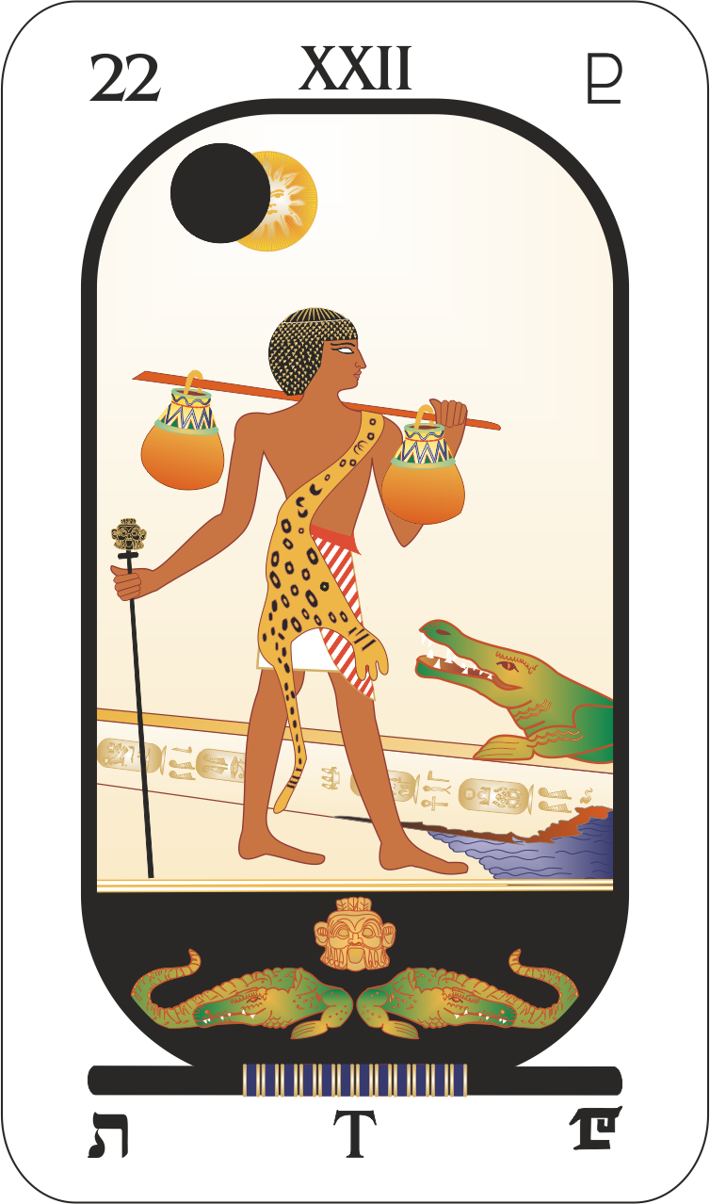

Pluto’s alternate influence on humankind and on the individual is explained on the card in the language of symbolical pictograph thus:

It is figured by a blind person carrying bags on their left shoulder; but whether they are blind to spiritual illumination or to material advantage is not indicated, only that if, out of necessity, they take heed of one, they are blind to the other. The bags over the shoulder indicate the material things of life they have spent their efforts acquiring, or they represent ability to minister in physical ways to those in need.

Leaning on a black staff, this person walks toward a fallen obelisk behind which a crocodile with wide-open mouth awaits to devour them. The staff of experience with good and evil is black, indicating that prudence is either subservient to the demands of the senses, or that the demands for uplifting and protecting others is so great that, though enlightened, they ignore all danger.

The fallen obelisk symbolizes the final overthrow of all temporal work and power. The crocodile indicates the ultimate fate of all who are blind to spiritual things, and it indicates also the persecution of those who work to spread the true facts of spirituality.

Above is an eclipse of the Sun. This eclipse signifies that the spiritual light from within has been obscured by material interests, or that dark forces from the inner plane try to shut away the spiritual illumination which guides the neophyte. It even denotes the eclipse of the proper understanding of the various forces which Pluto rules through confusion of terminology, for Pluto, the ruler of the sign Scorpio, is now known to rule the invisible realm (where the so-called dead sojourn), radio and telepathic methods of communication, and the energies of the inside of things such as the intra-atomic force which is said to bind the atoms together with a force a thousand times stronger than that of gravitation.

Material science has not advanced far enough to enable us to comprehend much of inner plane phenomena. It is not surprising that the terminology applied to it is confusing. Nor is it surprising that confusion has arisen, since the etheric body, which is part of a persons invisible domain, was only demonstrated in 1936 by material science to be electrical in origin. The cells of the physical body are like miniature batteries furnishing the electricity which become nerve currents with measurable charges and radiations.

While it undoubtedly is true that when velocities in excess of a certain unknown rate are present, new types of conditions and attributes are present which are characteristic of the spiritual plane, yet nearly all of that which commonly is attributed to the spiritual plane in reality belongs to the spiritual levels of the astral world. The truly spiritual world is too far removed from the physical to be much more than occasionally glimpsed by the most advanced in the use of psychic perception. And even the upper reaches of the astral are so refined and spiritual that it requires unusually high spiritual development to even momentarily contact them.

Therefore, for all practical purposes, the truly spiritual world — which has freedom and characteristics as strange to those dwelling in the astral realm as the freedom of movement and the different relations of time, space and gravitation that exist on the astral plane seem strange to those accustomed to physical conditions and limitations — may be ignored in the study of inner plane phenomena. It has an existence, but its environment is too far removed to give observation much value.

For practical purposes we consider the invisible world, ruled by Pluto, as embracing the etheric realm and the astral world. As pointed out when considering *The Sarcophagus* tarot card, when an object gains a velocity greater than that of light, the common laws of gravitation and those relating to time and space no longer hold. Then, It is something belonging to the astral plane. Thoughts and the unconscious mind have such velocities and therefore are not physical things, nor are they etheric, where velocities are those of light. They are movements and organizations of astral substance. Planetary energies that exert an influence upon human life are charted by astrology to also have velocities greater than light and thus are forces of the astral plane.

In between physical substance and astral substance are the borderline energies — electromagnetic vibrations, radiations and light — that have the critical velocity of about 186,000 miles a second which gives them some qualities of the physical plane and some of the astral plane. These so-called etheric forces are transitional energies, transforming readily the energy of one plane into the energy of the other plane; and those of them that are invisible, belong to Pluto’s domain. Light, however, being visible is not part of his realm. While it is true that highly evolved humans have the rudiments of a spiritual body, which so far as it is present belongs to the spiritual plane, for all practical purposes, in considering humans and occult forces, we only need to investigate two planes and the borderline energy which permits exchanges between them.

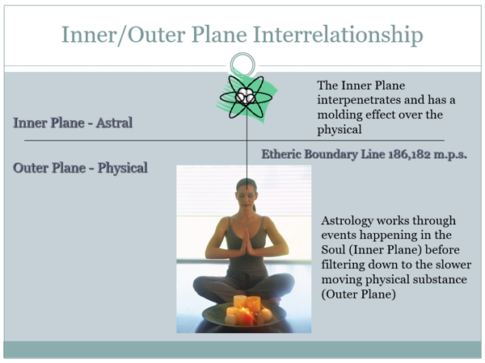

When we are confronted with the experience of a psychic who sees the physical body, the etheric body, an emotional body, an astral body, a mental body, a solar body, and so-on, we are not called upon to dispute what is seen, but we are privileged to interpret it in the light of most recent findings.

The aura of the etheric body, for instance, does have two quite distinct zones. It can be seen by the normal person who sensitizes his eyes with **Kilnur’s dicyanin screen**, or better still with the pinacyanol screen developed by Bagnall. **Oscar Bagnall** in his book, *The Origin and Properties of the Human Aura* made a distinct and valuable contribution to our knowledge of the etheric body. He approaches the matter effectively as a material scientist. His screen shows that there is a denser brighter inside aura which extends some three inches from the skin of the physical body. It has certain properties that are similar to those of a magnetic field.

Then outside this inside aura, and extending six to eight inches beyond it, is an outer haze which fades into nothingness at its outer margin and which around the body is more or less oval in shape. This outside aura behaves more in the manner of ultra violet light than as a magnetic field.

Now it is common for psychics to see these two zones of the aura and to give them names which imply they are of quite different planal substance. The inner aura, for instance, often is said to belong to the etheric body and the outer aura then is said to belong to the emotional body, which by them is believed to be of the substance of the astral plane. Yet it is obvious from the fact that they can be seen by the physical eye properly sensitized to perceive vibrations slightly higher in frequency than violet light, that both these zones of the aura are phenomena of the etheric order. That is, they are electric in origin and constitute an electromagnetic field, and radiations from electrically charged particles, which are but slightly higher in frequency, and have the same speed as light. The currents which carry messages over the nerves, the vitality of the physical body, the etheric body and both the inner and the outer aura, are phenomena of the borderline etheric substance.

These same psychics also consider that there are several inner planes, each with its own type of substance. Thus the emotional body and events which transpire on the emotional plane are coarser and of lower vibration than the mental body and the event which transpire on the mental plane. As we have just seen, however, that which most of them call the emotional body really belongs to the borderline energy, grading off from etheric in nature to that which is truly astral. And that which these same psychics call mental substance is but one type of many manifestations of astral energy on the astral plane, that which is called spiritual by them being but another.

This is not stated for the purpose of criticizing these psychics. It merely points to the fact that recent discoveries in material science give us a more precise conception of what they actually see. For the effect of a strong emotion upon both the etheric body and the astral body is very different than the effect upon them of intellectually working to solve some problem. Yet both emotion and intellectual effort, each in its own way, has a profound influence upon both the etheric energies and the astral energies of the person so engaged.

Let us consider that desire is the energies of certain thought-cells or groups of thought-cells within the unconscious mind in a potential state, straining to be released in a given activity: to move the physical body, to acquire sustenance, to destroy an enemy, to realize love, to enjoy a certain sensation, to solve a complex mental problem, or any one of innumerable other things. That is, desire is energy which has produced a tension which seeks release in some activity. And this activity, in which the desire energy finds release, in turn gives rise to more or less feeling.

Certain desires, however, are powerful enough that the discharge of their energy when the tension is released creates a profound and widespread disturbance of the electrical currents which flow over the nerves. These more violent desires are responses of the life-form to emergency situations. Some of these situations are: the call to conflict, stimulating anger; realizing inadequacy to handle a situation, stimulating fear; realization of loss sustained and consequent inadequacy, stimulating sorrow; belief that a fond desire will be realized, stimulating hope; realization of a fond hope stimulating joy; and the thought or presence of a loved one, stimulating passion or love. Such situations demand that energies be present in more than normal volume. Hence the tensions of the nervous system are such as quickly to generate electrical currents so powerful that when these energies are released they are violent enough to give rise to profound disturbances of the etheric body and the astral body and to develop those intense feelings which are termed emotion.

Intellectual thinking, however, makes use of desire energies far removed from emergency situations. It uses images and symbols which are more or less abstractions of the things which arouse the strong primitive desires. Hence the electrical currents generated in the process, while perhaps having an exceedingly high potential and able consequently to radiate much shorter wavelengths than emotion normally does, nevertheless have far less volume, and their release does not set up such profound and widespread disturbances in either the etheric body or the unconscious mind.

Intellectual thinking and emotion both make use of the substance of the same planes and utilize the same kind of energies. However, Emotion is energy released with violence and in volume, while intellectual thinking releases similar energy with less violence and volume, but commonly with shorter wavelength radiations. I say commonly, advisedly, because spiritual aspiration and the higher types of love also have high voltage and a vibratory rate sufficiently great that they reach and have an influence upon the upper astral levels.

While the substance affected is the same whether it is acted upon by emotion or by intellect, the vibratory level of this substance may be markedly different. The astral world contains innumerable vibratory levels, just as there are innumerable different frequencies over each of which a radio program on earth can be broadcast. And on each of these thousands of vibratory levels, corresponding in the astral substance to possible frequencies in etheric substance that might be used in radio work, there are objects and life-forms undergoing experiences that to them are as objective as the experiences of people on earth. In fact, when one has tuned in on the particular level or moved there through having a similar basic vibration, its world, its denizens and its happenings are as intense and objective as physical experiences can be. And usually those on one level are quite unconscious of what is happening on other levels.

Herein lies the difference between the so-called emotional body and the mental body; for the more common emotions not only generate a great supply of rather low potential electrical energy, but their vibratory rate is such that they tune the individual to the lower levels of the astral world. High aspirations reach the higher levels, but most of the emotions do not lift the thoughts and thus the vibrations above the physical plane. This means that the individual tunes in on levels of the astral world where the program — which is the actual life of that level — is very much the same as that by which the individual is surrounded in his everyday life.

If a person is psychic, and exercises extrasensory perception, the things they see, hear and feel are neither more nor less spiritual than those they commonly contact on the physical plane. That is, the intelligences with which they commune are just as selfish, just as envious, just as petty as are those on the physical plane and just as likely to try to take advantage of them for their own ends.

This does not mean that all, or even any large portion, of contacts on the inner plane are lacking in noble qualities; it simply means that of the innumerable levels of astral existence, one's own thoughts and basic vibration tuned them in on a level where the denizens have a similar basic vibratory rate.

Now let us consider that Pluto is the ruler of the invisible realm, which includes both the boundary energies — for some of these are used in radio, which it has been demonstrated Pluto rules — and the energies of the astral plane. In reference to the radio, we have collected the birth charts of a great many associated in some way closely with it, observed the progressed aspects when they took up radio work and also noted the aspects in the cycle charts when news relating to the radio came prominently before the notice of the public. Pluto almost invariably is involved. We find also that when people most readily get telepathic messages and especially when they recognize thoughts sent to influence them, getting the thoughts clearly and becoming aware of the sender, is when there is a progressed aspect to Pluto in their birth charts.

From birth chart studies we have also noted that for establishing rapport between two individuals — not the ESP that is ruled by Neptune — whether one has left the physical plane or both are still in physical bodies and exchanging thoughts, that the wavelengths generated by the nervous system when Pluto is prominent in the birth chart and by progression are by far the most effective of all. They seem not so conducive to tuning in on objects or to perceiving astral scenes, as are the wavelengths of Neptune, but as the means by which one intelligence, whether of the physical world or the astral, can impress its thoughts upon another at a distance they rank first.

Through the better side of its nature, Pluto rules the noblest aspirations of people and those who labor unselfishly for human advancement. With the other side. it rules the gangster, the racketeer and those who are the enemies of human progress. It follows that intelligences of both extremes, as well as those of less pronounced tendencies, occupy the unseen realm which both by mythology and by practical research Pluto is deemed to rule. Furthermore, just as we witness on earth today in the struggle between dictatorships and democracy and between the efforts to penalize those who teach and practice astrology and those who are trying to give astrology to the public as the most valuable aid to better living it is possible for them to acquire, so the outstanding tendency of Pluto, which is to split into two opposing factions, has made itself felt in the invisible realm he rules.

In the border region, where velocities are slightly, if at all, greater than light, and where the etheric and astral energies blend, innumerable creatures dwell. They include fairies, sylphs, salamanders, gnomes and undines; and various other kinds, such as the mischievous ones which are usually responsible for the well-attested and not too uncommon poltergeist phenomena, in which stones are thrown, crockery smashed, doors opened, knocks and rappings and other annoying events take place in the presence of some particular person, usually of a youth near the age of puberty.

During the glandular readjustment of such a youngster, conditions may be such as to cause their nervous system to generate large volumes of low potential electricity. They give off great surpluses of etheric energy of just the type that most easily can be contacted and used by the creatures on the borderline between etheric and astral. Such phenomena usually cease as the youngster furnishing the energy matures.

The velocities of astral and etheric energies are not far different from that of light, and this borderline region where they blend is the home of intelligences which in their basic vibrations are similar to the creatures of earth. Some are not vicious, merely lacking in spirituality. Yet there are also others which resemble in appearance and in predatory habits the lion, the tiger, the bear and the wolf. That is, if one, with sufficiently developed ESP, were so inclined they can view the jungle of the astral plane, just as one can go to a not dissimilar jungle in the physical world.

But of greater importance to humans — because most people have no occasion to visit the jungle — are the discarnate human beings who occupy this borderline realm. On vibratory levels far above it dwell those who strive continually to benefit the human race, who inspire people to noble effort and encourage them in every unselfish and worthy enterprise. And if the individual tunes in on them or reaches them through an extension of his consciousness, they will aid him through the impressions of their thoughts.

But in the lower astral levels and in the borderland, zone continue to dwell those who, for some reason, are earthbound. That is, their attachment to the conditions of the earth is so obsessive that they cannot rise to higher vibratory levels. Nor can those whose lives have been actuated solely by the predatory instincts of carnivorous beasts rise above the vibratory level of this border sphere. The racketeers, the gangsters — those who would prey upon the unwary and who are devoid of pity for the sufferings of others — persist as denizens of this astral-etheric Pluto border realm.

Many of those who died in war, unable to free themselves from the desire to be revenged upon their enemies, also linger in this domain close to earth and from it impress their desires and their plans upon those living who are sufficiently sensitive.

Both the high and the low, the refined and the gross in the invisible regions are portions of Pluto’s domain; and the thoughts and ambitions, aspirations and greed that today have divided the world into two contending camps, have largely been prompted from these regions. Pluto’s discovery was coincident with a more profound influence upon the earth of the invisible realm he rules.